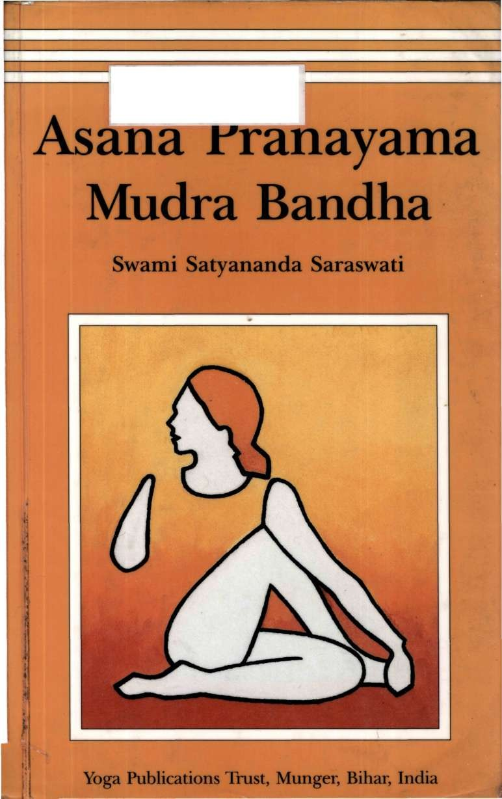

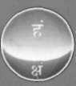

SATYANANDA YOGA BIHAR YOGA

*Asana Pranayama Mudra Bandha* is recognised internationally as one of the most systematic yoga manuals available today. Since its first publication by the Bihar School of Yoga in 1969, it has been reprinted thirteen times and translated into many languages. It is the main reference tex t used by yoga teachers and students of Bihar Yoga/Satyananda Yoga withi n the International Yoga Fellowship Movement, and many other traditions as well.

This comprehensive tex t provides clear illustrations, step by step directions and details of chakra awareness. It guides the practitioner or teacher fro m the simplest to the most advanced practices of the hatha yoga system. A therapeutic index is included for use by doctors and yoga therapists incorporating recent information fro m research into yoga. This edition successfully brings the exposition of yoga practices to the standard of a university text.



Price: Indian Rs. 175/-

# Asana Pranayama Mudra Bandha

Swami Satyananda Saraswati

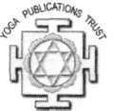

Yoga Publications Trust, Munger, Bihar, India

© Bihar School of Yoga 1996

All rights reserved. No part of this publication may be reproduced, transmitted or stored in a retrieval system, in any form or by any means, without permission in writing from Yoga Publications Trust.

Printed by Bihar School of Yoga First published 1969

Reprinted 1971

Second edition 1973

Reprinted 1977, 1980, 1983, 1989, 1993, 1995, 1996

Third revised edition 1996 (by Bihar Yoga Bharati with permission of Bihar School of Yoga)

Reprinted 1997,1999

Printed by Yoga Publications Trust Reprinted 2002

**ISBN:** 81-86336-14-1

**Price:** Indian rupees one hundred and seventy five only

Publisher and distributor: Yoga Publications Trust, Ganga Darshan, Munger, Bihar, India.

Website: [www.yogavision.net](http://www.yogavision.net/) E-mail: [ypt@yogavision.net](mailto:ypt@yogavision.net)

Printed at Thomson Press (India) Limited, New Delhi, 110001

SWAMI SIVANAND A SARASWATI

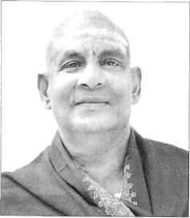Swami Sivananda was born at Patta- madai, Tamil Nadu, in 1887. After serving as a medical doctor in Malaya, he renounced his practice, went to Rishikesh and was initiated into Dash- nami sannyasa in 1924 by Swami Vishwananda Saraswati. He toured extensively throughout India, inspiring people to practise yoga and lead a divine life. He founded the Divine Life Society at Rishikesh in 1936, the

Sivananda Ayurvedic Pharmacy in 1945, the Yoga Vedanta Forest Academy in 1948 and the Sivananda Eye Hospital in 1957. During his lifetime Swami Sivananda guided thousands of disciples and aspirants all over the world and authored over 200 books.

SWAMI SATYANANDA SARASWATI

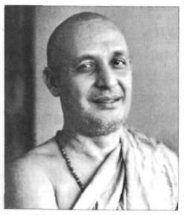Swami Satyananda was born at Almora, Uttar Pradesh, in 1923. In 1943 he met Swami Sivananda in Rishikesh and adopted the Dashnami sannyasa way of life. In 1955 he left his guru's ashram to live as a wandering mendicant and later founded the International Yoga Fellowship in 1963 and the Bihar School of Yoga in 1964. Over the next 20 years Swami Satyananda toured internation• ally and authored over 80 books. In

1987 he founded Sivananda Math, a charitable institution for aiding rural development, and the Yoga Research Foundation. In 1988 he renounced his mission, adopting kshetra sannyasa, and now lives as a paramahamsa sannyasin.

SWAM I NIRANIANANAND A SARASWATI

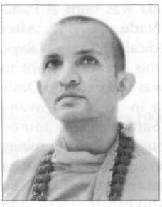Swami Niranjanananda was born at Rajnandgaon, Madhya Pradesh, in 1960. At the age of four he joined the Bihar School of Yoga and was initiated into Dashnami sannyasa at the age of ten. From 1971 he travelled overseas and toured many countries for the next 11 years. In 1983 he was recalled to India and appointed President of Bihar School of Yoga. During the following 11 years he guided the development of Ganga

Darshan, Sivananda Math and the Yoga Research Foundation. In 1990 he was initiated as a paramahamsa and in 1993 anointed preceptor in succession to Swami Satyananda. Bihar Yoga Bharati was founded under his direction in 1994. He has authored over 20 books and guides national and international yoga programs.

SWAM I SATYASANGANAND A SARASWATI

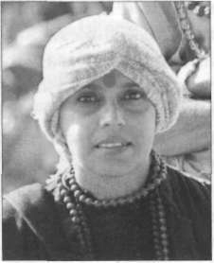Swami Satyasangananda (Satsangi) was born on 24th March 1953, in Chan- dorenagore, West Bengal. From the age of 22 she experienced a series of inner awakenings which led her to her guru, Swami Satyananda. From 1981 she trav• elled ceaselessly with her guru in India and overseas and developed into a scholar with deep insight into the yogic and tantric traditions as well as modern sciences and philosophies. She is an effi•

cient channel for the transmission of her guru's teachings. The establishment of Sivananda Math in Rikhia is her creation and mission, and she guides all its activities there, working tirelessly to uplift the weaker and underprivileged areas. She embodies compas• sion with clear reason and is the foundation of her guru's vision.

##### Preface

The first edition of *Asana Pranayama Mudra Bandha,* pub• lished in 1969, was derived from the direct teaching of Swami Satyananda Saraswati during the nine month Teachers' Train• ing Course conducted by him at Bihar School of Yoga, Munger in 1969.

The second edition was published in 1973 to commemorate the Golden Jubilee of Swami Satyananda Saraswati. At this time, the text was completely revised and new material added from class notes taken during the 1970-71 Sannyasa Training Course, which was the last course to be personally conducted by him.

In response to popular demand and to meet the require• ments of a university text, APMB was totally revised and updated unde r the direction and inspiration of Swami Niranjanananda Saraswati, the successor of Swami Satyananda Saraswati. This enlarged edition was first published by Bihar Yoga Bharati in 1996, with the permission of Bihar School of Yoga, and is now being reprinted by Bihar School of Yoga.

This text is currently being used as the main practical text for the teaching of asana, pranayama, mudra, bandha and shatkarma within the Certificate and Diploma Courses in Yogic Studies at Bihar Yoga Bharati. It is also a primary reference for the postgraduate MA/MSc Courses in Yoga Psychology, Yoga Philosophy and Applied Yogic Science.

Since publication of the first edition, interest in yoga has spread widely. Now APMB is used in ashrams, centres and yoga schools in every country as the standard textbook for teachers and students alike. The techniques presented have

been assimilated by fields as diverse as medicine, education, entertainment, business and sport.

The science of yoga applies itself to all aspects of life. Obviously, a subject of this breadth cannot be encapsulated in one volume. This revised edition presents basic yogic practices including *asanas,* postures; *pranayamas,* breathing techniques; *mudras,* positions or gestures which represent the psyche; *bandhas,* locks for channelling energy; and *shatkarmas,* cleansing practices. All of these techniques purify the body, mind and energy systems to prepare the ground for higher practices of meditation an d for the ultimate experience of cosmic consciousness. Also included is a section introducing the *chakras,* psychic centres, and other aspects of the subtle body.

The effects of yogic practices during and after performance are currently being researched by scientists and doctors around the world. Their results show that asanas, pranayamas, mudras and bandhas are a potent means to restore and maintain physical and mental health. In the near future we hope to see an increasing application of yoga in all walks of life.

*s*students, spiritual seekers and for those studying yoga in depth. Although many health professionals consult this text as a guide when constructing programs to provide clients with physical, mental and emotional balance, these techniques are not primarily for the sick but for the healthy.

When learning the practices of yoga, the guidance of a qualified yoga teacher is recommended. This text provides yogic practices and information for personal evolution. When practised faithfully, unde r the guidance of a competent teacher, these techniques will expand your consciousness.

*xii*

##### Introduction to Yoga

*"Yoga is not an ancient myth buried in oblivion. It is the most valuable inheritance of the present. It is the essential need of today and the culture of tomorrow."*

Swami Satyananda Saraswati

Yoga is the science of right living and, as such, is intended to be incorporated in daily life. It works on all aspects of the person: the physical, vital, mental, emotional, psychic and spiritual.

The word *yoga* means 'unity' or 'oneness' and is derived from the Sanskrit word *yuj* which means 'to join'. This unity or joining is described in spiritual terms as the union of the individual consciousness with the universal consciousness. On a more practical level, yoga is a means of balancing and har• monising the body, mind and emotions. This is done through the practice of asana, pranayama, mudra, bandha, shatkarma and meditation, and must be achieved before union can take place with the higher reality.

The science of yoga begins to work on the outermost aspect of the personality, the physical body, which for most people is a practical and familiar starting point. When imbalance is experienced at this level, the organs, muscles and nerves no longer function in harmony, rather they act in opposition to each other. For instance, the endocrine system might become irregular and the efficiency of the nervous system decrease to such an extent that a disease will manifest. Yoga aims at bring• ing the different bodily functions into perfect coordination so that they work for the good of the whole body.

From the physical body, yoga moves on to the mental and emotional levels. Many people suffer from phobias and neuroses as a result of the stresses and interactions of everyday living. Yoga cannot provide a cure for life but it does present a proven method for coping with it.

Swami Sivananda of Rishikesh explained yoga as an "...integration and harmony between thought, word and deed, or integration between head, heart and hand". Through the practices of yoga, awareness develops of the interrelation between the emotional, mental and physical levels, and how a disturbance in any one of these affects the others. Gradually, this awareness leads to an understanding of the more subtle areas of existence.

There are many branches of yoga: raja, hatha, jnana, karma, bhakti, mantra, kundalini and laya, to name but a few, and many texts explain them in detail. Each individual needs to find those yogas most suited to his/her particular personality and need. In the last half of this century, hatha yoga has become the most well known and widely practised of the systems. However, the concept of what constitutes yoga is broadening as more people take it up, and this knowledge is spreading. In the ancient texts, hatha yoga consists of the shatkarmas, cleansing practices, only. Today, however, hatha yoga commonly embraces the practices of asana, pranayama, mudra and bandha as well.

History of yoga

The yoga we know today was developed as a part of the tantric civilisation which existed in India and all parts of the world more than ten thousand years ago. In archaeological excava• tions made in the Indus Valley at Harappa and Mohenjodaro, now in modern Pakistan, many statues have been found de• picting deities resembling Lord Shiva and Parvati performing various asanas and practising meditation. These ruins were once the dwelling place of people who lived in the pre-vedic age before the Aryan civilisation started to flourish in the Indus subcontinent. According to mythical tradition, Shiva is said to be the founder of yoga and Parvati, his first disciple.

Lord Shiva is widely considered to be the symbol or em• bodiment of supreme consciousness. Parvati represents supreme knowledge, will and action, and is responsible for all creation. This force or energy is also known as *kundalini shakti,* the cosmic force which lies dormant in all beings. Parvati is regarded as the mother of the whole universe. The individual soul is embodied and bound to the world of name and form, and also liberated from the bondage of the world and united with supreme consciousness through her grace. Out of love and compassion for her children, she imparted her secret knowledge of liberation in the form of tantra. The techniques of yoga have their source in tantra and the two cannot be separated, just as consciousness, Shiva, cannot be separated from energy, Shakti.

*Tantra* is a combination of two words, *tanoti* and *trayati,* which mean 'expansion' and 'liberation' respectively. There• fore, it is the science of expanding the consciousness and liberating the energy. Tantra is the way to attain freedom from the bondage of the world while still living in it. The first step in tantra is to know the limitations and capacities of the body and mind. Next it prescribes techniques for the expan• sion of consciousness and the liberation of energy whereby individual limitations are transcended and a higher reality experienced.

Yoga arose at the beginning of human civilisation when man first realised his spiritual potential and began to evolve techniques to develop it. The yogic science was slowly evolved and developed by ancient sages all over the world. The essence of yoga has often been shrouded in or explained by different symbols, analogies and languages. Some traditions believe that yoga was a divine gift revealed to the ancient sages so that mankind could have the opportunity to realise its divine nature. In ancient times, yoga techniques were kept secret and were never written down or exposed to public view. They were passed on from teacher or guru to disciple by word of mouth. In this way there was a clear understanding of their meaning and aim. Through personal experience, realised yogis and sages were able to guide sincere aspirants along the

3

correct path, removing any confusion, misunderstanding and excessive intellectual contemplation.

The first books to refer to yoga were the ancient *Tantras* and later the *Vedas* which were written about the time the Indus Valley culture was flourishing. Although they do not give specific practices, they allude to yoga symbolically. In fact, the verses of the Vedas were heard by the *rishis,* seers, in states of deep, yogic meditation or *samadhi,* and are regarded as revealed scriptures. It is, however, in the *Upanishads* that yoga begins to take a more definable shape. These scriptures collectively form *Vedanta,* the culmination of the Vedas, and are said to contain the essence of the Vedas.

Sage Patanjali's treatise on raja yoga, the *Yoga Sutras,* codi• fied the first definitive, unified and comprehensive system of yoga. Often called the eight-fold path, it is comprised of *yama,* self-restraints, *niyama,* self-observances, *asana, pranayama, pratyahara,* disassociation of consciousness from the outside environment, *dharana,* concentration, *dhyana,* meditation and *samadhi,* identification with pure consciousness.

In the 6th century BC, Lord Buddha's influence brought the ideals of meditation, ethics and morality to the fore and the preparatory practices of yoga were ignored. However, Indian thinkers soon realised the limitations of this view. The yogi Matsyendranath taught that before taking to the prac• tices of meditation, the body and its elements need purifying. He founded the Nath cult and the yogic pose matsyendrasana was named after him. His chief disciple, Gorakhnath, wrote books on hatha yoga in the local dialect and in Hindi.

Indian tradition previously required that original texts be written in Sanskrit. In some cases they clothed their writings in symbolism so that only those prepared and ready for a teach• ing would be able to understan d it. One of the most outstanding authorities on hatha yoga, Swami Swatmarama, wrote the *Hatha Yoga Pradipika,* or 'Light on Yoga', in San• skrit, collating all extant material on the subject. In doing so, he reduced the emphasis on yama and niyama from hatha yoga, thereby eliminating a great obstacle experienced by many beginners. In the *Hatha Yoga Pradipika,* Swatmarama starts

**4**

with the body and only later, when the mind has become more stable and balanced, are self-control and self-discipline introduced.

The relevance of yoga today

Today, as we prepare to enter the 21st century, a spiritual heritage is being reclaimed of which yoga is very much a part. While yoga's central theme remains the highest goal of the spiritual path, yogic practices give direct and tangible benefits to everyone regardless of their spiritual aims.

Physical and mental therapy is one of yoga's most important achievements. What makes it so powerful and effective is the fact that it works on the wholistic principles of harmony and unification. Yoga has succeeded as an alternative form of therapy in diseases such as asthma, diabetes, blood pressure, arthritis, digestive disorders and other ailments of a chronic and constitutional nature where modern science has not. Research into the effects of yogic practices on HIV is currently underway with promising results. According to medical scientists, yoga therapy is successful because of the balance created in the nervous and endocrine systems which directly influences all the other systems and organs of the body.

For most people, however, yoga is simply a means of main• taining health and well-being in an increasingly stressful society. Asanas remove the physical discomfort accumulated during a day at the office sitting in a chair, hunched over a desk. Relaxation techniques help maximise the effectiveness of ever-diminishing time off. In an age of mobile phones, beepers and twenty-four hour shopping, yogic practices make great personal and even business sense.

Beyond the needs of individuals, the underlying principles of yoga provide a real tool to combat social malaise. At a time when the world seems to be at a loss, rejecting past values without being able to establish new ones, yoga provides a means for people to find their own way of connecting with their true selves. Through this connection with their real selves it is pos• sible for people to manifest harmony in the current age, and for compassion to emerge where hitherto there has been none.

In this respect, yoga is far from simply being physical exercises, rather, it is an aid to establishing a new way of life which embraces both inner and outer realities. However, this way of life is an experience which cannot be understood intellectually and will only become living knowledge through practice and experience.

**6**

# Asana

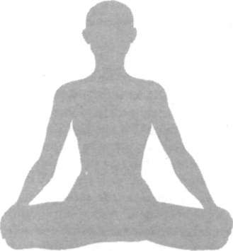

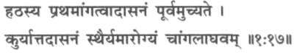

*Hathasya prathamaangatvaadaasanam pooruamuchyate. Kuryaattadaasanam sthairyamaarogyam chaangalaaghavam.*

Prior to everything, asana is spoken of as the first part of hatha yoga.

Having done asana, one attains steadiness of body and mind, freedom from disease and lightness of the limbs.

*Hatha Yoga Pradipika (1:17)*

Asana means a state of being in which one can remain physically and mentally steady, calm, quiet and comfortable. In the Yoga Sutras of Patanjali there is a concise definition of yogasanas: "Sthiram sukham aasanam", meaning that position which is comfortable and steady. So, we can see that yogasanas in this context are practised to develop the practitioner's ability to sit comfortably in one position for an extended length of time, as is necessary during meditation.

In raja yoga, asana refers to the sitting position, but in hatha yoga it means something more. Asanas are specific body positions which open the energy channels and psychic centres. They are tools to higher awareness and provide the stable foundation for our exploration of the body, breath, mind and beyond. The hatha yogis also found that by developing control of the body through asana, the mind is also controlled. Therefore, the practice of asana is foremost in hatha yoga.

##### Introduction to Yogasana

I

n the *Yoga Sutras* of Patanjali there is a concise definition of yogasanas: *"Sthiramsukhamaasanam",* meaning 'that position which is comfortable and steady'. In this context, asanas are practised to develop the ability to sit comfortably in one position for an extended period of time, an ability necessary for meditation. Raja yoga equates yogasana to the stable sitting

position.

The hatha yogis, however, found that certain specific body positions, asanas, open the energy channels and psychic centres. They found that developing control of the body through these practices, enabled them to control the mind and energy. Yogasanas became tools to higher awareness, providing the stable foundation necessary for the exploration of the body, breath, mind and higher states. For this reason, asana practice comes first in hatha yoga texts such as *Hatha Yoga Pradipika.*

In the yogic scriptures it is said that there were originally 8,400,000 asanas, which represent the 8,400,000 incarnations every individual must pass through before attaining liberation from the cycle of birth and death. These asanas represented a progressive evolution from the simplest form of life to the most complex: that of a fully realised human being. Down through the ages the great rishis and yogis modified and reduced the number of asanas to the few hundred known today. Through their practice, it is possible to side-step the karmic process and bypass many evolutionary stages in one lifetime. Of these few hundred, only the eighty-four most useful are discussed in detail.

Animal **postures**

Many of the yogasanas described in this book are named after and reflect the movements of animals. Through observation, the rishis understood how animals live in harmony with their environment and with their own bodies. They understood, through experience, the effects of a particular posture and how the hormonal secretions could be stimulated and control• led by it. For example, by imitating the rabbit or hare in shashankasana they could influence the flow of adrenaline responsible for the 'fight or flight' mechanism. Through imi• tating animal postures, the rishis found they could maintain health and meet the challenges of nature for themselves.

Yogasanas and prana

*Prana,* vital energy, which corresponds to *ki* or *chi* in Chinese medicine, pervades the whole body, following flow patterns, called *nadis,* which are responsible for maintaining all individual cellular activity. Stiffness of the body is due to blocked prana and a subsequent accumulation of toxins. When prana begins to flow, the toxins are removed from the system ensuring the health of the whole body. As the body becomes supple, postures which seemed impossible become easy to perform, and steadiness and grace of movement develop. When the quantum of prana is increased to a great degree, the body moves into certain postures by itself and asanas, mudras and pranayamas occur spontaneously. (For further information on prana, see the section on pranayama or the Bihar School of Yoga publication *Prana, Pranayama, Prana Vidya).*

Yogasanas **and kundalini**

The ultimate purpose of yoga is the awakening of *kundalini shakti,* the evolutionary energy in man. Practising asanas stimu• lates the chakras, distributing the generated energy of kundalini all over the body. About thirty-five asanas are spe• cifically geared to this purpose: bhujangasana for manipura chakra, sarvangasana for vishuddhi, sirshasana for sahasrara and so on. The other asanas regulate and purify the nadis facilitating the conduction of prana throughout the body.

The main object of hatha yoga is to create balance between the interacting activities and processes of the pranic and mental forces. Once this has been achieved, the impulses generated give a call of awakening to *sushumna nadi,* the central pathway in the spine, through which the kundalini shakti rises to sahasrara chakra, thereby illumining the higher centres of human consciousness.

Hatha yoga, therefore, not only strengthens the body and improves health but also activates and awakens the higher centres responsible for the evolution of human consciousness. (For a fuller discussion of chakras, nadis and kundalini, see the chapter Psychic Physiology of Yoga.)

Yogasanas and the body-mind connection

The mind and body are not separate entities although there is a tendency to think and act as though they are. The gross form of the mind is the body and the subtle form of the body is the mind. The practice of asana integrates and harmonises the two. Both the body and the mind harbour tensions or knots. Every mental knot has a corresponding physical, muscular knot and vice versa.

The aim of asana is to release these knots. Asanas release mental tensions by dealing with them on the physical level, acting somato-psychically, through the body to the mind. For example, emotional tensions and suppression can tighten up and block the smooth functioning of the lungs, diaphragm and breathing process, contributing to a very debilitating illness in the form of asthma.

Muscular knots can occur anywhere in the body: tightness of the neck as cervical spondylitis, the face as neuralgia, etc. A well chosen set of asanas, combined with pranayama, shatkarmas, meditation and yoga nidra, is most effective in eliminating these knots, tackling them from both the mental and physical levels. The result is the release of dormant en• ergy; the body becomes full of vitality and strength, the mind becomes light, creative, joyful and balanced.

Regular practice of asana maintains the physical body in an optimum condition and promotes health even in an unhealthy

body. Through asana practice, the dormant energy potential is released and experienced as increased confidence in all areas of life.

Yogasana and exercise

Yogasanas have often been thought of as a form of exercise. They are not exercises, but techniques which place the physi• cal body in positions that cultivate awareness, relaxation, concentration and meditation. Part of this process is the development of good physical health by stretching, massaging and stimulating the pran k channels and internal organs.

Although asana is not exercise it is complementary to exercise. Before the difference between the two can be under• stood, it is necessary to know a little about the latter. Exercise imposes a beneficial stress on the body. Without it the muscles waste, the bones become weak, the capacity to absorb oxygen decreases, insulin insensitivity can occur, and the ability to meet the physical demands of sudden activity is lost.

There are several differences in the way asana and exercise affect body mechanisms. When yogasanas are performed, respiration and metabolic rates slow down, the consumption of oxygen and the body temperature drop. During exercise, however, the breath and metabolism speed up, oxygen con• sumption rises, and the body gets hot. Yoga postures tend to arrest catabolism whereas exercise promotes it. In addition, asanas are designed to have specific effects on the glands and internal organs, and to alter electrochemical activity in the nervous system.

Yogasanas classified

The asanas are classified into three groups: beginners, inter• mediate and advanced. It is not necessary to perform all the asanas in a particular group. Regular practice of a balanced programme, tailored to individual needs is recommended for maximum benefit.

**The beginners group** should be performed by those who have never practised yogasanas before, who are infirm in any way, weak or sick and who are therefore unable to perform the

more difficult practices. This group consists of elementary techniques designed to prepare the body and mind for major and meditation asanas. These practices are in no way inferior to the advanced asanas and are very useful in improving physical health. Included in this group are the pawanmuktasana series, eye exercises, relaxation, premeditation and meditation poses, asanas performed from vajrasana, standing asanas, surya and chandra namaskara.

**The intermediate group** consists of asanas which are rea• sonably difficult and are recommended for people who can perform the beginners group without discomfort or strain. These asanas require a greater degree of steadiness, concen• tration and coordination with the breath. Included in this group are asanas performed from padmasana, backward and forward bending, spinal twisting, inverted and balancing asanas.

**The advanced group** is intended for people with extensive control over their muscles and nervous system, who have already mastered the middle group of asanas. Practitioners should not be too eager to start these asanas. It is preferable to practise them under the guidance of an adept.

Dynamic and static yogasanas

Dynamic practices often involve energetic movements of the body. They are not intended to develop muscles or make the body fitter but to increase flexibility, speed up circulation, loosen the muscles and joints, release energy blocks and remove stagnant blood from different parts of the body. These asanas tone the skin and muscles, strengthen the lungs, encourage movement in the digestive and excretory systems. Dynamic practices are particularly useful for beginners. They include series and postures such as the pawanmuktasana series, surya namaskara, chandra namaskara, dynamic paschimottanasana and dynamic halasana.

Static practices are performed by intermediate and advanced practitioners. They have a more subtle and powerful effect on the pranic and mental bodies. They are performed with little or no movement, the body often remaining in one position for

a few minutes. These asanas are intended to gently massage the internal organs, glands and muscles as well as to relax the nerves throughout the body. They are specifically concerned with bringing tranquillity to the mind and preparing the practitioner for the higher practices of yoga, such as meditation. Some of them are particularly useful for inducing the state of sense withdrawal, *pratyahara.*

General notes for the practitioner

The following practice notes should be thoroughly under• stood before going any further. Although anybody can practise asanas, they become more efficacious and beneficial when performed in the proper manner after correct preparation.

**Breathing:** Always breathe through the nose unless specific instructions are given to the contrary. Try to coordinate the breath with the asana practice.

**Awareness:** This is as essential to the practice of asana as it is to all yoga practices. The purpose of asana practice is to influence, integrate and harmonise all the levels of being: physical, prank, mental, emotional, psychic and spiritual. At first it may appear that asanas are merely concerned with the physical level because they deal with the movement of different parts of the body. Actually, however, they have profound effects at every level of being if they are combined with awareness.

Awareness has many connotations, in this context, but it may be understood as consciously noting the physical move• ment, the posture itself, breath control and synchronisation, mental counting, sensations in the body, movement of prana, concentration on an area of the body or chakra and, most important, any thoughts or feelings that may arise during the practice. Implicit in the concept of awareness is the idea of acceptance of any thought which comes uninvited to the mind; 'good' and 'bad' thoughts should be accepted equally, without judgement. In the final analysis, thoughts are energy, neither good nor bad. This awareness is essential in order to receive optimum benefits from the practices.

**Relaxation:** Shavasana may be performed at any point during asana practice, especially when feeling physically or

mentally tired. It should also be practised on completion of the asana programme.

**Sequence:** After completing shatkarma, asana should be done, followed by pranayama, then pratyahara and dharana which lead to meditation.

**Counterpose:** When practising the middle and advanced group of asanas particularly, it is important that the pro• gramme is structured so that backward bends are followed by forward bends and vice versa, and that whatever is practised on one side of the body is repeated on the other side. This concept of counterpose is necessary to bring the body back to a balanced state. Specific counterposes are recommended for certain asanas described in this book. However, in some cases, when practising a particular asana for therapeutic reasons, a counterpose may not be needed.

**Time of practice:** Asana may be practised at any time of day except after meals. The best time, however, is the two hours before and including sunrise. This period of the day is known in Sanskrit as *brahmamuhurta* and is most conducive to the higher practices of yoga. At this time, the atmosphere is pure and quiet, the activities of the stomach and intestines have stopped, the mind has no deep impressions on the conscious level and it is empty of thoughts in preparation for the long day ahead. The practitioner will probably find that the muscles are stiffest early in the morning compared to the late afternoon when they become more supple, nevertheless this time is recommended for practice. In the evening the two hours around sunset is also a favourable time.

**Place of practice:** Practise in a well-ventilated room where it is calm and quiet. Asanas may also be practised outdoors but the surroundings should be pleasant, a beautiful garden with trees and flowers, for example. Do not practise in a strong wind, in the cold, in air that is dirty, smoky or which carries an unpleasant odour. Do not practise in the vicinity of furniture, a fire or anything that prevents free fall to the ground, espe• cially while performing asanas such as sirshasana. Many accidents occur because people fall against an object. Do not practise under an electric fan unless it is extremely hot.

**Blanket:** Use a folded blanket of natural material for the practices as this will act as an insulator between the body and the earth. Do not use a mattress which is spongy or filled with air as this does not give sufficient support to the spine.

**Clothes:** During practice it is better to wear loose, light and comfortable clothing. Before commencing, remove spectacles, wristwatches and any jewellery.

**Bathing:** Try to take a cold shower before starting. This will greatly improve the effect of the asanas.

**Emptying the bowels:** Before commencing the asana programme, the bladder and intestines should preferably be empty. If constipated, drink two or three glasses of warm, slightly salted water and practise the asanas given in the chapter on shankhaprakshalana, namely tadasana, tiryaka tadasana, kati chakrasana, tiryaka bhujangasana and udarakarshan asana. This should relieve the constipation. If not, practising pawanmuktasana part two should help. Choose one time daily to go to the toilet before doing asanas. Do not strain; try to relax the whole body. After some weeks the bowels will automatically evacuate at the set time every day. Try to avoid using laxative drugs.

**Empty stomach:** The stomach should be empty while do• ing asanas and to ensure this, they should not be practised until at least three or four hours after food. One reason why early morning practice is recommended is that the stomach is sure to be empty.

**Diet:** There are no special dietary rules for asana practi• tioners although it is better to eat natural food and in moderation. Contrary to popular belief, yoga does not say that a vegetarian diet is essential although in the higher stages of practice it is recommended. At meal times it is advised to half fill the stomach with food, one quarter with water and leave the remaining quarter empty. Eat only to satisfy hunger and not so much that a feeling of heaviness or laziness occurs. Eat to live rather than live to eat.

Foods which cause acidity or gas in the digestive system, which are heavy, oily and spicy, should be avoided, especially when asanas are practised with a spiritual aim. Specific dietary

restrictions are recommended for certain diseases, (see chapter Therapeutic Index).

No **straining:** Never exert undue force while doing asanas. Beginners may find their muscles stiff at first, but after several weeks of regular practice they will be surprised to find that their muscles are more supple.

**Age limitations:** Asana may be practised by people of all age groups, male and female.

**Contra-indications:** People with fractured bones or who are suffering from chronic ailments and diseases such as stom• ach ulcer, tuberculosis or hernia, and those recuperating from operations, should consult a yoga teacher or doctor before commencing asanas.

**Termination of asana:** If there is excessive pain in any part of the body the asana should be terminated immediately and, if necessary, medical advice sought. Do not stay in an asana if discomfort is felt.

**Inverted asana:** Do not practise any inverted asanas if there is gas or fermentation in the intestines, if the blood is exces• sively impure, during menstruation or in later stages of pregnancy. This is important to ensure that toxins do not go to the brain and cause damage, and, in the case of menstrua• tion, that blood does not enter the fallopian tubes.

**Sunbathing:** Never practise asanas after a long period of sunbathing as the body will be overheated.

Asana

### Beginners Group

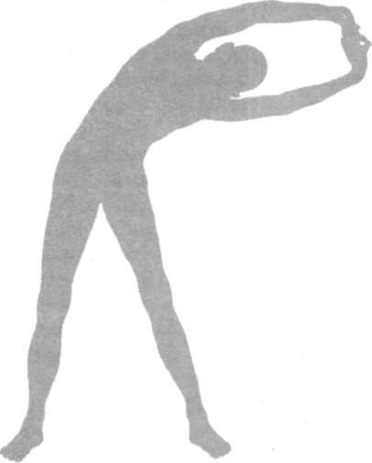

#### Pawanmuktasana Series

The pawanmuktasana series is one of the most important series of practices that has a very profound effect on the human body and mind and is thus a most useful tool for the yogic management of various disorders and maintenance of health. It is one of the special contributions of Bihar School of Yoga and the teachings of Paramahamsa Satyananda. Being the first practical series taught in hatha yoga, it is essential for laying a firm foundation in yogic life. Pawanmuktasana is valuable for understanding the meaning of asana by develop• ing awareness of the body's movements and the subtle effects they have at the various levels of being. It is very useful as a preparatory practice as it opens up all the major joints and relaxes the muscles of the body. The series may be practised by anyone: beginner or advanced, young or elderly, and by those convalescing or with disease conditions. It should never be ignored and treated casually just because the practices are simple, gentle and comfortable.

In Sanskrit these practices are referred to as *sukshma vyayama* which means 'subtle exercise'. The word *pawan* means 'wind' or 'prana'; *mukta* means 'release' and *asana* means 'pose'. Therefore, pawanmuktasana also means a group of asanas that remove any blockages which prevent the free flow of energy in the body and mind. Sometimes, due to bad posture, disturbed bodily functions, psychological or emotional prob• lems or an imbalanced lifestyle, the energy becomes blocked. This initially results in stiffness, muscular tension, lack of proper blood flow and minor functional defects. However, if these blockages become chronic, a limb, joint or physical

organ may malfunction, fail or become diseased. Regular practice of pawanmuktasana removes energy blockages from the body and prevents new ones from forming. In this way, it promotes total health, regulating and stabilising the flow of energy throughout the body.

Mind-body aspect

Most modern day diseases are psychosomatic in nature. Drug treatment of these ailments is only symptomatic and fails to touch the roots of the disease. These asanas, if done correctly, in a non-competitive and relaxed atmosphere, not only relax the muscles of the body but these relaxing impulses travel back to the brain and relax the mind. By integrating the breath synchronisation and awareness, the attentive faculty of the mind is made active and is not allowed to wander into tension and stress. The nature of these asanas is thus more mental than physical. If they are performed correctly they relax the mind, tune up the autonomic nerves, hormonal functions and the activities of internal organs. Therefore, these asanas are of great preventative and curative value.

Three groups

Pawanmuktasana is divided into three distinct groups of asanas: the anti-rheumatic group, the digestive/abdominal group and the shakti bandha or energy block group. All three groups supplement each other, stimulating and encouraging a free flow of energy throughout the body. Practitioners are advised to perfect each group before attempting the major asanas. Daily practice of pawanmuktasana parts 1, 2 and 3 over a period of months brings about a profound relaxation and toning of the entire psycho-physiological structure which is necessary for the practice of advanced techniques. Advanced yogasanas are frequently physically demanding and have a powerful effect on the body and mind. It is essential to respect this and prepare correctly.

The asanas in each group should be performed in the order given.

Pawanmuktasana Part 1

**ANTI-RHEUMATIC GROUP**

This group of asanas is concerned with loosening up the joints of the body. It is excellent for those with rheumatism, arthritis, high blood pressure, heart problems or other ail• ments where vigorous physical exercise is not advised. It is particularly useful for eliminating energy blockages in the joints and outer extremities of the physical body, and works on the pranic and mental bodies as well.

**Awareness:** The practices may be performed in three ways:

1. With awareness of the actual physical movement, the interaction between the various components of the body,

i.e. bones, joints, ligaments, muscles, etc.; the movement in relation to other parts of the body; with mental counting of each completed round; and with awareness of thoughts arising in the mind. This method of practice induces peace, balance and one-pointedness which in turn brings about harmony in the physical body.

1. With awareness and integrated breathing. In addition to the awareness of physical movement described above, individual movements are synchronised with the breath. The movements become slower which in turn slows the brain waves, further enhancing relaxation and awareness. This method of practice has a greater influence at the physical and pranic levels and is especially useful for harmonising and revitalising the body and improving the function of the internal organs. Breathing should be practised as indicated in the description of each asana. In addition, greater benefit will be gained if ujjayi pranayama (see section on pranayama practices) is used as a breathing

technique. This effectively stimulates and balances the pranic energy flowing through the nadis.

1. With awareness of the movement of prana in the body. Prana may be experienced as a tingling sensation in the body to which one becomes sensitised with practice.

**Periodic rest:** After every two or three movements, sit quietly in the base position with the eyes closed and be aware of the natural breath, of the part or parts of the body that have just been moved, and of any thoughts or feelings that come into the mind. After a minute or so continue the practice. This will not only rest the body but will also develop awareness of the internal energy patterns, and the mental and emotional processes. This rest period is almost as important as the asanas themselves and should not be neglected.

If tiredness is experienced at any point during the asana programme, rest in shavasana. Shavasana should be performed for three to five minutes at the end of the programme.

**Base position:** All the practices of pawanmuktasana part 1 are performed while sitting on the floor in the base position (see diagram). The body should be relaxed and only those muscles associated with the asana being executed should be used. Full awareness should be given to performance of the asana as per notes above. For maximum benefit the eyes should remain closed. Do not practise mechanically, be aware throughout the practice.

PRARAMBHIKSTHITI

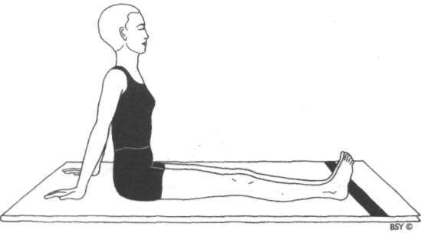

**Prarambhik Sthiti (base position)**

Sit with the legs outstretched.

Place the palms of the hands on the floor to the sides and just behind the buttocks.

The back, neck and head should be straight. Straighten the elbows.

Lean back slightly, taking the support of the arms.

Close the eyes and relax the whole body in this position.

PADANGULI NAMAN & GOOLF NAMAN

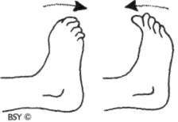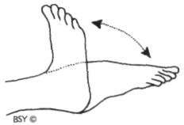

Practice I Practice 2

**Practice I: Padanguli Naman (toe bending)**

Sit in the base position with the legs outstretched and the feet slightly apart. Place the hands beside and slightly behind the buttocks.

Lean back a little, using the arms to support the back. Keep the spine as straight as possible.

Be aware of the toes. Move the toes of both feet slowly backward and forward, keeping the feet upright and the ankles relaxed and motionless.

Hold each position for a few seconds. Repeat 10 times.

**Breathing:** Inhale as the toes move backward.

Exhale as the toes move forward.

**Awareness:** On the breath, mental counting and the stretching sensation produced by the movement.

**Practice 2: Goolf Naman (ankle bending)**

Remain in the base position. Keep the feet slightly apart. Slowly move both feet backward and forward, bending them from the ankle joints. Try to stretch the feet forward to touch the floor and then draw them back towards the knees. Hold each position for a few seconds.

Repeat 10 times.

**Breathing:** Inhale as the feet move backward.

Exhale as the feet move forward.

**Awareness:** On the breath, mental counting and the stretch in the foot, ankle, calf and leg muscles or joints.

GOOLF CHAKRA

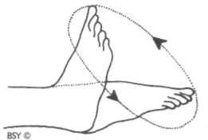

**Practice 3: Goolf Chakra (ankle rotation)**

Remain in the base position.

Separate the legs a little, keeping them straight.

Keep the heels on the ground throughout the practice.

**Stage I**: Slowly rotate the right foot clockwise from the ankle 10 times and then repeat 10 times anti-clockwise.

Repeat the same procedure with the left foot.

**Stage 2:** Place the feet together.

Slowly rotate both feet together in the same direction, keeping them in contact with each other.

Do not allow the knees to move.

Practise 10 times clockwise and then 10 times anti• clockwise.

**Stage 3:** Keep the feet separated.

Slowly rotate both feet from the ankles together but in opposite directions.

The big toes should touch each other on the inward stroke of each foot.

Do 10 rotations in one direction and then 10 rotations in the opposite direction.

**Breathing:** Inhale on the upward movement.

Exhale on the downward movement.

**Awareness:** On the breath, mental counting and rotation.

**Practice 5: Janufalak Akarshan (kneecap contraction)**

Stay in the base position.

Contract the muscle surrounding the right knee, drawing the kneecap back towards the thigh.

Hold the contraction for 3 to 5 seconds, counting mentally. Release the contraction and let the kneecap return to its normal position.

Practise 5 times. Repeat with the left kneecap 5 times, then with both kneecaps together.

**Breathing:** Inhale while contracting.

Hold the breath during contraction. Exhale while relaxing the knee muscles.

**Awareness:** On the breath, mental counting and contraction.

JANU NAMAN

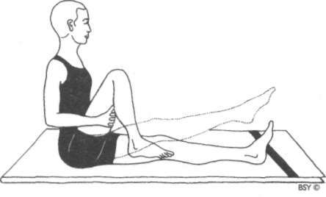

**Practice 6: Janu Naman (knee bending)**

Stay in the base position. Bend the right knee and clasp the hands under the right thigh.

Straighten the right leg, pulling up the kneecap.

Keep the hands under the thigh but straighten the arms. Do not allow the heel or toes to touch the floor.

Bend the right leg at the knee so that the thigh comes close to the chest and the heel near the buttocks.

Keep the head and spine straight.

This is one round.

Practise 10 rounds with the right leg and then 10 rounds with the left leg.

**Breathing:** Inhale while straightening the leg.

Exhale while bending the leg.

**Awareness:** On the breath, mental counting, stretch in the thigh muscles and synchronised movement.

**Practice note:** While bending the knee the hands may also clasp the lower shin. The thigh is then pressed against the abdomen helping to release wind from this area.

**Practice 7: Dwi Janu Naman (double knee bending)**

Sitting in the base position, place both palms flat on the floor at the side and slightly in front of the buttocks.

Bend both knees together, and place the feet on the floor in front of the buttocks.

Straighten the legs and raise the feet so that they are about 8 cm above the floor in the final position.

Point the toes forward.

The hands and arms should support and maintain stability of the body. Try to keep the head and spine upright.

Remain in the position for a second.

Bend the knees and bring the legs back to the starting position, keeping the heels slightly above the floor.

Draw the toes back towards the shins. This is one round.

Practise 5 to 10 rounds, keeping the heels off the floor throughout the practice.

**Breathing:** Inhale while straightening the legs.

Exhale while bending the legs.

**Awareness:** On the breath, mental counting, movement and balance.

**Contra-indications:** This is a strenuous practice and should not be attempted by people with weak abdominal muscles, back conditions, high blood pressure or heart conditions. **Practice note:** The hands may also be clasped under the thighs as in janu naman. This is a good preparatory asana for

brahmachary asana.

JANU CHAKRA

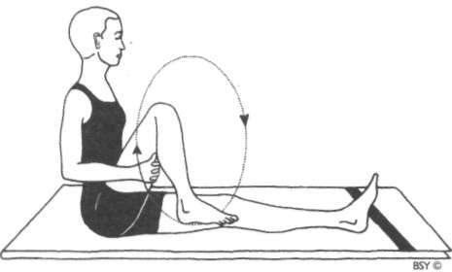

**Practice 8: Janu Chakra (knee crank)**

Sit in the base position.

Bend the right leg at the knee as described in practice 6. Place the hands under the right thigh and interlock the fingers or cross the arms holding the elbows.

Raise the right foot from the ground.

Rotate the lower leg from the knee in a large circular movement; try to straighten the leg at the top of the upward movement.

The upper leg and trunk should be completely still. Rotate 10 times clockwise and then 10 times anti-clockwise. Repeat with the left leg.

**Breathing:** Inhale on the upward movement.

Exhale on the downward movement.

**Awareness:** On the breath, mental counting, movement and perfection of circular rotation.

**Benefits:** Since the knee joint bears the whole weight of the body and has no strong muscles for support, it is most vulnerable to injuries, sprains and osteoarthritis. All the knee asanas strengthen the quadriceps muscle and the ligaments around the knee joint. These asanas rejuvenate the joint by activating the healing energies.

ARDHA TITALI ASANA

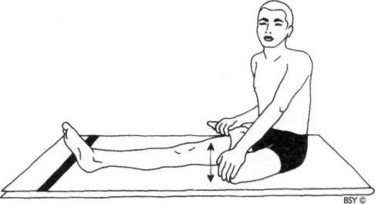

**Practice 9: Ardha Titali Asana (half butterfly)**

Sit in the base position.

Bend the right leg and place the right foot as far up on the left thigh as possible.

Place the right hand on top of the bent right knee. Hold the toes of the right foot with the left hand. This is the starting position.

Stage I: with breath synchronisation

While breathing in, gently move the right knee up towards the chest. Breathing out, gently push the knee down and try to touch the knee to the floor.

The trunk should not move.

Do not force this movement in any way.

The leg muscles should be passive, the movement being achieved by the exertion of the right arm.

Slowly practise 10 up and down movements.

**Awareness:** On the breath, mental counting, movement of hip joint and relaxation of inner thigh muscles.

Stage 2: without breath synchronisation

Remain in the same position with the right leg on the left thigh.

Relax the right leg muscles as much as possible.

Push the right knee down with the right hand and try to touch the knee to the floor.

Do not strain.

Let the knee spring up by itself.

The movement is achieved by use of the right arm only. Practise 30 up and down movements in quick succession. Breathing should be normal and unrelated to the practice. Repeat stages 1 and 2 and the unlocking procedure (see note below) with the left leg.

**Awareness:** On mental counting, movement of hip joint and relaxation of inner thigh muscles.

**Benefits:** This is an excellent preparatory practice for loos• ening up the knee and hip joints for meditative poses. Those people who cannot sit comfortably in cross-legged positions should practise ardha titali asana daily, both morning and evening.

**Practice note:** To unlock the leg after completing stage 2, slowly and carefully straighten the leg.

Bend it once, bringing the heel near the buttock. Straighten the leg.

This procedure will ensure that the knee joint is realigned correctly.

SHRONI CHAKRA

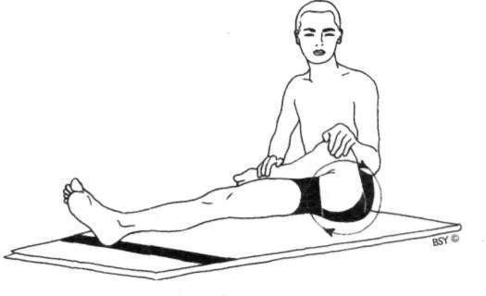

**Practice 10: Shroni Chakra (hip rotation)**

Sit in the same starting position as for asana 9 with the right leg on the left thigh.

Using the muscles of the right arm, rotate the right knee in a circle trying to make the circular movement as large as possible.

The index finger may be pointed out and used as a guide to perfection of the circular movement.

Practise 10 rotations clockwise and then 10 rotations anti• clockwise.

Straighten the leg slowly.

Release the knee as described in the note to asana 9. Repeat with the left leg.

**Breathing:** Inhale on the upward movement.

Exhale on the downward movement.

**Awareness:** On the breathing, mental counting and rotation of the hip joint.

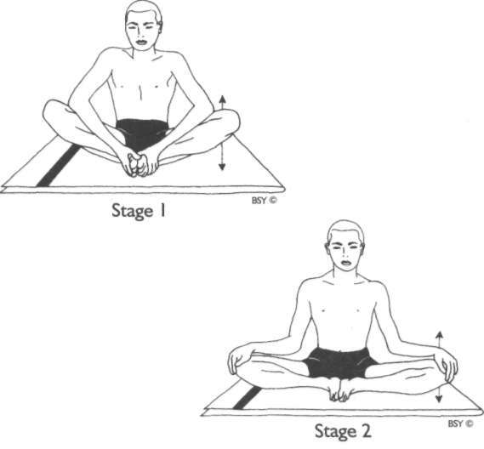POORNA TITALI ASANA

**Practice 11: Poorna Titali Asana (full butterfly)**

Sit in the base position.

Bend the knees and bring the soles of the feet together, keeping the heels as close to the body as possible.

Fully relax the inner thigh muscles.

**Stage I**: Clasp the feet with both hands.

Gently bounce the knees up and down, using the elbows as levers to press the legs down.

Try to touch the knees to the ground on the downward stroke.

Do not use any force.

Practise 30 to 50 up and down movements.

**Stage 2:** Keep the soles of the feet together.

Place the hands on the knees.

Using the palms, gently push the knees down towards the floor, allowing them to spring up again.

Do not force this movement. Repeat 20 to 30 times.

Straighten the legs and relax.

**Breathing:** Normal breathing, unrelated to the practice.

**Awareness:** On mental counting, movement and relaxation.

**Contra-indications:** People with sciatica and sacral conditions should avoid this asana.

**Benefits:** Both stages prepare the legs for mastery of padmasana and other meditative asanas. The inner thigh muscles hold a lot of tension which is relieved by these asanas. They also remove tiredness from long hours of standing and walking.

MUSHTIKA BANDHANA

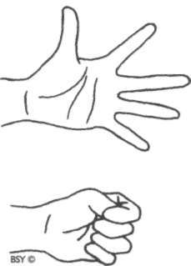

**Practice 12: Mushtika Bandhana (hand clenching)**

Sit in the base position or a cross-legged pose.

Hold both arms straight in front of the body at shoulder level.

Open the hands, palms down, and stretch the fingers as wide apart as possible.

Close the fingers to make a tight fist with the thumbs inside.

The fingers should be slowly wrapped around the thumbs. Again open the hands and stretch the fingers.

Repeat 10 times.

**Breathing:** Inhale on opening the hands.

Exhale on closing the hands.

**Awareness:** On the breath, mental counting, stretching sensa• tion and movement.

MANIBANDHA NAMAN

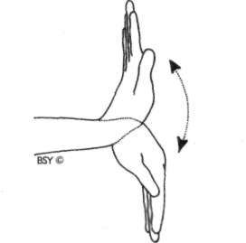

**Practice 13: Manibandha Naman (wrist bending)**

Remain in the base position or a cross-legged pose. Stretch the arms in front of the body at shoulder level. Keep the palms open and fingers straight throughout the entire practice.

Bend the hands backward from the wrists as if pressing the palms against a wall with the fingers pointing toward the ceiling.

Bend the hands forward from the wrists so that the fingers point toward the floor.

Keep the elbows straight throughout the practice. Do not bend the knuckle joints or fingers.

Bend the hands up again for the next round. Repeat 10 times.

**Breathing:** Inhale with the backward movement.

Exhale with the forward movement.

**Awareness:** On the breath, mental counting, movement in the wrist joint and stretching of the forearm muscles.

MANIBANDHA CHAKRA

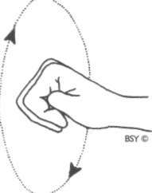

**Practice 14: Manibandha Chakra (wrist joint rotation)** Remain in the base position or a comfortable cross-legged pose, but keep the back straight.

**Stage I**: Extend the right arm forward at shoulder level.

Make a fist with the right hand, with the thumb inside. The left hand may be used as a support if necessary.

This is the starting position.

Slowly rotate the fist about the wrist, ensuring that the palm faces downward throughout the rotation.

The arms and elbows should remain perfectly straight and still. Make as large a circle as possible.

Practise 10 times clockwise and 10 times anti-clockwise. Repeat the same with the left fist.

**Stage 2:** Extend both arms in front of the body with the fists clenched.

Keep the arms straight and at shoulder level. Rotate the fists together in the same direction. Practise 10 times in each direction.

**Stage 3:** Practise as in stage 2.

Rotate the fists together in the opposite direction. Practise 10 times in each direction.

**Benefits:** The hand and wrist asanas are beneficial for arthritis of the related joints. They also relieve tension caused by prolonged writing, typing and so on.

KEHUNINAMAN

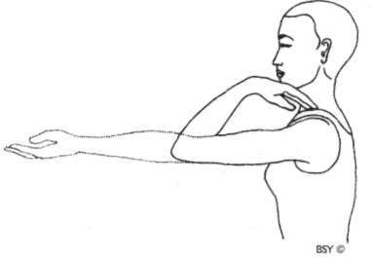

**Practice 15: Kehuni Naman (elbow bending)**

**Stage I**: Remain in the base position or a cross-legged pose. Stretch the arms in front of the body at shoulder level. The hands should be open with the palms facing up.

Bend the arms at the elbows and touch the fingers to the shoulders.

Straighten the arms again. This is one round.

Repeat 10 times.

**Stage 2:** Extend the arms sideways at shoulder level, hands open and palms facing the ceiling.

Bend the arms at the elbows and touch the fingers to the shoulders.

Again straighten the arms sideways. Repeat 10 times.

**Breathing:** Inhale while straightening the arms.

Exhale while bending the arms.

**Awareness:** On the breathing, the mental counting and the movement.

**Practice note:** Throughout both stages, the upper arms remain parallel to the floor, elbows at shoulder level.

SKANDHA CHAKRA

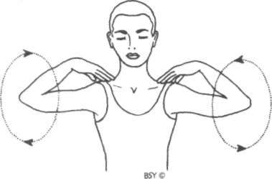

**Practice 16: Skandha Chakra (shoulder socket rotation) Stage I**: Remain in the base position or a cross-legged pose.

Place the fingers of the right hand on the right shoulder. Keep the left hand on the left knee and the back straight. Rotate the right elbow in a large circle.

Practise 10 times clockwise and 10 times anti-clockwise. Repeat with the left elbow.

Make sure that the head, trunk and spine remain straight and still.

**Stage 2:** Place the fingers of the left hand on the left shoulder and the fingers of the right hand on the right shoulder. Fully rotate both elbows at the same time in a large circle. Try to touch the elbows in front of the chest on the forward movement and touch the ears while moving up. Stretch the arms back in the backward movement and touch the sides of the trunk while coming down.

Practise slowly 10 times clockwise and then 10 times anti• clockwise.

**Breathing:** Inhale on the upward stroke.

Exhale on the downward stroke.

**Awareness:** On the breath, mental counting and the stretching sensation around the shoulder joint.

**Benefits:** The shoulder asanas relieve the strain of driving and office work, and are helpful in cervical spondylitis and frozen shoulder. They also maintain the shape of the shoulders and chest.

GREEVA SANCHALAN A

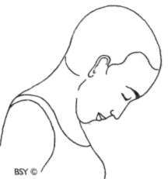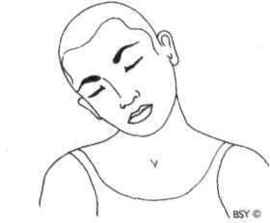

Stage I Stage 2

Practice 17: Greeva Sanchalana (neck movements)

**Stage I**: Sit in the base position or a cross-legged pose with the hands resting on the knees in jnana or chin mudra. Close the eyes.

Slowly move the head forward and try to touch the chin to the chest.

Move the head as far back as comfortable. Do not strain. Try to feel the stretch of the muscles in the front and back of the neck, and the loosening of the vertebrae in the neck.

Practise 10 times.

**Breathing:** Inhale on the backward movement.

Exhale on the forward movement.

**Stage 2:** Remain in the same position, keeping the eyes closed.

Face directly forward. Relax the shoulders.

Slowly move the head to the right and try to touch the right ear to the right shoulder without turning the head or raising the shoulders.

Move the head to the left side and try to touch the left ear to the left shoulder.

This is one round.

Do not strain; touching the shoulder is not necessary. Practise 10 rounds.

**Breathing:** Inhale on the upward movement.

Exhale on the downward movement.

**Awareness:** On the breath, counting, and the stretching sen• sation of the muscles in the sides of the neck.

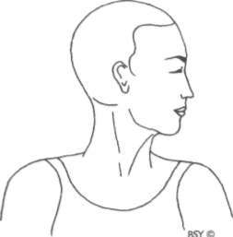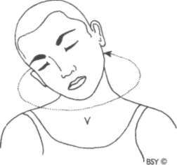

Stage 3 Stage 4

**Stage 3:** Remain in the base position.

Keep the head upright and the eyes closed.

Gently turn the head to the right so that the chin is in line with the shoulder.

Feel the release of tension in the neck muscles and the loosening of the neck joints.

Slowly turn the head to the left as far as is comfortable. Do not strain.

Practise 10 times on each side.

**Breathing:** Inhale while turning to the front.

Exhale while turning to the side.

**Stage 4:** Remain in the same position with the eyes closed. Slowly rotate the head downward, to the right, backward and then to the left side in a relaxed, smooth, rhythmic, circular movement.

Feel the shifting stretch around the neck and the loosening up of the joints and muscles of the neck.

Practise 10 times clockwise and then 10 times anti• clockwise.

Do not strain.

If dizziness occurs, open the eyes. After the practice, keep the neck straight and the eyes closed. Be aware of the sensations in the head and neck.

**Breathing:** Inhale as the head moves up.

Exhale as the head moves down.

**Awareness:** On the breath, mental counting and movement. **Contra-indications:** These four neck movements should not be performed by elderly people and those suffering from

low blood pressure, very high blood pressure or extreme cervical spondylosis. The advice of an expert should be sought for any of these problems. Patients of cervical spondylosis should strictly avoid forward bending of the neck.

**Benefits:** All the nerves connecting the different organs and limbs of the body pass through the neck. Therefore, the muscles of the neck and shoulders accumulate tension, especially after prolonged work at a desk. These asanas release tension, heaviness and stiffness in the head, neck and shoulder region.

Pawanmuktasana Part 2

**DIGESTIVE/ABDOMINAL GROUP**

This group of asanas is concerned specifically with strength• ening the digestive system. It is excellent for those persons suffering from indigestion, constipation, acidity, excess wind or gas, lack of appetite, diabetes, disorders of the male or female reproductive systems and varicose veins. It also elimi• nates energy blockages in the abdominal area.

**Awareness:** Throughout the practice become aware of the following:

1. Movement
2. Breathing
3. Mental counting
4. Intra-abdominal pressure
5. The stretch of the muscles

**Periodic rest:** Before starting the practice, the body and mind should be calm and relaxed. This state is best achieved through the practice of shavasana. In addition, a short rest should be taken between each asana, lying in shavasana. One minute or thirty seconds should be sufficient but a more reliable guide is to rest until the breathing returns to normal.

**No strain:** When starting this series, it is not advisable to attempt all the practices in one go, especially the ones which involve using both legs together. It is better to choose one practice at a time and incorporate that into the previous practices. The pawanmuktasana part 2 series requires a great deal of effort and may put a strain on the lower back. Therefore, be aware of physical limitations and do not strain.

**Contra-indications:** These practices should not be per• formed by people suffering from high blood pressure, serious

heart conditions, back conditions such as sciatica and slipped disc or soon after abdominal surgery. If there is any doubt, please consult a competent therapist.

**Base position:** All these asanas are performed from the supine position, that is, lying flat on the back with the legs together and straight. The arms should be by the sides, palms down, and the head, neck and spine in a straight line. Be sure to use a thin mat or a blanket, particularly with asanas such as supta pawanmuktasana and jhulana lurhakana where the body is balanced on the spinal vertebrae.

UTTHANPADASANA

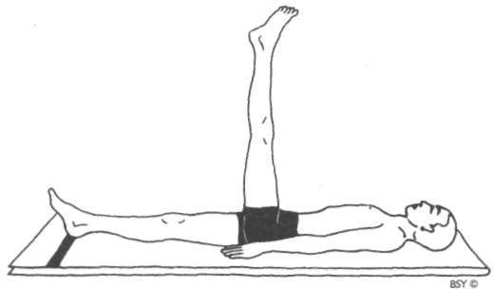

**Practice I: Utthanpadasana (raised legs pose)**

Lie in the base position with the palms flat on the floor. Inhale and raise the right leg as high as is comfortable, keeping it straight and the foot relaxed.

The left leg should remain straight and in contact with the floor.

Hold the posture for 3 to 5 seconds, counting mentally and retaining the breath.

Exhale and slowly lower the leg to the floor. This is one round.

Practise 5 rounds with the right leg and then 5 rounds with the left leg.

This may be repeated raising both legs together.

**Breathing:** Inhale while raising the leg(s).

Hold the posture and the breath. Exhale while lowering the leg(s).

**Awareness:** On synchronising the movement with the breath, the stretch in the legs and mental counting in the final position.

**Benefits:** This asana strengthens the abdominal muscles and massages the organs. It strengthens the digestive system, lower back, pelvic and perineal muscles and helps correct prolapse.

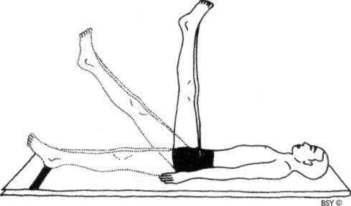

**Practice note:** Utthanpadasana may be repeated raising the legs to progressive heights of 15, 25, 35,45 cm respectively in each round.

***Note:*** *This is the hatha yoga version of utthanpadasana. There is also a raja yoga version described later in this book.*

CHAKRA PADASANA

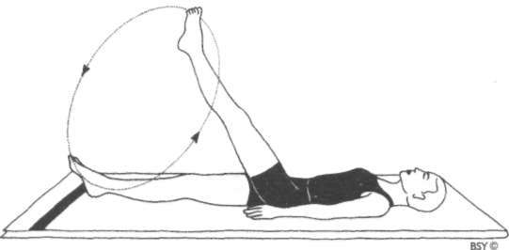

**Practice 2: Chakra Padasana (leg rotation) Stage I**: Lie in the base position.

Raise the right leg 5 cm from the ground, keeping the knee straight.

Rotate the entire leg clockwise 10 times in as large a circle as possible.

The heel should not touch the floor at any time during the rotation.

Rotate 10 times in the opposite direction. Repeat with the left leg.

Do not strain.

Rest in the base position introducing abdominal breathing until the respiration returns to normal.

**Stage 2:** Raise both legs together.

Keep them together and straight throughout the practice. Rotate both legs clockwise and then anti-clockwise 3 to 5 times.

The circular movement should be as large as possible.

**Breathing:** Breathe normally throughout the practice.

**Awareness:** On the mental counting of each round, rotation of the leg(s) and on the effects of the asana on the hips and abdomen.

**Benefits:** Good for hip joints, obesity, toning of abdominal and spinal muscles.

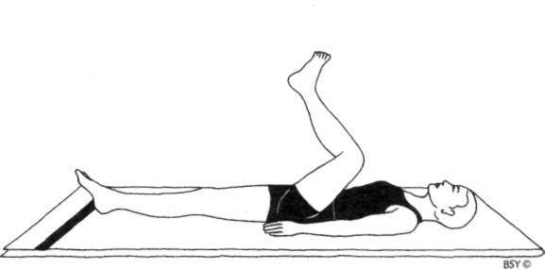PADA SANCHALANASANA

**Practice 3: Pada Sanchalanasana (cycling) Stage I**: Lie in the base position.

Raise the right leg.

Bend the knee and bring the thigh to the chest.

Raise and straighten the leg completely. Then, lower the straight leg in a forward movement.

Bend the knee and bring it back to the chest to complete the cycling movement.

The heel should not touch the floor during the movement. Repeat 10 times in a forward direction and then 10 times in reverse.

Repeat with the left leg.

**Breathing:** Inhale while straightening the leg.

Exhale while bending the knee and bringing the thigh to the chest.

**Stage 2:** Raise both legs.

Practise alternate cycling movements as though peddling a bicycle.

Practise 10 times forward and then 10 times backward.

**Breathing:** Breathe normally throughout.

**Stage 3:** Raise both legs and keep them together throughout the practice.

Bring the knees as close as possible to the chest on the backward movement and straighten the legs fully on the

forward movement. Slowly lower the legs together, keeping the knees straight, until the legs are just above the floor. Then bend the knees and bring them back to the chest.

Practise 3 to 5 forward cycling movements and the same in reverse.

Do not strain.

**Breathing:** Inhale while straightening the legs. Exhale while bending the legs to the chest.

**Awareness:** On the breath, mental counting of each round, and on smoothness of the movement and proper coordina• tion, especially while reverse cycling. When relaxing, be aware of the abdomen, hip, thighs and lower back.

**Benefits:** Good for hip and knee joints. Strengthens abdominal and lower back muscles.

**Practice note:** Keep the rest of the body, including the head, flat on the floor throughout the practice. After completing each stage remain in the base position and relax until the respiration returns to normal. If cramping is experi• enced in the abdominal muscles inhale deeply, gently pushing out the abdomen, and then relax the whole body with exhalation. Do not strain; this applies especially to stage 3.

SUPTAPAWANMUKTASANA

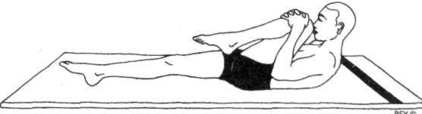

Stage 1

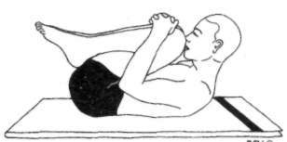

Stage 2

**Practice 4: Supta Pawanmuktasana (leg lock pose) Stage I**: Lie in the base position.

Bend the right knee and bring the thigh to the chest. Interlock the fingers and clasp the hands on the shin just below the right knee.

Keep the left leg straight and on the ground. Inhale deeply, filling the lungs as much as possible.

Holding the breath, raise the head and shoulders off the ground and try to touch the right knee with the nose.

Remain in the final position for a few seconds, retaining the breath and counting mentally.

While slowly exhaling, return to the base position. Relax the body.

Repeat 3 times with the right leg and then 3 times with the left leg.

**Practice note:** Ensure that the straight leg remains in contact with the ground.

It is important to start with the right leg because it presses the ascending colon directly.

Follow with the left leg which presses the descending colon directly.

**Stage *2:*** Remain in the base position.

Bend both knees and bring the thighs to the chest. Interlock the fingers and clasp the hands on the shin bones just below the knees.

Inhale deeply.

Holding the breath, raise the head and shoulders and try to place the nose in the space between the two knees.

Hold the breath in the raised position for a few seconds, counting mentally.

Slowly lower the head, shoulders and legs while breathing out.

Practise this 3 times.

**Awareness:** On the breath, mental counting in the final posi• tion, pressure on the abdomen and the movement.

**Contra-indications:** Not to be performed by persons suffering from high blood pressure or serious back conditions, such as sciatica and slipped disc.

**Benefits:** Supta pawanmuktasana strengthens the lower back muscles and loosens the spinal vertebrae. It massages the abdomen and the digestive organs and is, therefore, very effective in removing wind and constipation. By massaging the pelvic muscles and reproductive organs, it is also useful in the treatment of impotence, sterility and men• strual problems.

**Variation:** Repeat the practice as described in stages 1 and 2 but change the breathing pattern slightly. Instead of in• haling before raising the body, exhale deeply and hold the breath out in the final position for a few seconds, counting mentally.

Lower the head, shoulders and leg(s) while breathing in. Practise 3 rounds for both stages 1 and 2.

**Benefits:** This variation gives basically the same benefits as the main pose but has a more profound influence on the spine and pelvic region.

JHULANA LURHAKANASANA

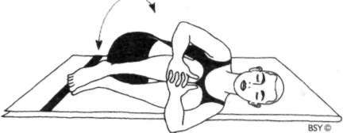

Stage **I**

Stage **2**

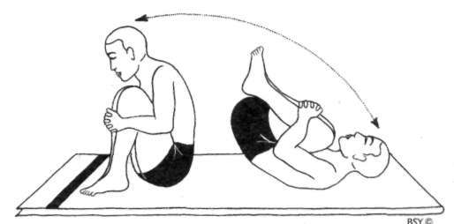

**Practice 5: Jhulana Lurhakanasana (rocking and rolling) Stage I**: Lie flat on the back. Bend both legs to the chest.

Interlock the fingers of both hands and clasp them around the shins just below the knees.

This is the starting position.

Roll the body from side to side 5 to 10 times, touching the side of the legs on the floor.

**Breathing:** Breathe normally throughout.

**Stage** 2: Sit in the squatting position with the buttocks just above the floor.

Interlock the fingers of both hands and clasp them around the shins just below the knees.

Rock the whole body backwards and forwards on the spine. Try to come up into the squatting pose on the feet when

rocking forward. If it is difficult to perform with the hands clasped on the shins then hold the side of the thighs adjacent to the knees.

Practise 5 to 10 backward and forward movements.

**Breathing:** Breathe normally throughout.

**Awareness:** On the coordination of movement.

While relaxing in shavasana be aware of the effects of the asana on the back and buttocks.

**Contra-indications:** Not to be performed by persons with serious back conditions.

**Benefits:** This asana massages the back, buttocks and hips. It is most useful if done first thing in the morning after waking.

**Practice note:** Use a folded blanket for this practice so that there is no possibility of causing damage to the spine.

While rocking back, the head should remain forward. Be careful not to hit the head on the floor.

SUPTA UDARAKARSHANASANA

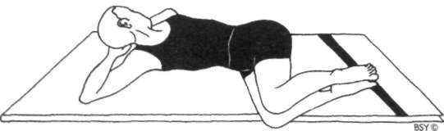

**Practice 6: Supta Udarakarshanasana (sleeping abdominal stretch pose)**

Lie in the base pose.

Bend the knees and place the soles of both feet flat on the ground, directly in front of the buttocks.

Keep the knees and feet together throughout the practice. Interlock the fingers of both hands and place the palms under the back of the head.

While breathing out, slowly lower the legs to the right, trying to bring the knees down to the floor. The feet should remain in contact with each other, although the left foot will move slightly off the floor. At the same time, gently turn the head and neck in the opposite direction to the legs. This will give a uniform twisting stretch to the entire spine. Hold the breath in the final position while mentally counting three seconds.

While breathing in, raise both legs to the upright position. Keep the shoulders and elbows on the floor throughout. Repeat on the left side to complete one round.

Practise 5 complete rounds.

**Breathing:** Exhale while lowering the legs to the sides.

Hold the breath in the final position. Inhale while raising the legs.

**Awareness:** On the breath, the mental counting in the final position and the twisting stretch on the paraspinal and abdominal muscles.

**Benefits:** This asana gives an excellent stretch to the abdominal muscles and organs, and thereby helps to improve diges• tion and eliminate constipation. The twisting stretch of the spinal muscles relieves the strain and stiffness caused by prolonged sitting.

**Variation:** Bend the knees and bring the thighs up to the chest. Interlock the fingers and place them behind the head. Roll the body from side to side, keeping the elbows on the floor.

SHAVA UDARAKARSHANASANA

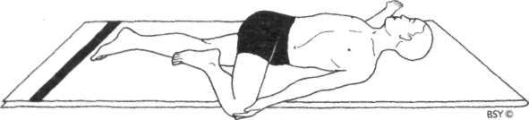

**Practice 7: Shava Udarakarshanasana (universal spinal twist)**

Lie flat on the back with the legs and feet together. Stretch the arms out to the sides at shoulder level with the palms of the hands facing down.

Bend the right leg and place the sole of the foot beside the left kneecap. Place the left hand on top of the right knee. This is the starting position.

Gently bring the right knee down to the floor on the left side of the body, keeping the leg bent and the foot in contact with the left knee.

Turn the head to the right, looking along the straight arm, and gaze at the middle finger of the right hand.

The left hand should be on the right knee and the right arm and shoulder should remain in contact with the floor. In the final position, the head should be turned in the opposite direction to the folded knee and the other leg should be completely straight.

Hold the position for as long as is comfortable.

Return to the starting position, bringing the head and knee to the centre. Stretch the right arm out to the side and straighten the right leg.

Repeat on the opposite side.

Practise once to each side, gradually extending the holding time.

**Breathing:** Inhale in the starting position.

Exhale while pushing the knee to the floor and turning the head.

Breathe deeply and slowly in the final position.

Inhale while centring the body and exhale while straight• ening the leg.

**Awareness:** Physical - on the breath or the relaxation of the back.

Spiritual - on manipura chakra.

**Sequence:** This asana should be performed after forward and backward bending asanas or those that are strenuous on the lower back, and after sitting in chairs or in meditation asanas for extended periods of time.

**Contra-indications:** This asana rectifies disorders of the hip joint. It should be stopped if the practice is painful.

**Benefits:** Tightness and tiredness are relieved, especially in the lower back. The pelvic and abdominal organs are toned through its massaging action.

NAUKASANA

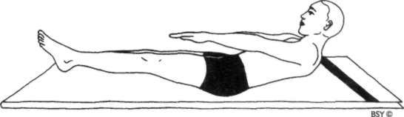

Practice 8: Naukasana (boat pose)

Lie in the base position, palms down. Keep the eyes open throughout.

Breathe in deeply. Hold the breath and then raise the legs, arms, shoulders, head and trunk off the ground.

The shoulders and feet should be no more than 15 cm off the floor. Balance the body on the buttocks and keep the spine straight.

The arms should be held at the same level and in line with the toes. The hands should be open with the palms down.

Look towards the toes.

Remain in the final position and hold the breath. Count to 5 mentally (or for longer if possible).

Breathe out and return to the supine position. Be careful not to injure the back of the head while returning to the floor.

Relax the whole body. This is one round.

Practise 3 to 5 rounds.

Relax in shavasana after each round, gently pushing out the abdomen with inhalation to relax the stomach muscles.

**Breathing:** Inhale before raising the body.

Retain the breath while raising, tensing and lowering the body.

Exhale in the base position.

**Awareness:** On the breath, movement, mental counting and tensing of the body (especially the abdominal muscles) in the final position.

**Benefits:** This asana stimulates the muscular, digestive, circu• latory, nervous and hormonal systems, tones all the organs and removes lethargy. It is especially useful for eliminating nervous tension and bringing about deep relaxation. It may be performed before shavasana in order to attain a deeper state of relaxation. If practised upon waking it immediately restores freshness.

**Variation:** Repeat the same process as above but clench the fists and tense the whole body as much as possible in the raised position.

Pawanmuktasana Part 3

SHAKTI BANDHA ASANAS (ENERGY BLOCK POSTURES)

This group of asanas is concerned with improving the energy flow within the body and breaking down neuro-muscular knots, especially in the pelvic region where energy tends to stagnate. The series is very useful for those with reduced vitality and a stiff back. It is especially useful for menstrual problems and toning the pelvic organs and muscles. It can be practised before and after pregnancy, facilitating the process of child• birth and retoning flaccid muscles. These asanas also eliminate energy blockages in the spine, activate the lungs and heart, and improve endocrine function.

The shakti bandha series may be started straight away if good health and fitness prevail, however, if there are any serious ailments, a therapist should be consulted.

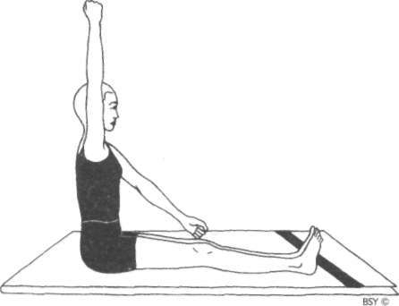RAJJU KARSHANASANA

**Practice I: Rajju Karshanasana (pulling the rope)**

Sit on the floor with the legs straight and together. Keep the eyes open.

Imagine that there is a rope hanging in front of the body. Breathe in while reaching up with the right hand as though to grasp the rope at a higher point.

Keep the elbow straight. Look upward.

While breathing out, slowly pull the right arm down, putting power into it as though pulling the rope down• wards. Let the eyes follow the downward movement of the hand.

Repeat with the left hand and arm to complete the first round.

Both arms do not move at the same time. Practise 5 to 10 rounds.

**Breathing:** Inhale while raising the arm.

Exhale while lowering the arm.

**Awareness:** On the breath, movement and stretch of the upper back and shoulder muscles.

**Benefits:** This asana loosens the shoulder joints and stretches the upper back muscles. It firms the breast and develops the muscles of the chest.

GATYATMAK MERU VAKRASANA

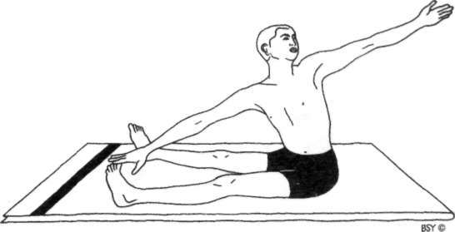

**Practice 2: Gatyatmak Meru Vakrasana (dynamic spinal twist)**

Sit on the floor with both legs outstretched. Separate the legs as far apart as possible.

Do not allow the knees to bend.

Stretch the arms sideways at shoulder level.

Keeping the arms straight, twist to the left and bring the right hand down towards the left big toe.

Stretch the straight left arm behind the back as the trunk twists to the left.

Keep both arms in one straight line.

Turn the head to the left and gaze at the left outstretched hand.

Twist in the opposite direction and bring the left hand down towards the right big toe.

Stretch the straight right arm behind the back. Turn the head to the right and gaze at the right outstretched hand. This is one round.

Practise 10 to 20 rounds.

Start slowly and then gradually increase the speed.

**Breathing:** To apply pressure in the abdomen: breathe in when twisting and breathe out when returning to the centre. To give maximum flexion of the spine: breathe out when twisting and breathe in when returning to the centre.

**Awareness:** On the breath, the twisting movement and the effect on the spinal vertebrae and muscles.

**Contra-indications:** People with back conditions should avoid this asana.

**Benefits:** This asana loosens up the vertebrae and removes stiffness of the back.

CHAKKI CHALANASANA

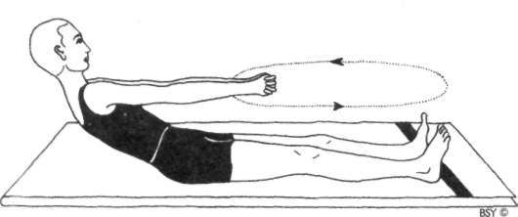

**Practice 3: Chakki Chalanasana (churning the mill)**

**Stage** I: Sit with the legs stretched out in front of the body about one foot apart. Interlock the fingers of both hands and hold the arms out straight in front of the chest.

Keep the arms straight and horizontal throughout the practice; do not bend the elbows.

Bend forward as far as possible. Imagine the action of churning a mill with an old-fashioned stone grinder.

Swivel to the right so that the hands pass above the right toes and as far to the right as possible.

Lean back as far as possible on the backward swing.

Try to move the body from the waist. On the forward swing, bring the arms and hands to the left side, over the left toes and then back to the centre position.

One rotation is one round.

Practise 5 to 10 rounds clockwise and then the same number of rounds anti-clockwise.

**Stage** 2: In the same sitting position, separate the legs as wide as possible, keeping them straight. Make large, cir• cular movements over both feet, again trying to take the hands over the toes on the forward swing and coming as far back as possible on the backward swing.

Practise 10 times in each direction.

**Breathing:** Inhale while leaning back.

Exhale while moving forward.

**Awareness:** On the breath, movement and lower back, hips and pelvic area.

**Benefits:** This asana is excellent for toning the nerves and organs of the pelvis and abdomen. It is very useful for regulating the menstrual cycle and may be performed during the first three months of pregnancy. It is also an excellent exercise for postnatal recovery.

NAUKA SANCHALANASANA

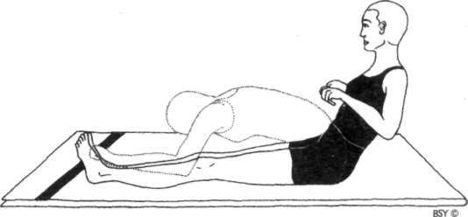

**Practice 4: Nauka Sanchalanasana (rowing the boat) Stage I**: Sit with both legs straight in front of the body.

Imagine the action of rowing a boat.

Clench the hands as though grasping oars, with the palms facing down.

Breathe out and bend forward from the waist as far as is comfortable, straightening the arms.

Breathing in, lean back as far as possible, drawing the hands back towards the shoulders.

This is one round.

The hands should make a complete circular movement in every round, moving up the sides of the legs and trunk. The legs should be kept straight throughout.

Practise 5 to 10 rounds.

Reverse the direction of the rowing movement as though going in the opposite direction.

Practise 5 to 10 times.

**Stage 2:** In the same sitting position, spread the legs so that the feet are about one metre apart.

The legs should remain straight throughout the practice. Repeat the procedure as given in stage 1.

First row over the right leg, then the left leg and then over the space between the feet.

**Breathing:** Inhale while leaning back. Exhale while bending forward.

**Awareness:** On the breath, movement and lower back and pelvic area.

**Benefits:** This asana has a positive effect on the pelvis and abdomen and eliminates energy blockages in these areas. It is especially useful for gynaecological disorders and postnatal recovery. It also removes constipation.

KASHTHATAKSHANASANA

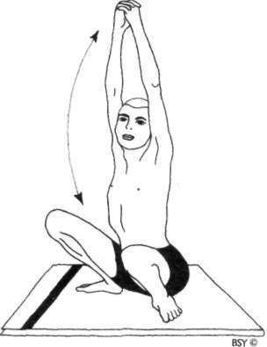

**Practice 5: Kashtha Takshanasana (chopping wood)**

Sit in the squatting position with the feet flat on the floor one and a half feet apart.

The knees should be fully bent and separated.

Clasp the fingers of both hands together and place them on the floor between the feet. Straighten the arms and keep them straight throughout the practice.

The elbows should be inside the knees. The eyes should remain open.

Imagine the action of chopping wood. Raise the arms as high as possible above and behind the head, stretching the spine upward. Look up towards the hands.

Make a downward stroke with the arms, as if chopping wood. Expel the breath making a 'Ha!' sound to remove all the air from the lungs. The hands should return to the floor in between the feet and the head is facing forward. This is one round.

Practise 5 to 10 rounds.

**Breathing:** Inhale while raising the arms.

Exhale while lowering the arms.

**Awareness:** On the breath, movement and stretch of the shoulder and upper back muscles.

**Benefits:** This asana loosens up the pelvic girdle and tones the pelvic muscles. It is useful for women preparing for childbearing and may be practised during the first three months of pregnancy. It also has a special effect on the usually inaccessible muscles of the back between the shoulder blades, as well as the shoulder joints and upper back muscles.

**Practice note:** Those people who find the squatting pose too difficult should practise in the standing position. The benefits, however, will be less.

NAMASKARASANA

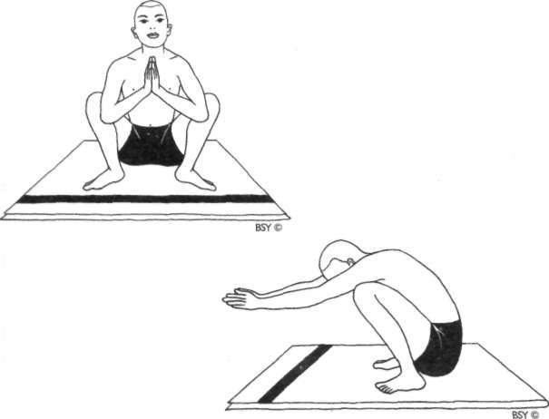

**Practice 6: Namaskarasana (salutation pose)**

Sit in the squatting position with the feet flat on the floor about two feet apart. The knees should be wide apart and the elbows placed against the inside of the knees.

Bring the hands together in front of the chest in a gesture of prayer.

Press the elbows against the insides of the knees. The eyes may be open or closed.

Inhale and bend the head backwards.

Simultaneously, use the elbows to push the knees as wide apart as possible.

This is the starting position.

Feel the pressure at the back of the neck.

Hold this position for 3 seconds while retaining the breath. Exhale and straighten the arms directly in front of the body.

At the same time, push in with the knees, pressing the upper arms inward.

The head should be bent forward with the chin pressed against the chest.

Tense the muscles of the upper back and shoulders as if someone is pulling the hands forward.

Hold this position, retaining the breath, for 3 seconds. Return to the starting position and bring the palms together in front of the chest, bending the head back.

This is one round. Practise 5 to 8 rounds.

**Breathing:** Inhale while bringing the palms together in front of the chest.

Exhale while extending the arms forward and retain.

**Awareness:** On the breath, movement, stretch on the back of the neck and chest in the starting position, and the upper back and shoulder muscles in the forward position.

**Benefits:** This asana has a profound effect on the nerves and muscles of the thighs, knees, shoulders, arms and neck. It increases flexibility in the hips.

VAYUNISHKASANA

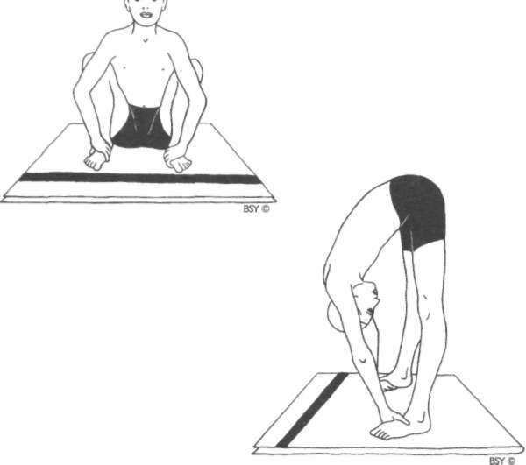

**Practice 7: Vayu Nishkasana (wind releasing pose)**

Sit in the squatting position with the feet two feet apart. Grasp the insteps of the feet, placing the fingers under the soles with the thumbs above.

The upper arms should be pressing against the inside of the knees with the elbows slightly bent.

The eyes should be open throughout the practice.

Inhale while moving the head back. Direct the gaze upward. This is the starting position.

Hold the breath for 3 seconds, accentuating the backward movement of the head.

While exhaling, straighten the knees, raise the buttocks and bring the head forward towards the knees.

Hold the breath for 3 seconds, accentuating the spinal bend. Do not strain.

Breathing in, return to the starting position. This is one round.

Practise 5 to 8 rounds.

**Breathing:** Inhale in the squatting position and retain.

Exhale in the raised position and retain.

**Awareness:** On the breath, movement, stretch of the neck in the starting position and the bend of the spine in the standing position.

**Benefits:** Like namaskarasana, this pose has a beneficial effect on the nerves and muscles of the thighs, knees, shoulders, arms and neck. The pelvic organs and muscles are mas• saged. It gives an equal stretch to the whole spine and both the arm and leg muscles. All the vertebrae and joints are pulled away from each other so that the pressure between them is balanced. Simultaneously, all the spinal nerves and dural sheaths are stretched and toned. It is also useful for relieving flatulence.

**Practice note:** More advanced practitioners may place the fingers under the front of the feet. Shambhavi mudra may also be practised throughout. This will help to tone the entire nervous system.

**KAWA CHALASANA**

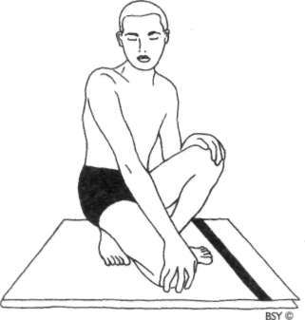

**Practice 8: Kawa Chalasana (crow walking)**

Sit in the squatting position with the feet apart and the buttocks above the heels.

Place the palms of the hands on the knees. Take small steps in the squatting position.

Try to keep the knees flexed so that the buttocks are not moved away from the heels. Walk either on the toes or the soles of the feet, whichever is most difficult.

As you take a step forward bring the opposite knee to the floor.

Take as many steps as possible, up to 50, and then relax in shavasana.

**Breathing:** Breathe normally throughout.

**Awareness:** While walking: on smoothness of movement.

While resting in shavasana: on the heart beat or breath and on the effects of the asana on the lower back, hips, knees and ankles.

**Contra-indications:** People suffering from disorders of the knees, ankles or toes should not practise this asana.

**Benefits:** This asana prepares the legs for meditation asanas and improves blood circulation in the legs. It also helps to remove constipation.

UDARAKARSHANASANA

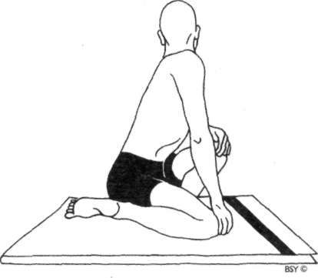

**Practice 9: Udarakarshanasana (abdominal stretch pose)** Sit in the squatting position with the feet apart and the hands on the knees.

Breathe in deeply.

Breathe out, bringing the right knee to the floor near the left foot.

Using the left hand as a lever, push the left knee towards the right, simultaneously twisting to the left.

Keep the inside of the right foot on the floor.

Try to squeeze the lower abdomen with the combined pressure of both thighs.

Look over the left shoulder.

Hold the breath out for 3 to 5 seconds in the final position. Breathe in when returning to the starting position.

Repeat on the other side of the body to complete one round.

Practise 5 rounds.

**Awareness:** On the breath synchronised with the movement and the alternate stretch and compression of the lower abdomen.

**Variation:** Those who have difficulty balancing, may support their backs against a wall while squatting. The heels should be about 20 cm from the wall to allow for the twist.

**Benefits:** This pose is very useful for abdominal ailments because it alternately compresses and stretches the organs and muscles of this region. It also relieves constipation.

**Practice note:** This is one of the asanas practised in shankha- prakshalana. During this practice, the breathing may be reversed to increase the pressure of the thigh against the abdomen. Take care not to over stretch the back as the body begins to feel lighter and more flexible.

Yoga Exercises for the Eyes

Many people wear spectacles or contact lenses to improve their vision. Glasses, however, do not actually cure bad eye• sight. In fact, eye problems frequently get worse through their use, necessitating ever more powerful lenses.

Factors which contribute to bad eyesight are: artificial and bad lighting, prolonged television or video watching, poor diet, muscle inefficiency due to prolonged hours of office work and study, mental and emotional tension, toxic condi• tion of the body and ageing.

Solving the problem of lighting is fairly straightforward. Diet, however, is more complex and it affects not only the health of the eyes but of the whole body. Simplifying the diet and avoiding heavy, indigestible, oily, spicy foods as well as tinned, processed, pre-packed and junk foods will help rectify poor vision. A vegetarian diet is also recommended or, at least, a reduction of non-vegetarian food.

Contrary to popular belief, long periods of reading do not damage the eyes providing the mind and eyes are relaxed whilst doing so. If there is tension, then even a short period of reading can strain the eyes. Try to develop the ability to read with relaxed awareness and a good posture. Before starting to read, if mental or muscular tension is experienced in the eyes, perform shashankasana for a few minutes. This asana will do much to calm the mind and relax the eyes.

Try to depend less on the use of glasses. Use them only when it is absolutely necessary. Leave them off during leisure time whenever possible. This will help the eyes to adjust and start functioning normally.

The habit of walking with bare feet on the grass, sand or bare earth, either early in the morning or around sunset, is claimed to have a relaxing and beneficial effect on the eyes. This is due to the reflex connections between the soles of the feet and the visual areas of the brain. It is especially recom• mended where the feet are often in restrictive footwear.

Another exercise recommended for relaxing the eye muscles is to stand with the feet shoulder width apart in front of a wide open space. Shift the weight of the body onto one side, raise the opposite heel off the ground, then swing back and forth for a few minutes while gazing into the distance, allowing the eyes to relax.

Gazing at the rising sun during the first 15 degrees of its trajectory from the horizon is highly recommended. After gazing for a few minutes, close the eyes and become aware of the after image. Keeping the spine straight, begin to perform pawanmuktasana part 1, practice 17, stage 3. Look over each shoulder from side.to side, keeping the eyes closed. At the same time, follow the after image as it moves back and forth through the field of inner vision, from centre to periphery and back again. Practise palming.

A simple sun bath may also be taken while facing the rising or setting sun. The eyes should be closed. Feel the ultra-violet rays soothing and relaxing the eyes.

**Therapeutic yoga exercises:** Excluding diseases such as glaucoma, trachoma and cataract, the most common eye disorders today are related to functional defects in the ocular muscles exacerbated by chronic mental and emotional tension. The following simple exercises help to alleviate various disorders related to the malfunctioning of the eye muscles such as short and long-sightedness, presbyopia and squint.

The eye exercises should be practised regularly with patience and perseverance. Do not expect instant cure or improvement. It takes years for the eyes to become defective; it will also take time, a few months or more, before noticeable progress will be made. However, improvement will come as it has to many people who have adopted a yogic way of life and gradually reduced the power of their glasses.

**Preparation:** Before starting the practices, it is a good idea to splash cold water onto the eyes a few times. Hold a little water in the palms above a water basin and splash it onto the eyelids. Do this about 10 times and then begin the exer• cises. This procedure will help stimulate the blood supply and generally tone up the eyes.

**Contra-indications:** Those who suffer from major eye dis• eases or disorders such as glaucoma, trachoma, cataract, retinal detachment, retinal artery or vein thrombosis, iritis, keratitis or conjunctivitis should only perform yoga practices after consulting an eye specialist. Inverted asanas and kunjal kriya should be avoided altogether while the condition lasts. Adopting a yogic lifestyle and a simple vegetarian diet, how• ever, may be of great benefit.

**Practice notes:** Eye exercises should be performed one after the other in the sequence given. The series should be practised in its entirety, once early in the morning and/or once in the evening.

The most important thing to remember during practice is to be totally relaxed. Do not strain as this will lead to fatigue and tiredness of the eyes. The facial muscles, eyebrows and eyelids should remain totally relaxed. After each exercise the eyes should be closed and rested for at least half a minute. The practice of palming may be performed at this time.

Glasses should not be worn while performing the exercises.

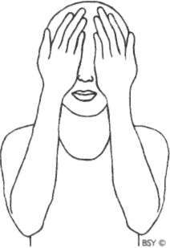PALMING

**Exercise I: Palming**

Sit quietly and close the eyes.

Rub the palms of the hands together vigorously until they become hot. Place the palms gently over the eyelids, without any undue pressure.

Feel the warmth and energy being transmitted from the hands into the eyes and the eye muscles relaxing.

The eyes are being bathed in a soothing darkness. Remain in this position until the heat from the hands has been absorbed by the eyes.

Then lower the hands, keeping the eyes closed.

Again rub the palms together until they become hot and place them over the closed eyes. (Make sure the palms and not the fingers cover the eyes).

Repeat this procedure at least 3 times.

**Benefits:** Palming relaxes and revitalises the eye muscles, and stimulates the circulation of the aqueous humour, the liquid that runs between the cornea and the lens of the eye, aiding the correction of defective vision.

**Practice note:** The benefits are enhanced if the exercise is practised in front of the rising or setting sun. Be aware of the warmth and light on the closed lids. Never look directly at the sun except for a few initial moments when it is just rising or when it is about to set.

**Exercise 2: Blinking**

Sit with the eyes open.

Blink the eyes 10 times quickly.

Close the eyes and relax for 20 seconds.

Repeat the blinking 10 times quickly and then again close the eyes and relax.

Repeat 5 times.

**Benefits:** Many people with defective eyesight blink irregularly and unnaturally. This is related to the state of habitual tension in the eyes. This exercise encourages the blinking reflex to become spontaneous, inducing relaxation of the eye muscles.

SIDEWAYS VIEWING

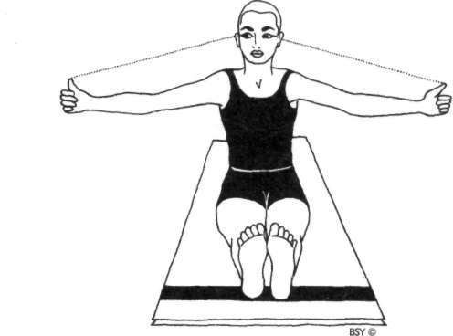

**Exercise 3: Sideways viewing**

Assume a sitting position with the legs straight in front of the body.

Raise the arms to the sides at shoulder level, keeping them straight, and point the thumbs upwards.

The thumbs should be just in the peripheral vision when

the head is facing forward. If they are not clearly visible, bring them slightly forward until they come into view. The head should not move. Look at a fixed point directly in front and on a level with the eyes. Fix the position of the head in this neutral position. Then, without moving the head sideways, focus the eyes on the following, one after the other:

* 1. left thumb
  2. space between the eyebrows, bhrumadhya
  3. right thumb
  4. space between the eyebrows
  5. left thumb.

Repeat this cycle 10 to 20 times keeping the head and spine straight throughout.

Finally, close and rest the eyes.

Palming may be performed several times.

**Breathing:** Inhale in the neutral position.

Exhale while looking to the sides. Inhale and come to the centre.

**Benefits:** Sideways viewing relaxes the tension of the muscles strained by constant reading and close work. It also prevents and corrects squint.

**Practice note:** If the arms become tired they should be sup• ported on two stools.

FRONT AND SIDEWAYS VIEWING

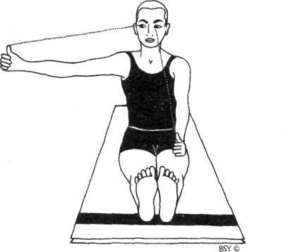

**Exercise 4: Front and sideways viewing**

Maintain the same body position as in exercise 3 but place the left thumb on the left knee so that it points upward. Hold the right thumb to the right of the body so that it points upward.

Without moving the head, focus the eyes on the left thumb, then on the right thumb and then return to the left thumb. Repeat this process 15 to 20 times, then rest and close the eyes.

Repeat the same procedure on the left side of the body. Keep the head and spine straight throughout.

Finally, close and rest the eyes.

Palming may be performed several times.

**Breathing:** Inhale in the neutral position.

Exhale while looking down. Inhale while looking up.

**Benefits:** Front and sideways viewing improves coordination of medial and lateral muscles.

ROTATIONAL VIEWING

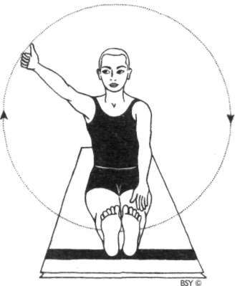

**Exercise 5: Rotational viewing**

Maintain the same body position as in exercise 4. Place the left hand on the left knee.

Hold the right fist above the right leg with the right thumb pointing upward and the elbow straight.

Make a large circular movement with the right arm to the left, then upward, curving to the right, and finally returning to the starting position. Keep the eyes focused on the thumb without moving the head.

Perform 5 times clockwise and then 5 times anti-clockwise. Repeat with the left thumb.

Keep the head and spine straight throughout. Finally, close and rest the eyes.

Palming may be performed several times.

**Breathing:** Inhale while completing the upper arc of the circle.

Exhale while completing the lower arc.

The breath should be smooth and synchronised with the forming of a perfect circle.

**Benefits:** Rotational viewing restores balance in the muscles surrounding the eyes and improves coordinated activities of both eyeballs.

UP AND DOWN VIEWING

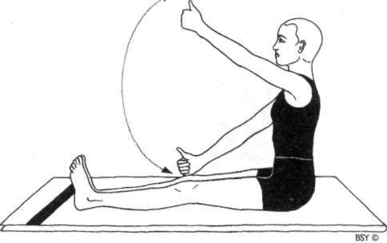

**Exercise 6: Up and down viewing**

Maintain the same position as in exercise 5.

Place both fists on the knees with both thumbs pointing upward.

Keeping the arms straight, slowly raise the right thumb while following the motion of the thumb with the eyes. When the thumb is raised to the maximum, slowly return to the starting position, all the time keeping the eyes focused on the thumb without moving the head.

Practise the same movement with the left thumb. Repeat 5 times with each thumb.

Keep the head and spine straight throughout. Finally, close and rest the eyes.

Palming may be performed several times.

**Breathing:** Inhale while raising the eyes.

Exhale while lowering the eyes.

**Benefits:** Up and down viewing balances the upper and lower eyeball muscles.

PRELIMINARY NASIKAGRA DRISHTI

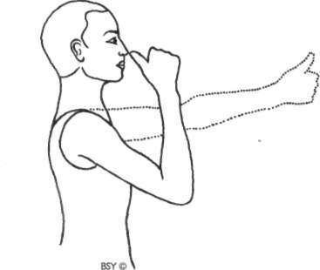

**Exercise 7: Preliminary Nasikagra Drishti (preliminary nosetip gazing)**

Sit with the legs straight in front or in a cross-legged pose.

Hold the right arm straight directly in front of the nose. Make a fist with the right hand, keeping the thumb pointing upward.

Focus both eyes on the tip of the thumb.

Bend the arm and slowly bring the thumb to the nose tip, keeping the eyes focused on the tip of the thumb.

Remain for a few seconds with the thumb held at the nose tip and the eyes focused there.

Slowly straighten the arm, continuing to gaze at the thumb tip.

This is one round. Practise 5 rounds.

**Breathing:** Breathe in as the thumb is drawn towards the nose.

Retain inside while holding the thumb at the nose tip. Breathe out as the arm is straightened.

**Benefits:** This exercise improves the accommodating and focusing power of the eye muscles.

**Exercise 8: Near and distant viewing**

Stand or sit at an open window, preferably with a clear view of the horizon, with the arms by the sides.

Focus the eyes on the nose tip, nasikagra drishti, for 5 seconds.

Then, focus on a distant object on the horizon for 5 seconds. Repeat this process 10 to 20 times.

Close the eyes and relax.

Palming may be performed at this time.

**Breathing:** Inhale during near viewing.

Exhale during distant viewing.

**Benefits:** Same as for Exercise 7 but the range of movements is further increased.

**Practice note:** Lie in shavasana for a few minutes after com• pleting all 8 exercises.

#### Relaxation Asanas

The importance of this series of relaxation poses cannot be over-emphasised. They should be performed before and after the asana session and at any time when the body becomes tired. The asanas in this group appear very easy at first, yet to do them properly is quite difficult for the tension in all the muscles of the body must be consciously released. The muscles often seem to be completely relaxed but, in fact, tightness still remains. Even during sleep, relaxation is elusive. The asanas in this chapter give the body the rest it so badly needs. Constant postural abnormalities put excess strain on the muscles of the back which hardly receive proper relaxation in the conventional supine position. Therefore certain relaxation practices which are done in the prone position are very relaxing to the spine and related structures. They are especially recommended for any back/spinal problem. These postures can be adopted during any time of the day for any comfortable duration. They can be combined with relaxing daily activities as well.

SHAVASANA

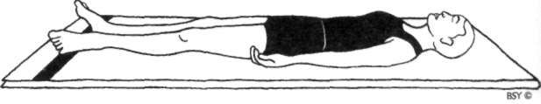

**Shavasana (corpse pose)**

Lie flat on the back with the arms about 15 cm away from the body, palms facing upward. A thin pillow or folded cloth may be placed behind the head to prevent discomfort. Let the fingers curl up slightly.

Move the feet slightly apart to a comfortable position and close the eyes.

The head and spine should be in a straight line.

Make sure the head does not fall to one side or the other. Relax the whole body and stop all physical movement.

Become aware of the natural breath and allow it to become rhythmic and relaxed.

Begin to count the breaths from number 27 backwards to zero. Mentally repeat, "I am breathing in 27,1 am breathing out 27,1 am breathing in 26,1 am breathing out 26", and so on, back to zero.

If the mind wanders and the next number is forgotten, bring it back to the counting and start again at 27. If the mind can be kept on the breath for a few minutes the body will relax.

**Duration:** According to time available. In general, the longer the better although a minute or two is sufficient between asana practices.

**Awareness:** Physical - first on relaxing the whole body, then on the breath and counting.

Spiritual - on ajna chakra.

**Benefits:** This asana relaxes the whole psycho-physiological system. It should ideally be practised before sleep; before,

during and after asana practice, particularly after dynamic exercises such as surya namaskara; and when the practi• tioner feels physically and mentally tired. It develops body awareness. When the body is completely relaxed, awareness of the mind increases, developing pratyahara.

**Practice note:** Try not to move the body at all during the practice as even the slightest movement will create mus• cular contraction.

A personal mantra may be repeated with every inhalation and exhalation.

**Variation:** While lying in shavasana, become aware of the right hand and relax it.

Slowly become aware of the right wrist, elbow, armpit, right side of the waist, right buttock, right thigh, right knee, calf, heel, sole of the foot, and relax them one by one.

Repeat this process with the left side of the body and all the parts of the head and trunk.

Make sure that each part of the body is relaxed, feel each part merging into the floor.

Repeat this process a few times and all the tensions will be removed.

**Practice note:** For maximum benefit, this technique should be performed after a hard day's work or just before sleep.

**Note:** *This asana is also known as* mritasana, *the dead man's pose.*

ADVASANA

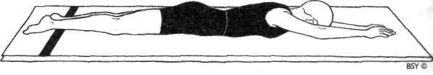

**Advasana (reversed corpse pose)**

Lie on the stomach.

Stretch both arms above the head with the palms facing downward. The forehead should be resting on the floor. Relax the whole body in the same way as described for shavasana.

If there is difficulty breathing or a sense of suffocation is experienced, a pillow may be placed under the chest.

**Breathing:** Natural and rhythmic. The number of breaths may be counted as in shavasana while gently pushing the abdomen against the floor.

**Duration:** For relaxation in the treatment of ailments, it should be performed for as long as possible. Before or during an asana session, a few minutes is sufficient.

**Awareness:** Physical - on the breath, the number of breaths and relaxing the whole body.

Spiritual - on ajna or manipura chakra.

**Benefits:** Recommended for those with slipped disc, stiff neck and stooping figure. People with these conditions will also find this asana an excellent sleeping position.

**Practice note:** Mantra may also be synchronised with the breath as in shavasana.

JYESTIKASANA

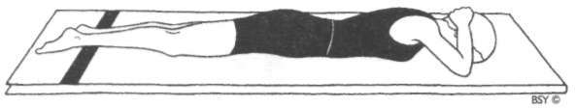

**Jyestikasana (superior posture)**

Lie flat on the stomach with the legs straight and the forehead resting on the floor.

Interlock the fingers and place the palms on the back of the head or neck.

Allow the elbows to rest on the floor.

Relax the whole body and become aware of the breathing process as described for shavasana.

**Breathing:** Natural and rhythmical.

**Awareness:** Physical - on the breath and relaxing the whole body. Feel the soothing warmth of the palms melting away the tensions in the neck and related areas.

Spiritual - on ajna or manipura chakra.

**Benefits:** This asana is helpful for all spinal complaints especially cervical spondylitis and stiff neck or upper back.

**Variation:** This asana may also be performed with the fingers of both hands interlocked and placed under the forehead, palms facing up.

MAKARASANA

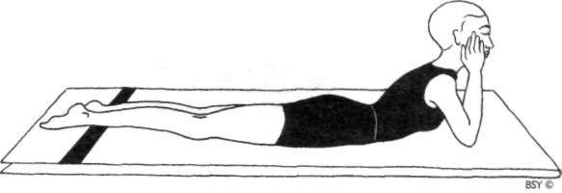

**Makarasana (crocodile pose)**

Lie flat on the stomach.

Raise the head and shoulders and rest the chin in the palms of the hands with the elbows on the floor.

Keep the elbows together for a more pronounced arch to the spine. Separate the elbows slightly to relieve excess pressure on the neck. In makarasana the effect is felt at two points: the neck and the lower back. If the elbows are too far in front, tension will be felt in the neck; if they are drawn too close to the chest, tension will be felt more in the lower back. Adjust the position of the elbows so that these two points are equally balanced. The ideal position is when the whole spine is equally relaxed.

Relax the whole body and close the eyes.

**Breathing:** Natural and rhythmic.

**Duration:** For as long as possible.

**Awareness:** Physical - on the breathing process or counting the breath with concentration on the lower back, and relaxing the whole body.

People with back or spinal complaints may practise breathing in, moving the awareness up along the spine from the tail bone to the neck and breathing out, bringing the awareness back down from the neck to the tail bone. Imagine that the breath is moving up and down the spine like mercury in a glass tube. This will quickly activate the healing energies in this area. For lower back pain due to tension, concentrate on this area and feel it expanding

and relaxing with every inhalation and exhalation. Spiritual - on manipura chakra or on the nose tip if practising nasikagra drishti.

**Contra-indications:** Those with back conditions should not practise this asana if any pain is experienced.

**Benefits:** This asana is very effective for people suffering from slipped disc, sciatica, lower back pain or any other spinal disorder. They should remain in this asana for extended periods of time as it encourages the vertebral column to resume its normal shape and releases compression of the spinal nerves. Asthmatics and people who have any other lung ailments should practise this simple asana regularly with breath awareness as it allows more air to enter the lungs.

MATSYA KRIDASANA

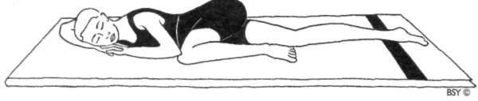

Matsya Kridasana (flapping fish pose)

Lie on the stomach with the fingers interlocked under the head. Bend the left leg sideways and bring the left knee close to the ribs.

The right leg should remain straight.

Swivel the arms to the left and rest the left elbow on the left knee. If this is not comfortable, rest it on the floor. Rest the right side of the head on the crook of the right arm, or a little further down the arm for more comfort. Relax in the final pose and, after some time, change sides. This position resembles a flapping fish.

**Breathing:** Normal and relaxed in the static pose.

**Duration:** Practise this asana for as long as possible on both sides. It may also be used for sleeping and resting.

**Awareness:** Physical - on the breath and relaxing the whole body.

Spiritual - on manipura chakra.

**Benefits:** This asana stimulates digestive peristalsis by stretch• ing the intestines and helps remove constipation. It relieves sciatic pain by relaxing the nerves in the legs. People with backache, for whom the practice of forward bending asanas is not recommended, may practise matsya kridasana as a counterpose after backward bending asanas. In the later months of pregnancy, lying on the back may cause pressure over major veins and block the circulation. In such circum• stances, this posture is ideal for relaxing, sleeping or practising yoga nidra. The bent knee and the head may be supported on a pillow for further comfort. This asana also redistributes excess weight around the waistline.

Meditation Asanas

The main purpose of the meditation asanas is to allow the practitioner to sit for extended periods of time without moving the body and without discomfort. Only when the body has been steady and still for some time will meditation be experienced. Deep meditation requires the spinal column to be straight and very few asanas can satisfy this condition. Furthermore, in high stages of meditation the practitioner loses control over the muscles of the body. The meditation asana, therefore, needs to hold the body in a steady position without conscious effort. Why not lie in shavasana, then, for meditation since it satisfies all the requirements? Because in shavasana there is a tendency to drift into sleep. It is essential to remain awake and alert while going through the various stages which lead to successful meditation.

Swami Sivananda of Rishikesh said the following about asanas and meditation: "You must be able to sit in one of the meditation asanas for a full three hours at a stretch without the body shaking. Then only will you gain true *asana siddhi,* mastery over the asana, and be able to practise the higher stages of pranayama and dhyana. Without securing a steady asana you cannot progress well in meditation. The more steady you are in your asana, the more you will be able to concentrate with a one-pointed mind. If you can be steady in a posture even for one hour, you will be able to acquire a one- pointed mind and feel the *atmic anandam,* infinite peace and soulful bliss inside you."

Initially, most people will find it difficult to sit in one asana for a long time. However, through the regular practice of the

pre-meditation poses listed here, the legs and hips will become flexible enough to comfortably maintain a steady posture.

**Pre-meditation asanas:** The following selected practices from the pawanmuktasana series are most useful for preparing the body for the meditation asanas:

1. Ardha titali asana (half butterfly)
2. Shroni chakra (hip rotation)
3. Poorna titali (full butterfly)
4. Vayu nishkasana (wind releasing pose)
5. Kawa chalasana (crow walking)
6. Udarakarshan asana (abdominal stretch pose)
7. Shaithalyasana (animal relaxation pose), refer to chapter on forward bending asanas.

**Stillness:** When sitting in meditation postures, programme the mind with suggestions like, "I am as steady as a rock" or "I am becoming motionless like a statue". This way the asana will quickly become steady and, after a while, will be comfortable for extended periods of time. This is the practice of *kaya sthairyam,* complete body stillness.

**Alternative postures:** Apart from the postures mentioned in this chapter, there are four other asanas which are useful for meditation. These are described in the chapter on the vajrasana group of asanas. They are:

1. Vajrasana (thunderbolt or pelvic pose)
2. Ananda madirasana (intoxicating bliss pose)
3. Padadhirasana (breath balancing pose)
4. Bhadrasana (gracious pose).

Other asanas, such as gorakhshasana or moola bandhasana, may also be used for meditation but they are advanced prac• tices and not comfortable for prolonged periods of time. These are described in the advanced asanas chapter.

**Precautions:** If there is severe discomfort or pain in the legs after sitting for some time in a meditation asana, slowly unlock the legs and massage them. When the blood circulation has returned to normal and there is no pain, resume the asana. However, be aware that the knee is a very delicate and much abused joint of the body and be careful not to strain it, especially while moving into or out of these meditation asanas.

Do not on any account use undue force or strain to sit in a meditation asana.

**Right or left leg:** In all the asanas discussed in this chapter, either the left or the right leg may be placed uppermost. It is a matter of personal preference and depends on whichever is the more comfortable. Ideally, the leg position should be alternated so that the balance on both sides of the body is maintained.

**Practice note:** A useful suggestion to make the following postures more comfortable is to place a small cushion under the buttocks.

**Note:** Padmasana may seem out of place in the beginners' group. It has been included, however, because a series of asanas in the intermediate group is performed using it as the base position.

SUKHASANA

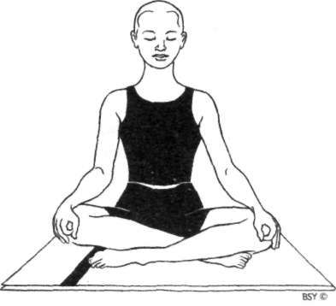

Sukhasana (easy pose)

Sit with the legs straight in front of the body.

Bend the right leg and place the foot under the left thigh. Bend the left leg and place the foot under the right thigh. Place the hands on the knees in chin or jnana mudra.

Keep the head, neck and back upright and straight, but without strain. Close the eyes.

Relax the whole body. The arms should be relaxed and not held straight.

**Benefits:** Sukhasana is the easiest and most comfortable of the meditation postures. It can be utilised without ill effect by persons who are unable to sit in the more difficult medita• tion postures. It facilitates mental and physical balance without causing strain or pain.

**Practice note:** Sukhasana is a relaxing posture which may be used after extended periods of sitting in siddhasana or padmasana.

Although sukhasana is said to be the simplest meditation posture, it is difficult to sustain for long periods of time unless the knees are close to the ground or on the ground. Otherwise most of the body weight is supported by the

buttocks and backache develops. The other meditation asanas create a larger and, therefore, steadier area of support.

**Variation:** For those who are extremely stiff, sukhasana may be performed sitting cross-legged with a belt or cloth tied around the knees and lower back.

Hold the spine upright.

Concentrate on the physical balance and equalising the weight on the right and left side of the body. A light, spacey feeling may be experienced.

While maintaining the posture, place the hands on the knees in chin or jnana mudra (see section on mudras).

ARDHA PADMASANA

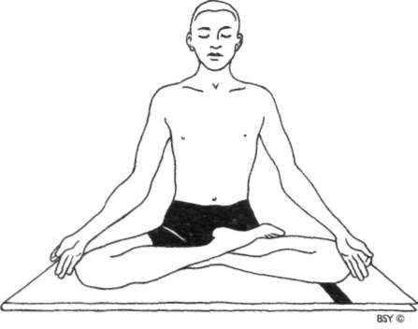

**Ardha Padmasana (half-lotus pose)**

Sit with the legs straight in front of the body.

Bend one leg and place the sole of the foot on the inside of the opposite thigh.

Bend the other leg and place the foot on top of the opposite thigh.

Without straining, try to place the upper heel as near as possible to the abdomen. Adjust the position so that it is comfortable.

Place the hands on the knees in either chin or jnana mudra.

Keep the back, neck and head upright and straight. Close the eyes and relax the whole body.

**Contra-indications:** Those who suffer from sciatica or sacral ailments should not perform this asana.

**Benefits:** The same as for padmasana but at a reduced level.

PADMASANA

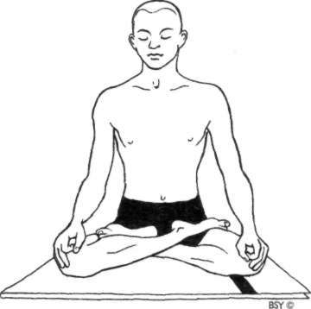

**Padmasana (lotus pose)**

Sit with the legs straight in front of the body.

Slowly and carefully bend one leg and place the foot on top of the opposite thigh.

The sole should face upward and the heel should be close to the pubic bone.

When this feels comfortable, bend the other leg and place the foot on top of the opposite thigh.

Both knees should, ideally, touch the ground in the final position.

Th e head and spine should be held upright and the shoulders relaxed.

Place the hands on the knees in chin or jnana mudra. Relax the arms with the elbows slightly bent and check that the shoulders are not raised or hunched.

Close the eyes and relax the whole body.

Observe the total posture of the body. Make the necessary adjustments by moving forward or backward until balance and alignment are experienced. Perfect alignment indi• cates the correct posture of padmasana.

**Contra-indications:** Those who suffer from sciatica, sacral infections or weak or injured knees should not perform this asana. This asana should not be attempted until flexibility of the knees has been developed through practice of the pre-meditation asanas.

**Benefits:** Padmasana allows the body to be held completely steady for long periods of time. It holds the trunk and head like a pillar with the legs as the firm foundation. As the body is steadied the mind becomes calm. This steadi• ness and calmness is the first step towards real meditation. Padmasana directs the flow of prana from mooladhara chakra in the perineum, to sahasrara chakra in the head, heightening the experience of meditation.

This posture applies pressure to the lower spine which has a relaxing effect on the nervous system. The breath becomes slow, muscular tension is decreased and blood pressure is reduced. The coccygeal and sacral nerves are toned as the normally large blood flow to the legs is redirected to the abdominal region. This activity also stimulates the digestive process.

SIDDHASANA

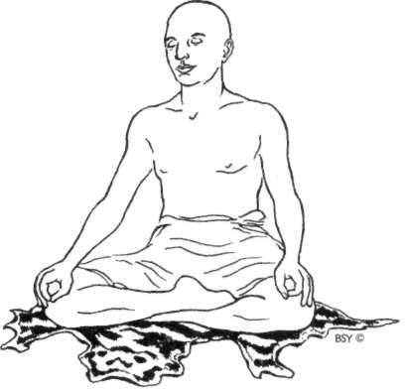

**Siddhasana (accomplished pose for men)**

Sit with the legs straight in front of the body.

Bend the right leg and place the sole of the foot flat against the inner left thigh with the heel pressing the perineum (the area midway between the genitals and the anus), sitting on top of the right heel.

This is an important aspect of siddhasana.

Adjust the body until it is comfortable and the pressure of the heel is firmly applied.

Bend the left leg and place the left ankle directly over the right ankle so that the ankle bones are touching and the heels are one above the other.

Press the pubis with the left heel directly above the genitals. The genitals will, therefore, lie between the two heels.

If this last position is too difficult, simply place the left heel as near as possible to the pubis.

Push the toes and the outer edge of the left foot into the space between the right calf and thigh muscles. If necessary, this space may be enlarged slightly by using the hands or temporarily adjusting the position of the right leg.

Grasp the right toes and pull them up into the space between the left calf and thigh.

Again adjust the body so that it is comfortable.

The legs should now be locked, with the knees touching the ground and the left heel directly above the right heel. Make the spine erect and feel as though the body is fixed on the floor. Place the hands on the knees in jnana, chin or chinmaya mudra.

Close the eyes and relax the whole body.

**Contra-indications:** Siddhasana should not be practised by those with sciatica or sacral infections.

**Benefits:** Siddhasana directs the energy from the lower psychic centres upward through the spine, stimulating the brain and calming the entire nervous system. The position of the lower foot at the perineum presses mooladhara chakra, stimulating moola bandha, and the pressure applied to the pubic bone presses the trigger point for swadhisthana, automatically activating vajroli/sahajoli mudra. These two psycho-muscular locks redirect sexual nervous impulses back up the spinal cord to the brain, establishing control over the reproductive hormones which is necessary in order to maintain brahmacharya for spiritual purposes. Prolonged periods in siddhasana result in noticeable tingling sensations in the mooladhara region which may last for ten to fifteen minutes. This is caused by a reduction in the blood supply to the area and by a rebalancing of the pranic flow in the lower chakras.

This posture redirects blood circulation to the lower spine and abdomen, toning the lumbar region of the spine, the pelvis and the abdominal organs, and balancing the reproductive system and the blood pressure.

**Practice note:** Siddhasana may be performed with either leg uppermost. Many people experience discomfort due to the pressure applied where the ankles cross each other. If necessary, place a folded cloth or piece of sponge between the legs at this point. At first the pressure at the perineum may be uncomfortable to maintain but with practice this will be eased.

***Note:*** *The Sanskrit word* siddha *means 'power' and 'perfection'. The word* siddhi *is derived from siddha and refers to a psychic power or faculty developed through yogic practices. Siddhis include clairvoyance and telepathy as well as many other lesser known powers such as the ability to disappear at will. Siddhasana, or siddha yoni asana for women, is believed to be the asana that helps develop these powers.*

SIDDHA YONI ASANA

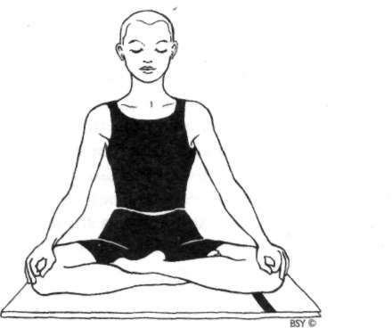

**Siddha Yoni Asana (accomplished pose for women)**

Sit with the legs straight in front of the body.

Bend the right leg and place the sole of the foot flat against the inner left thigh.

Place this heel firmly against or inside the labia majora of the vagina.

Adjust the body position so that it is comfortable while simultaneously feeling the pressure of the right heel.

Bend the left leg and place the left heel directly on top of the right heel so it presses the clitoris, and wedge the left toes down into the space between the calf and thigh so

they touch, or almost touch, the floor.

Grasp the toes of the right foot and pull them up into the space between the left calf and thigh.

Again, adjust the position so that it is comfortable. Ensure that the knees are firmly on the ground.

Make the spine fully erect and straight as though it were planted solidly in the earth.

Place the hands on the knees is chin, jnana or chinmaya mudra.

Close the eyes and relax the whole body.

**Contra-indications:** As for siddhasana.

**Benefits:** As for siddhasana.

**Note:** *The Sanskrit word* yoni *means womb' or 'source'.*

SWASTIKASANA

**Swastikasana (auspicious pose)**

Sit with the legs straight in front of the body.

Bend the left knee and place the sole of the left foot against the inside of the right thigh, so there is no contact between the heel and the perineum.

Bend the right knee and place the right foot in the space between the left thigh and calf muscle, so there is no contact between the heel and the pubis.

Grasp the toes of the left foot and pull them up into the space between the right calf and thigh.

Adjust the position so that it is comfortable. The knees should be firmly on the floor.

Straighten the spine.

Place the hands on the knees in chin, jnana or chinmaya mudra.

**Variation:** Sit with the legs straight in front of the body.

Bend the left leg, place the sole against the inside of the right thigh.

Similarly, bend the right leg and place the heel of the right foot on the floor in front of the left foot with the sole resting against the left shin. The heels will now be one in front of the other.

The hands may be placed on the knees in jnana, chin or chinmaya mudra, or they may be placed on the lap.

Close the eyes and relax the whole body.

**Contra-indications:** Swastikasana should not be performed by people with sciatica or sacral infections.

**Benefits:** Swastikasana is a healthy position to sit in especially for those suffering from varicose veins, tired and aching muscles or fluid retention in the legs.

**Practice note:** This is the easiest classical meditation asana and is a simplified version of siddhasana.

***Note:*** *Here the symbol of the swastika represents the different corners of the earth and universe, the spokes, and their meeting point and common centre of consciousness. This asana may be regarded as the one most favourable for realising the unity of existence.*

DHYANA VEERASANA

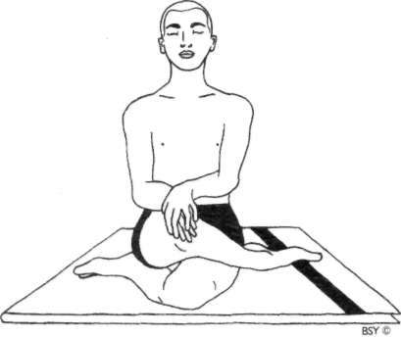

**Dhyana Veerasana (hero's meditation pose)**

Sit with both legs straight in front of the body.

Bend the left leg underneath the right leg so that the left heel is touching the right buttock.

Bring the right leg over the top of the bent left leg so that the right heel touches the left buttock.

Adjust the right knee so that it is above the left knee. Place the hands either on the right knee, one on top of the other, or on top of each foot, whichever is comfortable. Hold the head, neck and back straight.

Close the eyes and relax the whole body. Be aware of the breath at the nose tip.

**Benefits:** This asana is quite easy and comfortable to sustain for long periods of time as a comparatively large area of the body is in contact with the floor. It is a useful alternative to other meditation asanas. The legs and hips are not rotated outwards as in the other meditation postures, rather the knees are brought to the centre. This affects the pelvic structure and stretches the outer rather than the inner muscles of the thigh. This position also massages and tones the pelvic and reproductive organs.

SIMHASANA

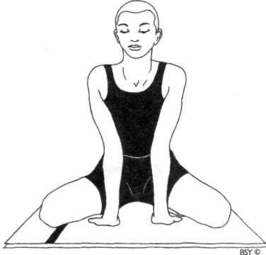

**Simhasana (lion pose)**

Sit in vajrasana with the knees about 45 cm apart.

The toes of both feet should remain in contact with each other.

Lean forward and place the palms of the hands on the floor between the knees, with the fingers pointing towards the body.

Straighten the arms fully and arch the back, giving the maximum stretch to the front of the neck.

Rest the body on the straight arms.

Tilt the head back so that there is a comfortable amount of tension in the neck.

Close the eyes and focus the inner gaze at the eyebrow centre, performing shambhavi mudra.

The eyes may also be kept open, in which case gaze at a point on the ceiling.

The mouth should be closed. Relax the whole body and mind.

**Benefits:** In this posture there is a very definite extension of the spinal cord and the body is absolutely fixed. There is total physical stability; no one part bears the whole weight

of the body. By focusing the inner gaze at the eyebrow centre, which represents the top of the spinal cord, the central nervous system is switched on, influencing the core structures around the hypothalamic-limbic system. Alpha waves are generated in the optic system at the back of the head by closing the eyes. By crossing them in a meditative attitude, shambhavi mudra, these waves spread from the back of the head to the frontal lobes, producing a profound meditative or relaxed state very quickly. Follow• ing the principles of reflexology, it may be inferred that the strong pressure on the palms helps relieve stress and tension, improve blood supply, tone up the nerves and balance the vital energy necessary for mastering meditation techniques.

***Note:*** *Generally, simhasana is associated with the roaring lion posture but the Upanishads give that posture as a variation of simhasana (see* simhagarjana, *the roaring lion, in the chapter Vajrasana Group of Asanas).*

*In this meditation asana the lion is sitting quietly, waiting for something to happen. This is the mental attitude the mind has to adopt in order to enter deep meditative states.*

###### Vajrasana Group of Asanas

The *vajra,* thunderbolt, is said to be the weapon of Indra, king of the *devas* or gods, just as the mind is the king of all the senses. Vajra is also the major nadi directly connected with the genito-urinary system which regulates the sexual energy in the body. Control of vajra nadi leads to sublimation and con• trol of sexual energy. Th e vajrasana series is, therefore, very beneficial for the reproductive as well as digestive organs and is also reasonably easy to perform.

VAJRASANA

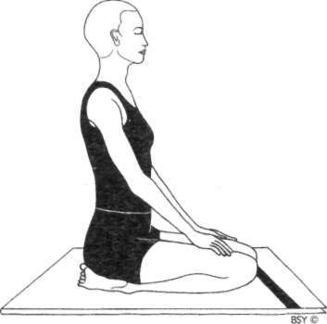

Vajrasana (thunderbolt pose)

Kneel on the floor.

Bring the big toes together and separate the heels. Lower the buttocks onto the inside surface of the feet with the heels touching the sides of the hips.

Place the hands on the knees, palms down.

The back and head should be straight but not tense. Avoid excessive backward arching of the spine.

Close the eyes, relax the arms and the whole body. Breathe normally and fix the attention on the flow of air passing in and out of the nostrils.

**Duration:** Practise vajrasana as much as possible, especially directly after meals, for at least 5 minutes to enhance the digestive function. In cases of acute digestive disorder, sit in vajrasana and practise abdominal breathing for 100 breaths before and after food.

**Awareness:** Physical - on the normal breathing process. This will bring tranquillity to the mind if practised with the eyes closed.

Spiritual - on manipura chakra.

**Benefits:** Vajrasana alters the flow of blood and nervous im• pulses in the pelvic region and strengthens the pelvic

muscles. It is a preventative measure against hernia and also helps to relieve piles. It increases the efficiency of the entire digestive system, relieving stomach ailments such as hyperacidity and peptic ulcer. It reduces the blood flow to the genitals and massages the nerve fibres which feed them, making it useful in the treatment of dilated testicles and hydrocele in men. It assists women in labour and helps alleviate menstrual disorders.

Vajrasana is a very important meditation posture because the body becomes upright and straight with no effort. It is the best meditation asana for people suffering from sciatica and sacral infections. It stimulates the vajra nadi, activates prana in sushumna and redirects sexual energy to the brain for spiritual purposes.

**Practice note:** If there is pain in the thighs, the knees may be separated slightly while maintaining the posture.

Beginners may find that their ankles ache after a short time in vajrasana. To remedy this, release the posture, sit with the legs stretched forward an d shake the feet vigorously one after the other until the stiffness disappears. The n resume the posture. A folded blanket or small cushion may be placed between the buttocks and the heels for added comfort.

***Note:*** *Vajrasana is used by Muslims and Zen Buddhists as a position for prayer and meditation. People who cannot perform padmasana or siddhasana, or find them uncomfortable, may sit in vajrasana for meditation practice.*

**Variation I**: Check the flow of breath through the nostrils. If the air flow through the left nostril is predominant, then place the left big toe on top of the right big toe; if the right flow is predominant, place the right big toe on top.

Sit in vajrasana as described.

This will help to balance the flow of the breath in the left and right nostrils, which are related to ida and pingala nadis, and thereby tranquillise the mind.

**Variation 2:** Separate the feet (not the knees) so that the big toes are about 25cm apart.

Sit in vajrasana with the buttocks flat on the floor. This stimulates mooladhara chakra.

**Variation 3:** Place a rolled up blanket on the floor between the legs. Separate the feet (not the knees) about 25cm.

Sit on the blanket in vajrasana.

This variation is easier and is suitable for beginners as it takes the pressure off the feet and ankles. It also stimulates mooladhara chakra.

ANANDA MADIRASANA

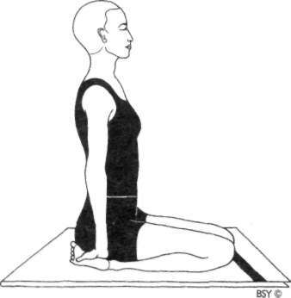

**Ananda Madirasana (intoxicating bliss pose)**

Sit in vajrasana. Place the palms on top of the heels so that the fingers are pointing towards each other. If this is uncomfortable, place the palms just above the heels.

Keep the head and spine erect, close the eyes and relax the whole body.

Fix the attention at bhrumadhya, the eyebrow centre.

**Breathing:** Slow and deep. Imagine that the breath is moving in and out of the eyebrow centre. Inhale from the eyebrow centre to ajna chakra and exhale from ajna to the eyebrow centre.

**Awareness:** Physical - in the early stages of the practice, awareness should be on the breathing process. When sufficient relaxation has been achieved, awareness may be transferred to the eyebrow centre.

Spiritual - on ajna chakra.

**Benefits:** This asana is used primarily to awaken ajna chakra. It also calms the mind, relaxes the nervous system and gives all the benefits of vajrasana.

***Note:*** *The thumbs may press any points on the soles according to specific effects required in the body. For exact details, seek the advice of someone with knowledge of either acupuncture or reflexology.*

*Ananda madirasana may also be performed as an alternative to classical meditation postures.*

PADADHIRASANA

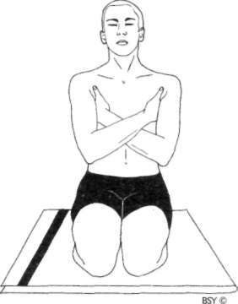

**Padadhirasana (breath balancing pose)**

Sit in vajrasana.

Cross the arms in front of the chest, placing the hands under the opposite armpits with the thumbs pointing upward.

The point between the thumb and first finger should be firmly pressed.

Close the eyes and become aware of the breathing process.

**Breathing:** Slow, deep and rhythmical. Practise until the flow of breath in both nostrils becomes equalised.

**Duration:** To prepare for pranayama, practise for 5 to 10 minutes.

For spiritual purposes, practise for extended periods of time.

**Awareness:** Physical - on the breathing process in the nose.

Spiritual - on ajna chakra.

**Practice note:** Padadhirasana may be used as a preparation for pranayama. It is specially useful when one or both nostrils are blocked.

If only one nostril is blocked, or partially blocked, place the hand of that side underneath the opposite armpit. Maintain the pressure for a minute or two, although changes may sometimes occur within a few seconds.

**Variation I**: For a stronger effect, make fists of the hands and place them under the armpits.

**Variation 2: Yoga Danda (balancing stick)**

The yoga danda is a special T-shaped stick traditionally used by yogis as an aid to meditation. The horizontal beam rests firmly under and supports the armpit with the bottom of the vertical stick on the ground. When the breath flow is equalised, the danda may be placed in front of the body. Both elbows may be rested on the horizontal beam with the arms folded or in any other position. The yoga danda may be used for long periods of time without the arms becoming tired.

**Benefits:** The pressure under both the armpits helps to open the nostrils to facilitate the practice of pranayama. Since the breath flow in the right and left nostrils influences the activities of the sympathetic and parasympathetic nervous systems respectively, opening of the two nostrils induces a state of autonomic balance.

BHADRASANA

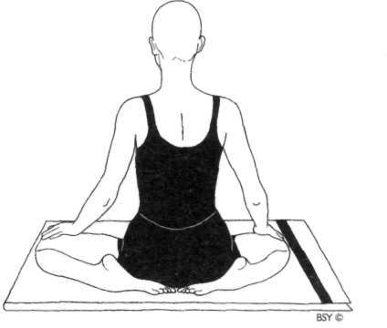

**Bhadrasana (gracious pose)**

Sit in vajrasana.

Separate the knees as far as possible, while keeping the toes in contact with the floor.

Separate the feet just enough to allow the buttocks and perineum to rest flat on the floor between the feet.

Try to separate the knees further but *do not strain.*

Place the hands on the knees, palms downward.

When the body is comfortable, practise nasikagra drishti, concentration on the nose tip. As the eyes become tired, close them for a short time and then resume nose tip gazing.

**Breathing:** Slow and rhythmic with awareness of the breath at the nose tip.

**Duration:** For extended periods of time if performed for spiritual aims.

A few minutes daily is sufficient to loosen up the legs. If any strain is experienced, stop the asana.

**Awareness:** Physical - on the natural breath or the nose tip.

Spiritual - on mooladhara chakra.

**Benefits:** This is predominantly a pose for spiritual aspirants as it has a stimulating influence on mooladhara chakra. It

is an excellent meditation pose. The benefits are basically the same as for vajrasana.

**Practice note:** If necessary, a folded blanket may be placed under the buttocks. Whether a blanket is used or not, it is important that the buttocks rest firmly on the ground in order to stimulate mooladhara chakra.

SIMHAGARJANASANA

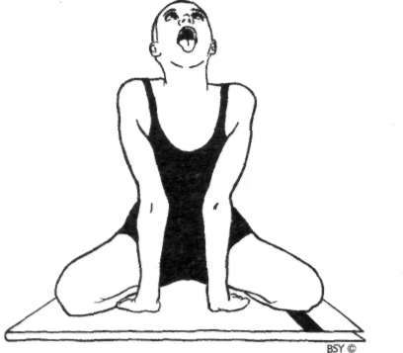

**Simhagarjanasana (roaring lion pose)**

Sit in vajrasana with the knees about 45 cm apart. If possible, face the sun.

Place the palms of the hands on the floor between the knees, with the fingers pointing towards the body.

Lean forward, resting the body on the straight arms. Arch the back and gently tilt the head back so that there is a comfortable amount of tension in the neck.

Open the eyes and gaze at the eyebrow centre, adopting shambhavi mudra (refer to section on mudra).

Relax the whole body. Keep the mouth closed.

Inhale slowly and deeply through the nose.

At the end of inhalation open the mouth and extend the tongue out as far as possible towards the chin.

While slowly exhaling, produce a clear, steady 'aaah' sound from the throat, keeping the mouth wide open.

At the end of exhalation, close the mouth and breathe in. This is one round.

**Breathing:** Inhale slowly through the nose and then slowly exhale through the mouth with the 'aaah' sound.

**Duration:** To maintain general health, practise 5 rounds daily.

For specific ailments, practise 10 to 20 rounds.

The eyes, tongue and mouth may be relaxed for a few moments between each round . This asana may be performed at any time.

**Awareness:** Physical-while inhaling, on the breath. While exhaling, on the sound produced and the effect on the throat area.

Spiritual - on vishuddhi or ajna chakra.

**Benefits:** This is an excellent asana for alleviating diseases of the throat, nose, ears, eyes and mouth. Tension is re• moved from the chest and diaphragm. Simhagarjanasana is useful for people who stutter or who are nervous and introverted. It develops a strong and beautiful voice.

Other benefits are as for shambhavi mudra.

**Variation I**: After performing shambhavi mudra, perform kechari mudra. Keep the mouth closed. Fold the tongue backward so that the tip and underside presses against the soft palate.

Inhale slowly and deeply through the nose.

At the end of inhalation, release the tongue, open the mouth and extend the tongue as far as possible.

**Variation 2:** Move the tongue slowly from side to side, while making a long 'aaah' sound.

VEERASANA

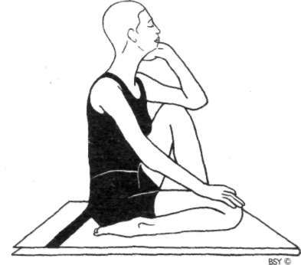

**Veerasana (hero's pose)**

Sit in vajrasana.

Raise the right knee and place the right foot flat on the floor beside the inside of the left knee.

Put the right elbow on the right knee and rest the chin on the palm of the right hand.

Close the eyes and relax.

Keep the body completely motionless and the spine and head straight.

Repeat with the left foot placed beside the right knee.

**Breathing:** Slow, deep breathing, imagining that the breath is flowing in and out of bhrumadhya, the eyebrow centre.

**Duration:** Practise for a minimum of two minutes. Repeat on the other side with the left elbow on the left knee.

**Awareness:** Physical - on keeping the head and spine straight and on the breath.

Spiritual - on ajna chakra.

**Benefits:** This asana balances the mind, increases the power of concentration, allows more awareness of the unconscious realms and induces physical and mental relaxation quickly. The thinking process becomes very clear and precise. It is useful for those who think too much or who have disturbed

117

or uncontrollable thoughts. It is very good for the kidneys, liver, reproductive and abdominal organs.

***Note:*** *This posture is also known as the thinker's or philosopher's pose.*

**Variation I**: This asana may also be practised by sitting on the heel so that it stimulates mooladhara chakra.

**Variation 2:** Sit on the heels in vajrasana.

Place the right foot on top of the left thigh as in the half lotus posture.

The foot should come up on the thigh as near to the lower abdomen as possible and the right knee should rest on the floor.

Place the palms together in front of the chest at the heart centre, in the prayer position.

Relax the whole body.

Slowly rise onto the knees, using the left leg as a lever and the right knee as a support.

The movement should be controlled without any jerking. Straighten the spine.

When balanced, raise the hands above the head, keeping the palms together and the fingers pointing upward.

Hold the final position for as long as is comfortable. Bring the hands back to the heart centre and gently and evenly lower the body down to the floor.

Repeat with the left foot on top of the right thigh. Practise up to 3 times on each side.

**Breathing:** Inhale while raising the body from the floor.

Breathe normally in the final position. Exhale while lowering the body.

**Awareness:** Physical - on maintaining balance and steadiness in the upright position.

Spiritual - on swadhisthana chakra.

**Contra-indications:** This asana should not be performed by people with weakness in the knees or inflammatory condi• tions such as arthritis, osteoarthritis, etc.

**Benefits:** This is a preliminary balancing pose which aids in stabilising the nervous system.

MARJARI-ASANA

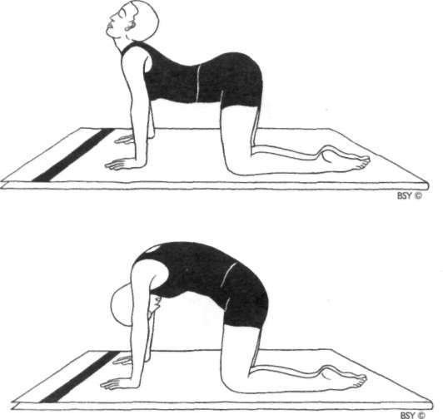

**Marjari-asana (cat stretch pose)**

Sit in vajrasana.

Raise the buttocks and stand on the knees.

Lean forward and place the hands flat on the floor beneath the shoulders with the fingers facing forward.

The hands should be in line with the knees; the arms and thighs should be perpendicular to the floor.

The knees may be together or slightly separated. This is the starting position.

Inhale while raising the head and depressing the spine so that the back becomes concave.

Expand the abdomen fully and fill the lungs with the maximum amount of air. Hold the breath for 3 seconds. Exhale, while lowering the head and stretching the spine upward.

At the end of exhalation contract the abdomen and pull in the buttocks.

The head will now be between the arms, facing the thighs. Hold the breath for 3 seconds, accentuating the arch of the spine and the abdominal contraction.

This is one round.

**Breathing:** Try to perform the movement breathing as slowly as possible. Aim at taking at least 5 seconds for both inhalation and exhalation. Ujjayi breathing may be used.

**Duration:** Perform 5 to 10 full rounds for general purposes.

**Awareness:** Physical - on the breath synchronised with the movement and flexion of the spine from top to bottom. Spiritual - on swadhisthana chakra.

**Benefits:** This asana improves the flexibility of the neck, shoulders and spine. It gently tones the female repro• ductive system. It may be safely practised up to the sixth month of pregnancy; forceful contraction of the abdomen, however, should be avoided after 3 months. Women suffering from menstrual disorders and leucorrhea will obtain relief by doing marjari-asana and it may be practised during menstruation for relief of cramps.

**Practice note:** Do not bend the arms at the elbows. Keep the arms and thighs vertical throughout.

VYAGHRASANA

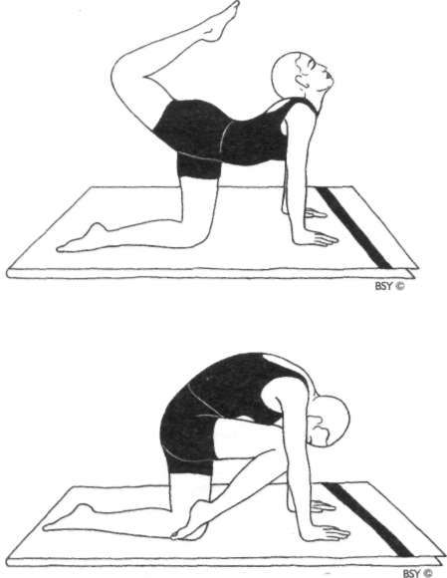

**Vyaghrasana (tiger pose)**

Assume vajrasana.

Move into marjari-asana and look forward.

The hands should be placed directly below the shoulders. Relax the whole body.

Straighten the right leg, stretching it up and back.

Bend the right knee and point the toes towards the head. Look up and try to touch the toes to the back of the head. Hold the breath for a few seconds in this position.

Straighten the right leg, bend the knee and swing the leg under the hips.

Simultaneously, arch the backup and bend the head down. The right foot should not touch the floor.

Press the knee against the chest and touch the nose to the knee. The spine should be convex.

Fix the eyes on the knee for a few seconds while retaining the breath outside.

Move the foot straight back and again stretch the leg. Bend the knee and continue with the slow swinging movements.

Repeat with the other leg.

**Breathing:** Inhale while stretching the leg backward.

Retain while bending the knee.

Exhale while swinging the knee to the chest.

**Duration:** Perform this asana 5 times with each leg.

**Awareness:** Physical - on the movement synchronised with the breath.

Spiritual - on swadhisthana chakra.

**Benefits:** This asana exercises and loosens the back by bending it alternately in both directions and tones the spinal nerves. It relaxes the sciatic nerves, relieving sciatica, and loosens up the legs. It tones the female reproductive organs and is especially beneficial for women after childbirth and those who have given birth to many children. It stretches the abdominal muscles, promotes digestion and stimulates blood circulation. Reduces weight from the hips and thighs.

***Note:*** *This asana is so called because it emulates the stretching movement made by a tiger as it wakes up from deep sleep.*

SHASHANKASANA

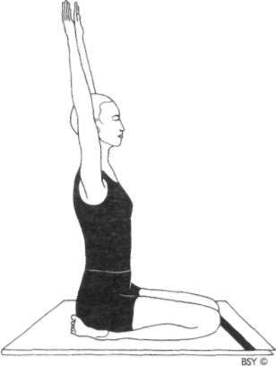

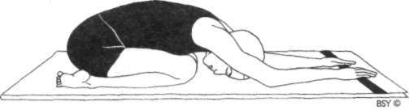

**Shashankasana (pose of the moon or hare pose)**

Sit in vajrasana, placing the palms on the thighs just above the knees.

Close the eyes and relax, keeping the spine and head straight.

While inhaling, raise the arms above the head, keeping them straight and shoulder width apart.

Exhale while bending the trunk forward from the hips, keeping the arms and head straight and in line with the trunk.

At the end of the movement, the hands and forehead should rest on the floor in front of the knees.

If possible, the arms and forehead should touch the floor at the same time.

Bend the arms slightly so that they are fully relaxed and let the elbows rest on the floor.

Retain the breath for up to 5 seconds in the final position. Then, simultaneously inhale and slowly raise the arms and trunk to the vertical position. Keep the arms and head in line with the trunk.

Breathe out while lowering the arms to the knees. This is one round.

Practise 3 to 5 rounds.

**Duration:** Beginners should slowly increase the length of time in the final position until they are able to hold it comforta• bly for at least 3 minutes. Those who wish to calm anger and frayed nerves should further increase the time to 10 minutes, breathing normally.

**Awareness:** Physical - on the breath synchronised with the physical movement. In the final position, on the pressure of the abdomen against the thighs.

Spiritual - on manipura or swadhisthana chakra in the final position.

**Contra-indications:** Not to be performed by people with very high blood pressure, slipped disc or those who suffer from vertigo.

**Benefits:** This asana stretches the back muscles and separates the individual vertebrae from each other, releasing pres• sure on the discs. Often nerve connections emanating from the spinal cord are squeezed by these discs, giving rise to various forms of backache. This posture helps to relieve this problem and encourages the discs to resume their correct position. It also regulates the functioning of the adrenal glands. It tones the pelvic muscles and the sciatic nerves and is beneficial for women who have an underdeveloped pelvis. It helps to alleviate disorders of both the male and female reproductive organs. Regular practice relieves constipation. When practised with ujjayi pranayama in the final position, it helps to eliminate anger and is very cooling for the brain.

***Note:*** *The Sanskrit word* shashank *means moon'. It is derived from two words:* shash *meaning 'hare' and* ank *meaning 'lap'. People in India have seen the dark patches on the full moon as resembling the shape of a hare with the moon in its lap. Furthermore, the moon symbolises peace and calm; it emits soothing and tranquil- Using vibrations. Shashankasana has a similar calming and cooling effect. More simply, it is the position frequently adopted by hares and rabbits.*

**Variation I**: Sit in vajrasana and close the eyes.

Hold the right wrist with the left hand behind the back. Relax the whole body and close the eyes.

Inhale and then, while exhaling, slowly bend the trunk forward from the hips so that the forehead rests on the floor. Remain in the final position for a comfortable length of time while breathing normally or deeply or in ujjayi. Return to the starting position while inhaling.

**Variation 2:** Sit in vajrasana.

Place the fists in front of the lower abdomen.

Inhale and then, while exhaling, slowly bend forward until the forehead touches the floor.

The fists will exert pressure on the lower abdominal organs. Retain the breath in the final position for as long as is comfortable.

Inhale while raising the trunk and head. Practise 2 to 3 rounds.

**Awareness:** Physical - on the pressure of the fists in the abdo• men in the final position.

**Benefits:** This variation massages and improves the efficiency of the intestines and digestive organs, relieving ailments such as constipation and excessive wind in addition to the benefits derived from the basic form of the practice.

**Variation 3:** Sit in vajrasana.

Interlock the fingers of both hands behind the back. Breathe in deeply. Then, breathing out, move the head and trunk forward and rest the head on the floor.

Simultaneously, raise the arms up and bring them as far forward as possible.

Hold the breath out and slowly move the arms from side to side 3 times. Do not strain.

Breathe in, raising the head and trunk and lowering the arms.

This is one round. Practise 2 to 3 rounds.

**Benefits:** This variation releases tension in the upper back and neck muscles, bringing great relief to those who experience stiffness in this area. It also gives the benefits of the basic practice.

SHASHANK BHUJANGASANA

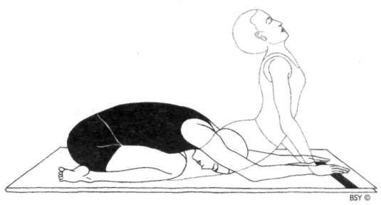

**Shashank Bhujangasana (striking cobra pose)**

Assume marjari-asana, placing the palms flat on the floor beneath the shoulders about half a metre apart.

Move into shashankasana with the arms outstretched in front of the shoulders.

Then, without moving the position of the hands, slowly move the chest forward, sliding it just above the floor until it is in line with the hands.

Move the chest further forward and then upward, as the arms straighten, and lower the pelvis to the floor.

Ideally, the nose and chest should just brush the surface of

the floor as the body moves forward like the movement of a snake. Do not strain to achieve this.

Try to bring the hips as near to the floor as possible.

In the final position, the arms should be straight, the back arched and the head raised as in bhujangasana. The navel does not touch the floor.

Hold this position for a few seconds, retaining the breath. Slowly raise the buttocks and move backwards, keeping the arms straight, returning to shashankasana.

Do not try to reverse the previous movement but keep the arms straight.

This is one round.

Relax the whole body for a short time before starting another round.

Practise 5 to 7 rounds.

**Breathing:** Inhale on the forward movement.

Hold the breath for a few seconds in the final position. Exhale while returning to shashankasana.

**Awareness:** Physical - on synchronising the movement with the breath.

Spiritual - on swadhisthana chakra.

**Sequence:** This asana may be practised directly after shashank• asana and followed by tadasana.

**Benefits:** Shashank bhujangasana gives similar benefits to bhujangasana and shashankasana. However, the benefits of the latter postures come from maintaining the final position, whereas shashank bhujangasana acts mainly by alternately flexing the spine backward and forward.

This asana gently tones the female reproductive organs, alleviates menstrual disorders and is an excellent post• natal asana, strengthening and tightening the abdominal and pelvic region. It tones and improves the functioning of the liver, kidneys and other visceral organs. It is particularly useful for relieving back pain and general stiffness of the spine as it helps to stimulate and balance all the spinal nerves.

**Practice note:** The hand position should not change through• out the entire practice.

PRANAMASANA

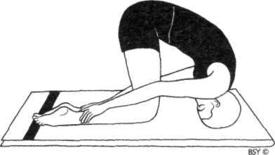

**Pranamasana (bowing pose)**

Sit in vajrasana. Grasp the lower calves just above the ankles, keeping the thumbs uppermost.

Slowly bend forward and place the crown of the head on the floor in front of the knees. (Place a small folded blanket under the head).

Raise the buttocks as high as possible, allowing the chin to press against the chest, until the thighs are as vertical as comfortable.

Remain in the final position for 5 to 20 seconds.

Lower the buttocks and come back into shashankasana for a short time before returning to vajrasana.

Practise this asana 5 times.

**Breathing:** Inhale in vajrasana and while raising the buttocks.

Exhale while lowering the head to the floor.

Hold the breath in the final position or breathe normally if remaining in the position for more than a few seconds. **Awareness:** Physical - on the synchronisation of breathing with the physical movement, the increased blood flow to the

brain or on the crown of the head in the final position. Spiritual - on sahasrara chakra.

**Contra-indications:** Not to be performed by people with vertigo, weak neck or high blood pressure.

**Benefits:** This asana increases the blood supply to the head. As a preparatory practice for sirshasana, the headstand

pose, it allows the brain to gradually adapt to the extra blood flow and pressure in the head when the body is inverted. It gives many of the benefits of sirshasana but to a lesser degree. Pranamasana is especially beneficial for the management of asthma. It promotes drainage of the lungs and chest and helps to open the air passages. It also decompresses the lower cervical and upper thoracic vertebrae and nerve roots which are often the seat of psycho-emotional tension in an asthma attack. It should be performed at the immediate onset of an asthma attack to obtain full benefits.

ARDHA USHTRASANA

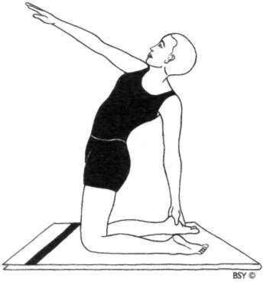

**Ardha Ushtrasana (half camel pose)**

Sit in vajrasana with the knees apart and the ankles at the side of the buttocks.

Stand up on the knees with the arms at the sides. Keep the feet flat behind the body.

While inhaling, stretch the arms sideways and raise them to shoulder level.

Then, while exhaling, twist to the right, reach back with the right hand and try to hold the left heel or ankle.

Simultaneously, stretch the left arm in front of the head so that the hand is at eyebrow level.

The head should be slightly back with the eyes gazing at the raised hand.

Push the abdomen forward in the final position and try to keep the thighs vertical.

Hold this position while holding the breath for a few seconds and retaining the gaze on the left hand.

Inhale and return to the starting position.

Repeat on the other side to complete one round, holding the right heel with the left hand.

Practise 3 to 5 rounds. Do not strain in any way.

**Awareness:** Physical - on the stretch in the back and neck, or on the normal breath if holding longer.

Spiritual - on anahata or vishuddhi chakra.

**Benefits:** As given for ushtrasana but at a reduced level.

**Variation I**: The final position may be held for 1 to 2 minutes whilst breathing normally, as long as there is no strain experienced.

**Variation *2:*** This is the same as the basic asana except the breathing changes. Inhale and come into the final posi• tion, hold the internal breath retention for a few seconds and then exhale while returning to the upright position. This is repeated in the same manner on the other side. This variation accentuates the effect on the abdomen whereas the basic asana accentuates the effect on the spine.

**Variation 3:** A simpler variation for beginners is to place the right hand on the right heel and the left hand on the left heel. This posture also becomes easier if the heels are raised.

**Variation 4:** After twisting, the outstretched arm may be raised above the head to a vertical position. The head should be held back with the eyes gazing at the raised hand.

USHTRASANA

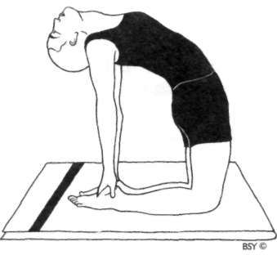

**Ushtrasana (camel pose)**

Sit in vajrasana.

Stand on the knees with the arms at the sides.

Th e knees and feet should be together but may be separated if this is more comfortable.

Lean backward, slowly reaching for the right heel with the right hand and then the left heel with the left hand.

Do not strain.

Push the abdomen forward, trying to keep the thighs vertical, and bend the head and spine backward as far as possible.

Try to relax the whole body, especially the back muscles, into the stretch.

The weight of the body should be evenly supported by the legs and arms.

The arms should anchor the shoulders to maintain the arch of the back.

Remain in the final position for as long as is comfortable. Return to the starting position by slowly releasing the hands from the heels one at a time.

**Breathing:** Normal in the final position. Do not try to breathe deeply because the chest is already stretched.

**Duration:** Practise up to 3 times as a dynamic asana.

Hold the final position up to 3 minutes as a static pose.

**Awareness:** Physical - on the abdomen, throat, spine or natural breathing.

Spiritual - on swadhisthana or vishuddhi chakra.

**Sequence:** It is important that this asana is followed by any forward bending asana, such as paschimottanasana, to release any tension in the back. The most convenient counterpose is shashankasana since it may be performed immediately from vajrasana without unnecessary body movement.

**Contra-indications:** People with severe back ailments such as lumbago should not attempt this asana without expert guidance. Those suffering from enlarged thyroid should also take care.

**Benefits:** This asana is beneficial for the digestive and repro• ductive systems. It stretches the stomach and intestines, alleviating constipation. The backward bend loosens up the vertebrae and stimulates the spinal nerves, relieving backache, lumbago, rounded back and drooping shoul• ders. The front of the neck is fully stretched, toning the organs in this region and regulating the thyroid gland.

**Practice note:** To accentuate the asana, the right heel may be grasped with the left hand and the left heel with the right hand.

To begin with this asana may be practised with the balls of the feet on the floor.

SUPTA VAJRASANA

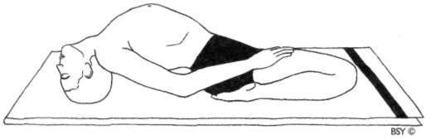

Supta Vajrasana (sleeping thunderbolt pose)

Sit in vajrasana. Slowly bend back, taking the support of first the right elbow and arm and then the left.

Bring the top of the head to the ground, arching the back. Place the hands on the thighs.

Try to keep the knees in contact with the floor. If necessary, separate the knees. Care should be taken not to strain the muscles and ligaments of the thighs and knees by forcing the knees to touch the ground in the final position.

Close the eyes and relax the body.

Breathe deeply and slowly in the final position.

Return to the starting position in the reverse order, breathing in and taking the support of the elbows and arms. Never leave the final position by straightening the legs first; this may dislocate the knee joints.

Return to vajrasana first and then straighten the legs.

**Breathing:** Deep and slow.

**Duration:** For physical benefits, up to one minute is sufficient.

For spiritual benefits, practise for longer periods. Beginners should start with only a few seconds in the final position, increasing the duration slowly.

**Awareness:** Physical - on the lower back, abdomen or breath. Spiritual - on swadhisthana, anahata or vishuddhi chakra. **Sequence:** Follow supta vajrasana with a forward bending asana. **Contra-indications:** This posture should not be practised by people suffering from sciatica, slipped disc, sacral ailments

or knee complaints.

**Benefits:** This asana massages the abdominal organs alleviat• ing digestive ailments and constipation. It tones the spinal nerves, makes the back flexible and realigns rounded shoulders. The nerves in the neck and the thyroid gland are particularly influenced. Th e chest is stretched and expanded to full capacity, filling the lungs and bringing more oxygen into the system. It is beneficial for those suffering from asthma, bronchitis and other lung ailments. It loosens up the legs in preparation for sitting in medit• ation asanas. It enhances creativity and intelligence and redirects sexual energy to the brain for spiritual purposes.

***Note:*** *The Sanskrit word* supta *means 'sleeping' and* vajra *refers to the nerve and energy pathway which connects the sexual organs to the brain.*

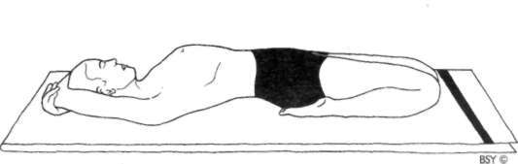

**Variation:** This method is the same as described for the basic form, except that the back of the head, instead of the top, is placed on the floor in the final position.

Join the hands together and place them under the back of the head, or fold the arms comfortably above the head. Try to keep the knees on the ground.

Close the eyes and relax the whole body.

**Breathing:** Deep and slow in the final position.

**Benefits:** This is an important variation which intensifies the stretch of the abdominal region.

**Practice note:** The basic form and the variation may be per• formed one after the other, spending half the time in each pose.

###### Standing Asanas

This series of asanas has a stretching and strengthening effect on the back, shoulders and leg muscles. They are particularly useful for those who spend a lot of time sitting down or who have stiffness or pain in the back. They improve posture, balance and muscular coordination. They also strengthen the muscles used to keep the back straight during meditation and increase oxygenation and lung capacity. Those who suffer from sciatica or slipped disc may practise hasta utthanasana, akarna dhanurasana and tadasana, but should not practise any of the other standing asanas except under the guidance of an experienced yoga teacher.

TADASANA

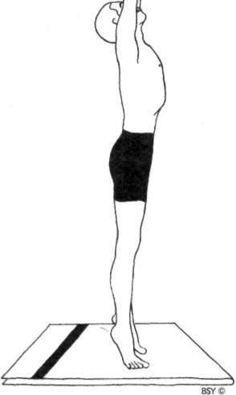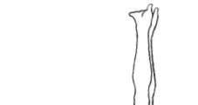

**Tadasana (palm tree pose)** Stand with the feet together or about 10 cm apart, and the arms by the sides.

Steady the body and distribute the weight equally on both feet.

Raise the arms over the head. Interlock the fingers and turn the palms upward.

Place the hands on top of the head.

Fix the eyes at a point on the wall slightly above the level of the head. Th e eyes should remain fixed on this point throughout the practice.

Inhale and stretch the arms, shoulders and chest upward. Raise the heels coming up onto the toes.

Stretch the whole body from top to bottom, without losing balance or moving the feet.

Hold the breath and the position for a few seconds.

At first it may be difficult to maintain balance but with practice it becomes easier.

Lower the heels while breathing out and bring the hands to the top of the head.

This is one round.

Relax for a few seconds before performing the next round. Practise 5 to 10 rounds.

**Breathing:** The breath should be synchronised with the raising and lowering of the arms.

**Awareness:** Physical - on the breathing, maintaining balance and the stretch of the whole body from top to bottom.

Spiritual - initially on mooladhara chakra to provide stability; once balance is achieved, change to ajna.

**Sequence:** Tadasana can be followed by any inverted asana.

**Benefits:** This asana develops physical and mental balance. The entire spine is stretched and loosened, helping to clear up congestion of the spinal nerves at the points where they emerge from the spinal column. Tadasana stretches the rectus abdomini muscles and the intestines and is useful during the first six months of pregnancy to keep the abdominal muscles and nerves toned.

**Variation I**: Tadasana may also be performed while gazing up at the interlocked fingers. It will be slightly more difficult to maintain balance in the final position.

**Variation 2:** Stand in tadasana with both arms overhead.

While balancing on the toes, lift one leg and extend it either forward or backward.

Repeat with the other leg. Practise 10 times.

**Practice note:** Those practitioners who have mastered tadasana with the eyes open may try it with the eyes closed.

***Note:*** *This is one of the asanas for shankhaprakshalana.*

TIRYAKA TADASANA

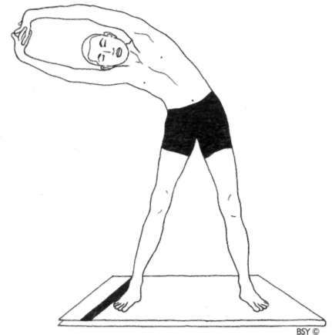

**Tiryaka Tadasana (swaying palm tree pose)**

Stand with the feet about 2 feet apart. Fix the gaze on a point directly in front.

Interlock the fingers and turn the palms outward. Inhale and raise the arms over the head.

While exhaling, bend to the left side from the waist. Do not bend forward or backward or twist the trunk.

Hold the position for a few seconds while retaining the breath outside.

Inhale and slowly come to the upright position. Repeat on the right side.

From the upright position, exhale while bringing the arms down to the sides.

This completes one round. Practise 5 to 10 rounds.

**Awareness:** Physical - on the breath synchronised with the movement, keeping balance, the stretch along the side of

the body, and keeping the body and head facing forward without twisting.

Spiritual - on mooladhara or manipura chakra.

**Benefits:** As for tadasana, but it especially massages, loosens and exercises the sides of the waist. It balances the right and left groups of postural muscles.

**Variation:** Balance on the toes in this practice. The fingers may be interlocked with the palms facing downward or turned upward.

***Note:*** *This is one of the asanas for shankhaprakshalana.*

KATI CHAKRASANA

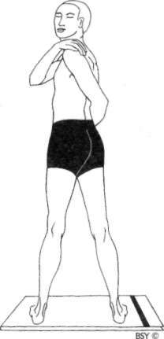

**Kati Chakrasana (waist rotating pose)**

Stand with the feet about half a metre apart and the arms by the sides.

Take a deep breath in while raising the arms to shoulder level. Breathe out and twist the body to the left.

Bring the right hand to the left shoulder and wrap the left arm around the back. Bring the left hand around the right side of the waist. Look over the left shoulder as far as possible.

Keep the back of the neck straight and imagine the top of the spine is the fixed point around which the head turns. Hold the breath for two seconds, accentuate the twist and try to gently stretch the abdomen.

Inhale and return to the starting position. Repeat on the other side to complete one round.

Keep the feet firmly on the ground while twisting.

Relax the arms and back as much as possible throughout the practice.

Do not strain. The movement should be relaxed and spontaneous.

Perform the rotation smoothly, without jerking or stiffness. Practise 5 to 10 rounds.

**Awareness:** On the breathing synchronised with the movement, and on the stretch of the abdomen and spinal muscles.

**Benefits:** This asana tones the waist, back and hips. It is useful for correcting back stiffness and postural problems. The relaxation and swinging movement induces a feeling of lightness and may be used to relieve physical and mental tension at any time during the day.

**Practice note:** This asana may be performed in a more dynamic way by swinging rhythmically with the arms without syn• chronising the movements with the breath.

***Note:*** *This is one of the asanas for shankhaprakshalana.*

UTTHITA LOLASANA

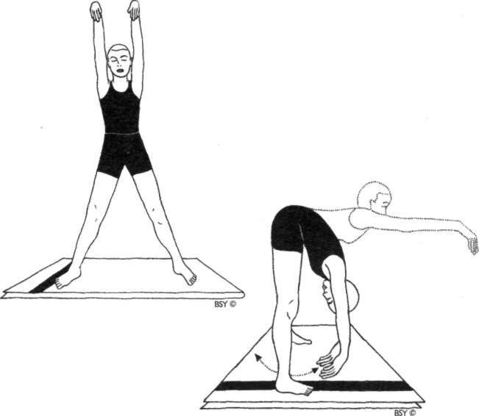

**Utthita Lolasana (swinging while standing pose)**

Stand erect with the feet a metre apart.

Raise the arms over the head keeping the elbows straight. Bend the wrists forward so that the hands hang limp.

Bend forward and swing the trunk down from the hips, allowing the arms and head to swing through the legs.

Be tension-free like a rag doll. On the upward swing, raise the trunk so that it is parallel to the floor.

On the downward swing bring the hands as far back as possible behind the feet.

After 5 complete swings return to the upright position with the arms raised, then lower the arms to the sides.

Repeat up to 5 times.

**Breathing:** Inhale fully through the nose while raising the arms and while returning to the upright position.

Exhale forcefully through the mouth on each downward swing to make sure all the stagnant air has been expelled from the lower lungs.

While swinging up, slight inhalation will be a minor reflex action only, but the main object is to empty the lungs totally on the down swing. For added effect, the sound 'ha' may be made with each forced exhalation. This sound should come from the abdomen and not the throat, so the movement of the diaphragm should be emphasised.

**Awareness:** On the movement of the diaphragm and breath, keeping the body loose and on the rhythmic swinging movement.

**Contra-indications:** Not to be practised by people who suffer from vertigo, high blood pressure or back conditions.

**Benefits:** This asana helps remove tiredness by stimulating the circulation and toning the spinal nerves. It stretches the hamstrings and back muscles, loosens the hips and mas• sages the visceral organs. It speeds up lymphatic flow in the major ducts and improves drainage, especially from the abdomen and the base of the lungs. This is an excellent pre-pranayama practice as it opens up all the alveoli and rebalances the ventilation-perfusion matching in the lungs. It has the added benefits of inverted asanas, especially on the brain.

###### Surya Namaskara

SALUTATIONS TO THE SUN

The Sanskrit name *surya* here refers to the sun and *namaskara* means 'salutations'. Surya namaskara has been handed down from the enlightened sages of the Vedic Age. The sun symbol• ises spiritual consciousness and , in ancient times, was worshipped on a daily basis. In yoga the sun is represented by pingala or surya nadi, the pranic channel which carries the vital, life-giving force.

This dynamic group of asanas is not regarded as being a traditional part of hatha yoga practices as it was added to the original asana group at a later time. However, it is an effective way of loosening up, stretching, massaging and toning all the joints, muscles and internal organs of the body. Its versatility and application make it one of the most useful methods of inducing a healthy, vigorous and active life while, at the same time, preparing for spiritual awakening and the resulting ex• pansion of awareness.

Surya namaskara is a complete *sadhana,* spiritual practice, in itself for it includes asana, pranayama, mantr a and meditation techniques. It is an excellent group of asanas with which to start morning practice. Surya namaskara has a direct vitalising effect on the solar energy of the body which flows through pingala nadi. Regular practice of surya namaskara regulates pingala nadi, whether it is under-active or over• active. Regulation of pingala nadi leads to a balanced energy system at both mental and physical levels.

Surya namaskara is composed of three elements: form, energy and rhythm. The twelve asanas are the physical matrix around which the form of the practice is woven. These asanas

generate prana, the subtle energy which activates the psychic body. Their performance, in a steady, rhythmic sequence, reflects the rhythms of the universe; the twenty-four hours of the day, the twelve zodiac phases of the year and the biorhythms of the body. The application of this form and rhythm to the body/mind complex generates the transforming force which produces a fuller and more dynamic life.

**Time of practice:** The ideal time to practise surya namaskara is at sunrise, the most peaceful time of day. Whenever possible, practise in the open air, facing the rising sun. Sunset is also a good time to practise as it stimulates the digestive fire. Surya namaskara, however, may be practised at any time provided the stomach is empty.

**Preparation:** Before commencing the practice, stand with the feet together or slightly apart, and the arms hanging loosely by the side of the body. Close the eyes gently and become aware of the whole physical body as one homogene• ous unit. In this position the body may sway from side to side or backward and forward. Try to minimise this oscillation and balance the body weight equally on both feet.

Bring the awareness inside the body and mentally begin to relax it. Starting from the top of the head, take the awareness systematically through all the parts, releasing any tension. Intensify, once more, the awareness of the whole physical body and feel in harmony with it.

Take the awareness to the soles of the feet in contact with the floor. Feel that the whole body is being pulled downwards by gravity and that any tensions are being pulled down, through the body and into the ground. At the same time, experience the vital force surging up from the earth and flooding the whole being.

Finally, take the awareness to the eyebrow centre and visu• alise a brilliant, red rising sun infusing the whole body and mind with its vitalising and healing rays. Imagine you are facing the early morning sunrise, about to practise surya namaskara with smooth synchronised movements, flowing into one another like a dance.

SURYA NAMASKARA

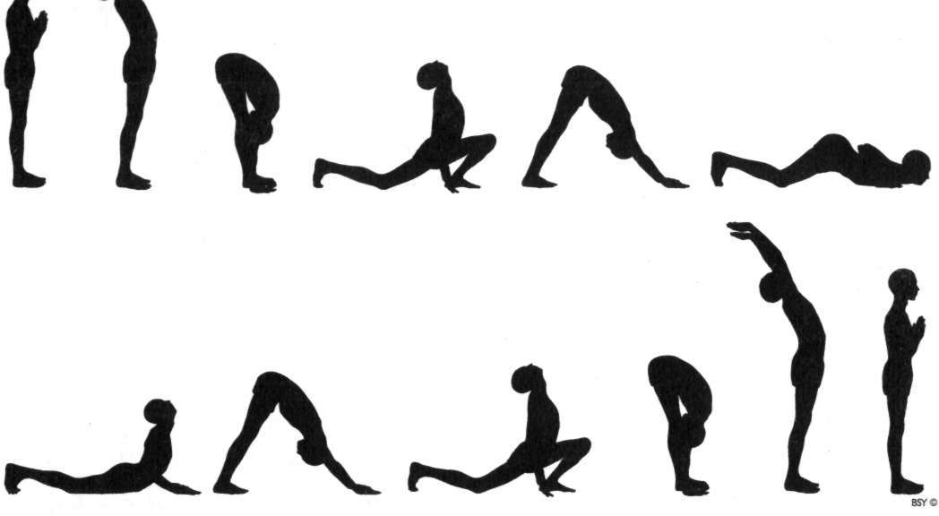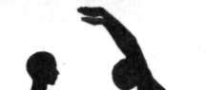

HASTA UTTHANASANA

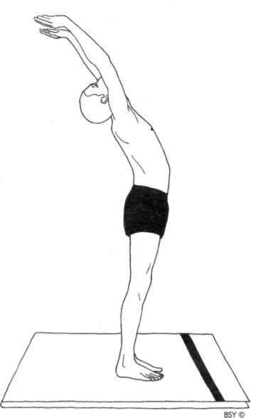

**Position 2: Hasta Utthanasana (raised arms pose)** Raise and stretch both arms above the head. Keep the arms separated, shoulder width apart. Bend the head, arms and upper trunk backward.

**Breathing:** Inhale while raising the arms.

**Awareness:** Physical - on the stretch of the abdomen and expansion of the lungs.

Spiritual - on vishuddhi chakra.

**Mantra:** *Om Ravaye Namaha,* salutations to the shining one.

**Benefits:** This pose stretches all the abdominal organs and improves digestion. It exercises the arm and shoulder muscles, tones the spinal nerves, opens the lungs and removes excess weight.

PADAHASTASANA

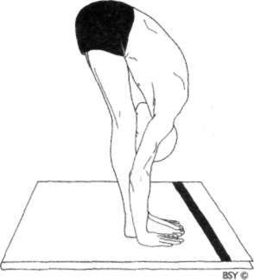

**Position 3: Padahastasana (hand to foot pose)**

Bend forward until the fingers or palms of the hands touch the floor on either side of the feet.

Try to touch the knees with the forehead. Do not strain.

Keep the knees straight.

**Breathing:** Exhale while bending forward.

Try to contract the abdomen in the final position to expel the maximum amount of air from the lungs.

**Awareness:** Physical - on the pelvic region.

Spiritual - on swadhisthana chakra.

**Mantra:** *Om Suryaya Namaha,* salutations to he who induces activity.

**Contra-indications:** People with back conditions should not bend forward fully. Bend from the hips, keeping the spine straight, until the back forms a ninety degree angle with the legs, or bend only as far as comfortable.

**Benefits:** This pose is useful in eliminating or preventing stomach or abdominal ailments. It reduces excess weight in the abdominal region, improves digestion and helps to remove constipation. It improves blood circulation, makes the spine supple and tones the spinal nerves.

ASHWA SANCHALANASANA

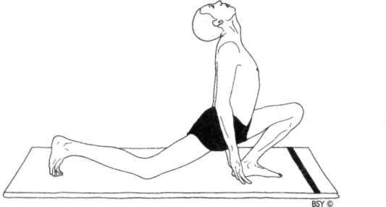

**Position 4: Ashwa Sanchalanasana (equestrian pose)**

Place the palms of the hands flat on the floor beside the feet.

Stretch the right leg back as far as possible.

At the same time, bend the left knee, keeping the left foot on the floor in the same position. Keep the arms straight. In the final position, the weight of the body should be supported on both hands, the left foot, right knee and toes of the right foot. The head should be tilted backward, the back arched and the inner gaze directed upward to the eyebrow centre.

**Breathing:** Inhale while stretching the right leg back.

**Awareness:** Physical - on the stretch from the thigh to the chest or on the eyebrow centre.

Spiritual - on ajna chakra.

**Mantra:** *Om Bhanave Namaha,* salutations to he who illumines. **Benefits:** This pose massages the abdominal organs and im• proves their functioning, strengthens the leg muscles and

induces balance in the nervous system.

**Practice note:** In the final pose the palms of the hands should be flat on the floor initially. Later on, more advanced practitioners may come up onto the fingertips.

PARVATASANA

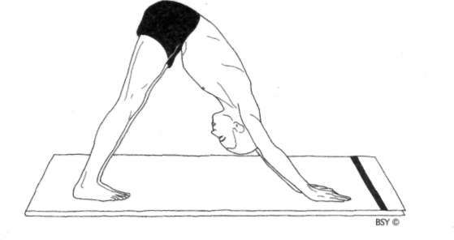

**Position 5: Parvatasana (mountain pose)**

Take the left foot back beside the right foot. Simultaneously, raise the buttocks and lower the head between the arms, so that the back and legs form two sides of a triangle.

The legs and arms should be straight in the final position. Try to keep the heels on the floor in the final pose and bring the head towards the knees.

Do not strain.

**Breathing:** Exhale while taking the left leg back.

**Awareness:** Physical - on relaxing the hips or on the throat region.

Spiritual - on vishuddhi chakra.

**Mantra:** *Om Khagaya Namaha,* salutations to he who moves quickly in the sky.

**Benefits:** This pose strengthens the nerves and muscles in the arms and legs. The spinal nerves are toned and circulation is stimulated especially in the upper spine, between the shoulder blades.

ASHTANGA NAMASKARA

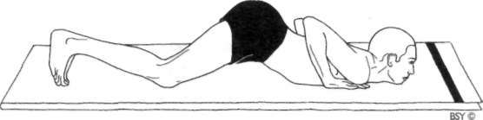

**Position 6: Ashtanga Namaskara (salute with eight parts or points)**

Lower the knees, chest and chin to the floor.

In the final position only the toes, knees, chest, hands and chin touch the floor. The knees, chest and chin should touch the floor simultaneously. If this is not possible, first lower the knees, then the chest, and finally the chin.

The buttocks, hips and abdomen should be raised.

**Breathing:** The breath is held outside in this pose. There is no respiration.

**Awareness:** Physical - on the abdominal region.

Spiritual - on manipura chakra.

**Mantra:** *Om Pushne Namaha,* salutations to the giver of strength. **Benefits:** This pose strengthens the leg and arm muscles, develops the chest and exercises the region of the spine

between the shoulder blades.

BHUJANGASANA

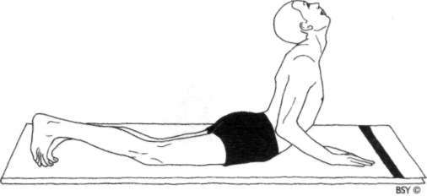

**Position 7: Bhujangasana (cobra pose)**

Lower the buttocks and hips to the floor,

Straightening the elbows, arch the back and push the chest forward into the cobra pose.

Bend the head back and direct the gaze upward to the eyebrow centre.

The thighs and hips remain on the floor and the arms support the trunk.

Unless the spine is very flexible the arms will remain slightly bent.

**Breathing:** Inhale while raising the torso and arching the back.

**Awareness:** Physical - on relaxation of the spine.

Spiritual - on swadhisthana chakra.

**Mantra:** *Om Hiranya Garbhaya Namaha,* salutations to the golden, cosmic self.

**Benefits:** This pose keeps the spine supple, improving circu• lation in the back region and toning the spinal nerves. It tones the reproductive organs, stimulates digestion and relieves constipation. It also tones the liver and massages the kidneys and adrenal glands.

**Position 8: Parvatasana (mountain pose)**

This stage is a repeat of position 5.

From bhujangasana assume parvatasana.

The hands and feet do not move from position 7. Raise the buttocks and lower the heels to the floor.

**Breathing:** Exhale while raising the buttocks.

**Awareness:** Physical - on relaxing the hips or on the throat region.

Spiritual - on vishuddhi chakra.

**Mantra:** *Om Marichaye Namaha,* salutations to the Lord of the Dawn.

**Position 9: Ashwa Sanchalanasana (equestrian pose)**

This stage is the same as position 4. Keep the palms flat on the floor.

Bend the left leg and bring the left foot forward between the hands.

Simultaneously, lower the right knee so that it touches the floor and push the pelvis forward.

Tilt the head backward, arch the back and gaze at the eyebrow centre.

**Breathing:** Inhale while assuming the pose.

**Awareness:** Physical - on the stretch from the thigh to the chest, or on the eyebrow centre.

Spiritual - on ajna chakra.

**Mantra:** *Om Adityaya Namaha,* salutations to the son of Aditi, the cosmic Mother.

**Position 10: Padahastasana (hand to foot pose)**

This position is a repeat of position 3.

Bring the right foot forward next to the left foot. Straighten both knees.

Bring the forehead as close to the knees as possible without straining.

**Breathing:** Exhale while performing the movement.

**Awareness:** Physical - on the pelvic region.

Spiritual - on swadhisthana chakra.

**Mantra:** *Om Savitre Namaha,* salutations to Lord of Creation.

**Position 11: Hasta Utthanasana (raised arms pose)**

This stage is a repeat of position 2.

Raise the torso and stretch the arms above the head. Keep the arms separated, shoulder width apart.

Bend the head, arms and upper trunk backward.

**Breathing:** Inhale while straightening the body.

**Awareness:** Physical - on the stretch of the abdomen and expansion of the lungs.

Spiritual - on vishuddhi chakra.

**Mantra:** *Om Arkaya Namaha,* salutations to he who is fit to be praised.

**Position 12: Pranamasana (prayer pose)**

This is the final position and is the same as position 1. Bring the palms together in front of the chest.

**Breathing:** Exhale while assuming the final position.

**Awareness:** Physical - on the region of the heart.

Spiritual - on anahata chakra.

**Mantra:** *Om Bhaskaraya Namaha,* salutations to he who leads to enlightenment.

**Positions 13-24:** The twelve positions of surya namaskara are practised twice to complete one round. Positions 1 to 12 constitute half a round. In the second half, the positions are repeated with two small changes:

* 1. In position 16, instead of stretching the right foot backward, stretch the left foot back.
  2. In position 21, bend the right leg and bring the right foot between the hands.

**Conclusion:** On the completion of each half round, lower the arms to the side, relax the body and concentrate on the breath until it returns to normal. After completing surya namaskara, practise shavasana for a few minutes. This will allow the heartbeat and respiration to return to normal and all the muscles to relax.

**Practice note:** In reference to position 4: when practising surya namaskara for general or therapeutic purposes, begin by placing the right leg back to activate pingala nadi as

described above; if practising for mental concentradon or for a more meditadonal effect, begin with the left leg which will activate ida nadi.

**Beeja mantras:** As an alternative to the twelve names of the sun, there is a series of *beeja mantras* or seed syllables. Beeja mantras do not have any literal meaning but set up powerful vibrations of energy within the mind and body. The beeja mantras are six in number and are repeated consecutively in the following order, four times during a complete round of surya namaskara:

* + 1. *Om Hraam* 4. *Om Hraim*
    2. *Om Hreem* 5. *Om Hraum*
    3. *Om Hroom* 6. *Om Hrah*

When surya namaskara is practised too fast to repeat the sun mantras, the beeja mantras may be used.

**Duration:** For spiritual benefits, practise 3 to 12 rounds slowly. For physical benefits, practise 3 to 12 rounds more quickly. Beginners should start with 2 or 3 rounds and add one more round every few weeks to avoid fatigue. Advanced students may practise a larger number of rounds, however, strain should be avoided at all times. In special cases, a daily practice of 108 rounds may be undertaken for purification, but only under expert guidance.

**Sequence:** Surya namaskara is ideally practised before other asanas.

**Contra-indications:** The practice of surya namaskara should be immediately discontinued if a fever, acute inflammation, boils or rashes occur. These may develop due to excess toxins in the body. When the toxins have been eliminated, the practice may be resumed.

Surya namaskara should not be practised by people suffering from high blood pressure, coronary artery diseases, or by those who have had a stroke, as it may over stimulate or damage a weak heart or blood vessel system. It should also be avoided in cases of hernia or intestinal tuberculosis.

People with back conditions should consult a medical expert before commencing this practice. Although some

back conditions may be alleviated by this practice, conditions such as slipped disc and sciatica will be better managed through an alternative asana programme.

During the onset of menstruation, this practice should be avoided. If there are no adverse effects, the practice may be resumed after the initial flow or towards the end of the period. During pregnancy it may be practised with care until the beginning of the twelfth week. Following child• birth, it may be commenced approximately forty days after delivery for re-toning the uterine muscles.

**General benefits:** The practice of surya namaskara as a whole gives a great number of benefits.

It stimulates and balances all the systems of the body, including the endocrine, circulatory, respiratory and digestive systems. Its influence on the pineal gland and the hypothalamus helps to prevent pineal degeneration and calcification. This balances the transition period between childhood and adolescence in growing children. Synchronising the breath with the physical movements of surya namaskara ensures that the practitioner, at least for a few minutes daily, breathes as deeply and rhythmically as possible. This removes carbon dioxide from the lungs and replaces it with fresh oxygen, increasing mental clarity by bringing fresh, oxygenated blood to the brain.

To conclude, surya namaskara is the ideal practice to increase awareness and bestow good health and wellbeing.

***Note:*** *For more information on this practice see the Bihar School of Yoga publication* Surya Namaskara: A Technique of Solar Revitalization.

###### Chandra Namaskara

SALUTATIONS TO THE MOON

The word *chandra* means 'moon'. Just as the moon, having no light of its own, reflects the light of the sun, so the practice of chandra namaskara reflects that of surya namaskara. The se• quence of asanas is the same as surya namaskara except that ardha chandrasana is performed after ashwa sanchalanasana. This posture develops balance and concentration which adds another dimension to the practice.

Whereas the twelve positions of surya namaskara relate to the twelve zodiac or solar phases of the year, the fourteen positions of chandra namaskara relate to the fourteen lunar phases. In the lunar calander the fourteen days before the full moon are known as *sukla paksha,* the bright fortnight, and the fourteen days after the full moon are known as *Krishna paksha,* the dark fortnight. The name of each day introduces each asana and is used as a basis for learning the days of the lunar cycle. (For more details see the Bihar School of Yoga publica• tion, *Swara Yoga: The Tantric Science of Brain Breathing).*

The lunar energy flows within ida nadi. It has cool, relaxing and creative qualities. Ida is the negative, introverted, feminine or mental force which is responsible for consciousness. Similarly, the lunar mantras ascribed to this practice are those which glorify Devi, the female or lunar aspect of divinity.

It is advisable to learn surya namaskara before attempting chandra namaskara as the postures are the same for both, except for one extra pose. In chandra namaskara the added pose, ardha chandrasana, is inserted in the sequence at posi• tions 5 and 11, in the first half of the round, and positions 19 and 25 in the second.

**Time of practice:** Chandra namaskara is best practised at night, especially when the moon is visible, or at dawn at the time of the full moon. Be aware of the different experiences given by the changing aspects of the moon. When practising at night ensure the stomach is empty.

**Preparation:** Before beginning chandra namaskara, a few moments should be allowed to prepare the body and mind.

Stand in the upright position with the feet together, the eyes closed and the arms at the sides. The weight of the body should be evenly distributed on both feet. Adjust the position if necessary. Try to observe any spontaneous movement of the body as it relaxes.

Gradually become more aware of the natural flow of the breath with each inhalation and exhalation. Then include awareness of the movement in the body with the rhythm of the breath. Retain this awareness for a few moments.

Slowly withdraw the awareness from the breath and become aware of *bhrumadhya,* the space between the eyebrows. Within this space, visualise the full moon in a clear night sky, shining brightly upon the waves of the ocean. The full reflection of the moon penetrates the deep waters and the cool shade of moonlight catches the tops of the waves as they dance. See the image clearly and develop awareness of any feelings or sensations that are created in the mind and body.

Slowly let the visualisation fade and again become aware of the whole body in the standing position.

**Practice:** The physical practice of the asana sequence is similar to surya namaskara. However, there is one extra asana, ardha chandrasana or the half moon pose, which emphasises the link with the lunar energies set up by the preparatory visualisations. Also, in chandra namaskara the force of each asana is changed subtly by the repetition of mantras related to the lunar energies.

In the chandra namaskara sequence of fourteen postures move from position 4, ashwa sanchalana, into ardha chandr• asana position 5, as described opposite. This posture is repeated at position 11.

ARDHA CHANDRASANA

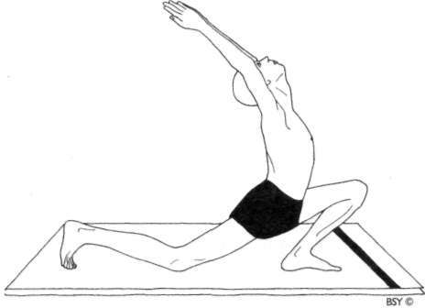

**Position 5: Ardha Chandrasana (half moon pose)** Maintaining balance, raise the hands and bring the palms together in front of the chest, forming namaskara mudra. Stretch both arms over the head, keeping the palms together. Arch the back and look up, raising the chin as high as possible.

There should be a gentle curve from the tips of the fingers to the tips of the toes, resembling a crescent moon.

Hold the pose for a short time.

Lower the hands to the chest in namaskara mudra, then, separating them, place the hands on each side of the left foot as in position 4.

**Breathing:** Inhale deeply while raising the arms, arching the back and bending the head back.

Retain the breath inside while lowering the arms or start exhalation while lowering the arms.

**Awareness:** Physical - on the smooth controlled movement and balance.

Spiritual - on swadhisthana chakra.

**Benefits:** This practice develops a sense of balance and gives a good stretch through the front of the body.

CHANDRA NAMASKARA

**1st day:** Prathama

**Position I: Pranamasana (prayer pose)**

**Mantra:** *Om Kamesvaryai Namaha,* salutations to she who fulfills desires.

**2nd day: Dwitiya**

**Position 2: Hasta Utthanasana (raised arms pose)**

**Mantra:** *Om Bhagamalinyai Namaka,* salutations to she who wears the garland of prosperity.

**3rd day: Tritiya**

**Position 3: Padahastasana (hand to foot pose)**

**Mantra:** *Om Nityaklinnayai Namaha,* salutations to she who is ever compassionate.

**4th day:** Chaturthi

**Position 4: Ashwa Sanchalanasana (equestrian pose)**

**Mantra:** *Om Bherundayai Namaha,* salutations to she who is ferocious.

**5th day:** Panchami

**Position 5: Ardha Chandrasana (half moon pose)**

**Mantra:** *Om Vahnivasinyai Namaha,* salutations to she who resides in fire.

**6th day:** Shastami

**Position 6: Parvatasana (mountain pose)**

**Mantra:** *Om Vajreshvaryai Namaha,* salutations to she who pos• sesses vajra, the thunderbolt, and is adorned with diamond ornaments.

**7th day:** Saptami

**Position 7: Ashtanga Namaskara (salute with 8 parts)**

**Mantra:** *Om Dutyai Namaha,* salutations to she whose messenger is Shiva.

**8th day:** Ashtami

**Position 8: Bhujangasana (cobra pose)**

**Mantra:** *Om Tvaritayai Namaha,* salutations to she who is swift.

**9th day: Navami**

**Position 9: Parvatasana (mountain pose)**

**Mantra:** *Om Kulasundaryai Namaha,* salutations to she who is virtuous, respectable and charming.

**10th day:** Dashami

**Position 10: Ashwa Sanchalanasana (equestrian pose)**

**Mantra:** *Om Nityayai Namaha,* salutations to she who is eternal.

**IIth day:** Ekadashi

**Position 11: Ardha Chandrasana (half moon pose)**

**Mantra:** *Om Nilapatakinyai Namaha,* salutations to she who is adorned with a blue flag.

1**2th day:** Dwadashi

**Position 12: Padahastasana (hand to foot pose)**

**Mantra:** *Om Vijayayai Namaha,* salutations to she who is ever victorious.

1**3th day:** Tryaodashi

**Position 13: Hasta Utthanasana (raised arms pose)**

**Mantra:** *Om Sarvamangalayai Namaha,* salutations to she who is the source of all good fortunes.

**14th day:** Chaturdashi

**Position 14: Pranamasana (prayer pose)**

**Mantra:** *Om Jvalamalinyai Namaha,* salutations to she who is fenced with instant flames.

**Positions 15-28:** Positions 1-14 form the first half of the round and positions 15-28 form the second. In the second half, the same positions are repeated with the following changes:

1. in position 18, ashwa sanchalanasana, instead of stretching the right foot backward, the left leg is stretched back first.
2. in position 24, the same pose, the left knee is bent and the right foot is brought forward in between the hands. After completion of one whole round there is a cross over in the leg positions of these stages, creating a balanced

effect in the body.

**Conclusion:** After completing the desired number of rounds, stand upright with the eyes closed, the hands by the sides of the body and again visualise the full moon shining over the waves of the ocean until the body becomes steady. Relax in shavasana.

**Duration:** For spiritual benefits, slowly practise 3 to 7 rounds. In position 4, take the left leg back first to activate ida nadi.

For physical benefits, practise 3 to 12 rounds more quickly. **Awareness:** Physical - on synchronising the movement with the breath and on the different parts of the body mentioned

while holding each position.

Spiritual - on coordinating the movement with the breath and on the appropriate chakra while holding each position.

**Sequence:** Chandra namaskara is ideally practised before doing other asanas.

**Other details:** As given for surya namaskara.

**Variations:** In the practices of chandra namaskara and surya namaskara, some people find it very difficult to move into the position of ashtanga namaskara and from there into bhujangasana. The following variations give alternatives:

**Variation I:** Instead of performing ashtanga namaskara, bring the knees to the floor and practise shashankasana.

Then, raising the buttocks slightly, slide the body along the floor and move into bhujangasana.

**Variation 2:** This is a gentle alternative to ashtanga namaskara and bhujangasana suitable for older people and those unable to bend the spine to the extent these postures require.

Instead of ashtanga namaskara, drop the knees to the floor coming into the position of marjari-asana, the cat pose.

Instead of bhujangasana, move the hips forward and down towards the floor, straightening the legs. The arms can be kept straight if necessary to support the body. Move the chest forward and bend the head back as far as comfortable.

## Asana

### Intermediate Group

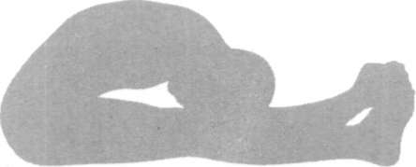

Backward Bending Asanas

Backward bending asanas are postures which turn the body out to face the world. They are stimulating and extroverting. Because they expand the chest and encourage inhalation, they are associated with the attitude of embracing life. They are also dynamic postures which move counter to gravity and, therefore, require strength and energy to perform.

Some people are known to bend over backwards to please others and these people often have the same ability on the physical level. Those who have difficulty in bending backwards, may be frightened to face life and give of themselves with love. These common fears are instinctual or due to unpleasant past experiences. This psychic stiffness dampens spontaneity and adversely affects the external personality. It translates itself via the brain and nervous system into the body and is called 'body armour'. Backward bending asanas break down this body armour. Their effects reach far into the depths of the mental and psychic bodies, helping to remould and reshape the personality.

On a physical level, the backward bending asanas stretch the abdominal muscles and tone and strengthen the muscles controlling the spine, helping prevent slipped disc and other back conditions. The spinal nerves, which emerge from between the adjoining vertebrae, are also toned. This has beneficial repercussions throughout the body since these nerves give energy to all the other nerves, organs and muscles in the body. The spinal column is a 'stacked pile' of vertebrae and discs.

Groups of muscles extend all along it, covering and support• ing it from all sides. Maintenance of the spine in a straight

and aligned position, despite all movement, depends totally on the balanced, supportive contraction and tone of the mus• cles. The muscles themselves are controlled unconsciously through posture.

Subconscious tensions and 'hang-ups' are often reflected in the tonic activity of the back muscles, resulting in too hard or too lax zones instead of homogeneous consistency. Recent research has shown that 90% of backache has its origin in muscular imbalance. If these imbalances are prolonged then the 'stack pile' of the vertebral column is disaligned, the ligaments are strained and symptoms of spondylitis, slipped disc, sciatica and osteoarthritis begin to manifest.

Th e practice of backward bending asanas can correct postural defects and neuromuscular imbalances of the verte• bral column. As with all asanas it is important to perform these practices with proper control and synchronisation of the breath so that the whole group of muscles is uniformly contracted.

Impure blood has a tendency to accumulate in the back region where circulation tends to be sluggish due to continu• ous maintenance of an upright position. These asanas help to circulate, purify and enrich the blood in this region.

Backward bending asanas create a negative pressure in the abdomen and pelvis, helping neuro-circulatory toning of all the related organs. They also massage the abdomen and pelvic organs by stretching the muscles in this area, especially the rectus abdomini.

SPHINX ASANA

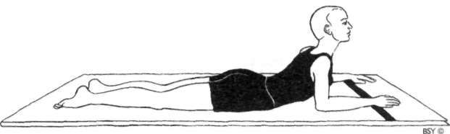

Sphinx asana

Lie flat on the stomach with the forehead resting on the floor, the legs straight, feet together, and the soles of the feet uppermost.

Bend the arms and place the forearms on the floor with the palms downward on each side of the head. The fingertips point forward but are in line with the crown of the head. The forearms and elbows are close to the body. Relax the whole body.

Raise the head, shoulders and chest by bringing the upper arms to the vertical position.

The elbows, forearms and hands will remain on the floor. Relax in the position for a comfortable length of time and then slowly lower the body.

This is one round.

**Breathing:** Inhale while raising the head, shoulders and chest.

Exhale while lowering to the floor. Breathe normally in the final position.

**Duration:** Hold the position for 3 to 4 minutes as a static pose or practise up to 5 rounds as a dynamic pose.

**Awareness:** Physical - on the breath and relaxing the back.

Spiritual - on swadhisthana chakra.

**Sequence:** A good preparatory pose for bhujangasana.

Follow with a forward bending asana.

**Benefits:** The benefits of this asana are the same as for bhujang• asana but at a reduced level. It is especially good for stiff backs and those with acute backache or slipped disc may relax in it for as long as they are comfortable.

BHUJANGASANA

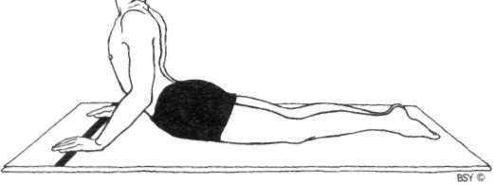

**Bhujangasana (cobra pose)**

Lie flat on the stomach with the legs straight, feet together and the soles of the feet uppermost.

Place the palms of the hands flat on the floor, below and slightly to the side of the shoulders.

The fingers should be together and pointing forward. The arms should be positioned so that the elbows point backward and are close to the sides of the body.

Rest the forehead on the floor and close the eyes. Relax the whole body, especially the lower back.

Slowly raise the head, neck and shoulders. Straightening the elbows, raise the trunk as high as possible. Use the back muscles more than the arm muscles.

Be aware of using the back muscles first while starting to raise the trunk. Then use the arm muscles to raise the trunk further and arch the back. Gently tilt the head backward, so that the chin points forward and the back of the neck is compressed.

In the final position, the pubic bone remains in contact with the floor and the navel is raised a maximum of 3 cm. If the navel is raised too high, the bend tends to be in the knees and not in the back.

The arms may or may not be straight; this will depend on the flexibility of the back.

Hold the final position.

To return to the starting position, slowly bring the head forward, release the upper back by bending the arms,

lower the navel, chest, shoulders and finally the forehead to the floor. Relax the lower back muscles.

This is one round.

**Breathing:** Inhale while raising the torso.

Breathe normally in the final position or retain the breath if the pose is held for a short time.

Exhale while lowering the torso.

**Duration:** Practise up to 5 rounds, gradually increasing the length of time in the final position.

**Awareness:** Physical - on synchronising the breath with the movement and the smooth, systematic arching movement of the back.

Spiritual - on swadhisthana chakra.

**Sequence:** This asana gives maximum benefits if preceded or followed by a forward bending asana. It may also be performed in conjunction with shalabhasana and dhanur- asana for effective general health of the back and spine.

**Contra-indications:** People suffering from peptic ulcer, hernia, intestinal tuberculosis or hyperthyroidism should not practise this asana without expert guidance.

**Benefits:** This asana can relocate slipped disc, remove backache and keep the spine supple and healthy. A stiff spine interferes with all nervous impulses sent from the brain to the body and vice versa. By arching the spine, improving circulation in the back region and toning the nerves, better communication between the brain and body results.

This asana tones the ovaries and uterus, and helps alleviate menstrual and other gynaecological disorders. It stimulates the appetite, alleviates constipation and is beneficial for all the abdominal organs, especially the liver and kidneys. The adrenal glands, situated on top of the kidneys, are also massaged and stimulated to work more efficiently. The secretion of cortisone is maintained and the thyroid gland is regulated.

On a pranic level, bhujangasana has a strong effect on all the organs related to swadhisthana, manipura, anahata and vishuddhi chakras.

TIRYAKA BHUJANGASANA

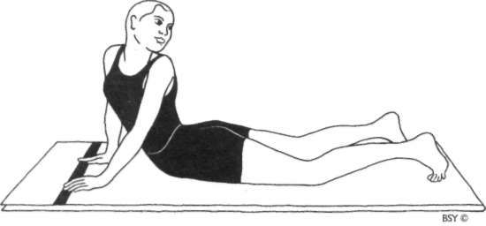

**Tiryaka Bhujangasana (twisting cobra pose)**

Assume the final position of bhujangasana with the legs separated about half a metre. The toes should be tucked under and the heels raised, so that the foot rests on the ball of the foot.

The head should be facing forward instead of bending backward as in bhujangasana.

Twist the head and upper portion of the trunk, and look over the left shoulder.

Gaze at the heel of the right foot.

In the final position, the arms remain straight or slightly bent as the shoulders and trunk are twisted.

Try to feel a diagonal stretch of the abdomen.

Relax the back and keep the navel as close to the floor as possible.

Stay in the final position for a few seconds.

Face forward again and repeat the twist on the other side without lowering the trunk.

Return to the centre and lower the body to the floor. This is one round.

**Breathing:** Inhale while raising.

Retain the breath inside while twisting to both sides. Exhale while lowering to the floor.

**Duration:** Practise 3 to 5 rounds.

**Awareness:** Physical - on the stretch of the muscles of the back and intestines.

Spiritual - on swadhisthana chakra.

**Benefits:** As for bhujangasana, with increased influence on the intestines.

***Note:*** *The word* tiryaka *means 'diagonal' or 'triangular' and is used because the gaze is directed over the shoulder diagonally across the back of the body to the opposite heel. The direction of the gaze also forms two sides of a triangle, while the width between the shoulders forms the base or third side.*

*In this asana, when performed as part of the shankhaprakshalana series, the breath is exhaled when twisting to the side.*

POORNA BHUJANGASANA

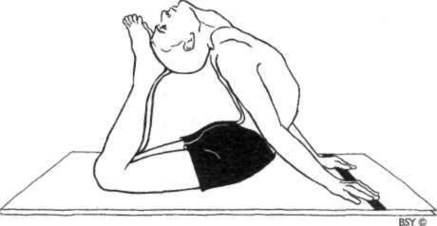

**Poorna Bhujangasana (full cobra pose)**

Assume bhujangasana. Holding the position, breathe in and out normally a few times.

Bend the knees and raise the feet.

Stretch the head, neck and shoulders back a little further and try to touch the back of the head with the toes or with the soles of the feet.

This is the final position.

Hold the final position for as long as is comfortable.

To return to the starting position, lower the feet. Relax in bhujangasana for a few moments.

Release the pose and relax with the arms by the side of the body and the head turned to one side.

This is one round.

**Breathing:** Inhale while assuming bhujangasana.

Exhale while raising the feet to touch the head with the toes.

Breathe normally in the final position.

Exhale while returnin g to bhujangasana and while returning to the prone position.

**Duration:** Up to 3 rounds, gradually extending the duration in the pose.

**Awareness:** Physical - on synchronising the breath with the movement, relaxing the spine and the stretch in the abdominal and chest areas. After completing each round, allow the respiration and heart beat to return to normal. Spiritual - on swadhisthana chakra.

**Sequence:** This asana gives maximum benefits if preceded or followed by a forward bending asana.

**Practice note:** This variation is only suitable for adepts or children over the age of 12 with very supple backs.

**Benefits:** As for bhujangasana with increased levels.

ARDHA SHALABHASANA

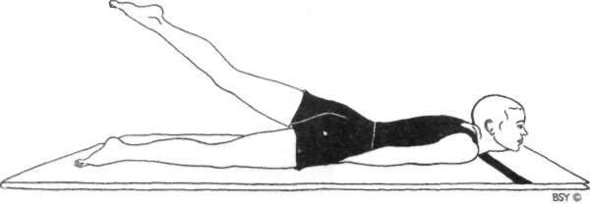

**Ardh a Shalabhasana (half locust pose)**

Lie flat on the stomach with the hands under the thighs, palms downwards or hands clenched.

Keep both the legs straight throughout the practice. Place the chin on the floor, slightly stretched forward, to give the best possible stretch to the neck muscles and nerves.

Using the back muscles, raise the left leg as high as possible, keeping the other leg straight, relaxed and in contact with the floor.

Retain the position for as long as is possible without strain. Do not tilt or twist the pelvis.

Lower the leg to the floor.

Repeat the same movement with the right leg. This is one round.

**Breathing:** Inhale in the starting position.

Retain the breath inside while raising the leg and in the final position.

Exhale while lowering the leg to the starting position.

**Duration:** Up to 5 rounds when performed dynamically. Up to 3 rounds when performed statically.

**Awareness:** As for shalabhasana with reduced effects.

**Benefits:** Ardha shalabhasana is recommended in yoga therapy for the management of sciatica and slipped disc if it can be performed without pain. It also alleviates constipation.

**Practice note:** The left leg should be raised first so that pressure is applied on the right side of the abdomen to massage the ascending colon of the large intestine, following the direction of intestinal peristalsis.

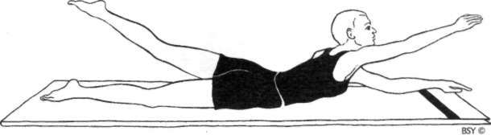

**Variation:** Lie on the stomach with the legs and feet together and the forehead touching the floor.

Stretch both arms above the head in advasana. Place the chin on the floor.

Keep the arms and legs straight throughout the practice. Simultaneously, raise the left leg, the head and right arm as high as possible.

The left leg should be stretched backwards and the right arm stretched forward as they are raised.

Retain the position for as long as possible without straining.

Lower the leg, head and arm to the starting position. Relax in advasana, allowing the respiration to return to normal.

Repeat the same movement with the right leg and left arm.

This is one round.

**Breathing:** Inhale while raising the leg, arm and head.

Retain while holding the position.

Exhale while lowering the leg, arm and head to the starting position.

**Duration:** Up to 5 rounds.

**Awareness:** Physical - on synchronising the breath with the movement and on the diagonal stretch through the body from the tips of the toes of the raised leg to the fingertips of the opposite hand.

Spiritual - on swadhisthana chakra.

**Benefits:** This asana is beneficial for beginners with weak and stiff backs as it helps to tone the back muscles and stimulate the nerves, particularly in the lower back, while simulta• neously giving a strong diagonal stretch to the body. It develops concentration through awareness of coordination of movement with breath.

SHALABHASANA

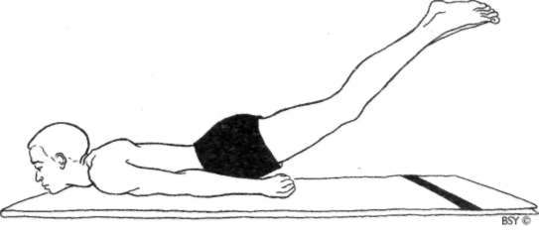

**Shalabhasana (locust pose)**

Lie flat on the stomach with the legs and feet together and the soles of the feet uppermost.

The arms may be placed either under the body or by the sides, with the palms downward or the hands clenched. Stretch the chin slightly forward and rest it on the floor throughout the practice.

Close the eyes and relax the body. This is the starting position.

Slowly raise the legs as high as possible, keeping them straight and together.

The elevation of the legs is produced by applying pressure with the arms against the floor and contracting the lower back muscles.

Hold the final position for as long as is comfortable without strain.

Slowly lower the legs to the floor. This is one round.

Return to the starting position and relax the body with the head turned to one side.

Allow the respiration and heart beat to return to normal.

**Breathing:** Inhale deeply in the starting position.

Retain the breath inside while raising the legs and holding the position. Exhale while lowering the legs.

Beginners may find it helpful to inhale while raising the legs.

Advanced practitioners may exhale after returning to the starting position.

**Duration:** Up to 5 rounds when performed dynamically. Up to 3 rounds when performed statically.

**Awareness:** Physical - on synchronising the breath with the movement or on the lower back, abdomen and heart.

Spiritual - on vishuddhi chakra.

**Sequence:** Most beneficial when performed after bhujangasana and before dhanurasana.

**Contra-indications:** Shalabhasana requires a great deal of physical effort, so it should not be practised by people with a weak heart, coronary thrombosis or high blood pressure. Those suffering from peptic ulcer, hernia, intes• tinal tuberculosis and other such conditions are also advised not to practise this asana.

**Benefits:** The parasympathetic nerves are particularly prom• inent in the regions of the neck and pelvis. Shalabhasana stimulates the whole autonomic nervous system, especially the parasympathetic outflow. It strengthens the lower back and pelvic organs, and tones the sciatic nerves, providing relief for those with conditions such as backache, mild sciatica and slipped disc as long as the condition is not serious. It tones and balances the functioning of the liver and other abdominal organs, alleviates diseases of the stomach and bowels, and stimulates the appetite.

SARAL DHANURASANA

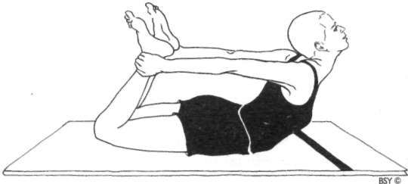

**Saral Dhanurasana (easy bow pose)**

Lie flat on the stomach with the legs and feet together, and the arms and hands beside the body.

Bend the knees and bring the heels close to the buttocks. Grasp the ankles with the hands.

Keep the knees and thighs firmly on the ground and the arms straight throughout the practice.

Place the chin on the floor. This is the starting position.

Tense the legs and try to push the feet backwards while raising the head and chest as high as possible from the

floor. Use the backward movement of the legs to assist the raising of the body, allowing the back muscles to remain passive.

In the final position the head is tilted back.

Hold the final position for as long as is comfortable. Slowly lower the chest and head to the ground by releasing the legs.

Relax in the prone position until the respiration returns to normal.

This is one round.

**Breathing:** Inhale deeply in the starting position.

Retain the breath inside while raising the body. Breathe deeply and slowly in the final position. Exhale while returning to the starting position.

**Awareness:** Physical - on the abdominal or back regions or on deep breathing in the final position.

Spiritual - on vishuddhi or anahata chakra.

**Sequence:** This is a good preparatory asana for beginners and also for those with stiff backs who are unable to perform dhanurasana.

**Benefits:** The same as for dhanurasana but at decreased levels. This posture is recommended as therapy for lower back pain due to slipped disc or cervical spondylitis when it can be performed without discomfort. It tones the heart and lungs, and is beneficial for all respiratory disorders.

DHANURASANA

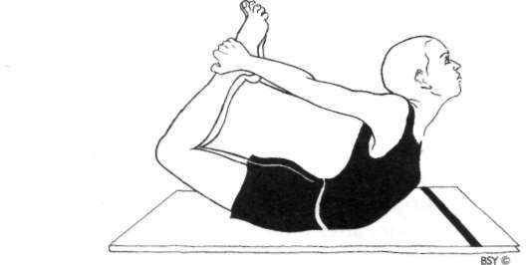

**Dhanurasana (bow pose)**

Lie flat on the stomach with the legs and feet together, and the arms and hands beside the body.

Bend the knees and bring the heels close to the buttocks. Clasp the hands around the ankles.

Place the chin on the floor. This is the starting position.

Tense the leg muscles and push the feet away from the body. Arch the back, lifting the thighs, chest and head together.

Keep the arms straight.

In the final position the head is tilted back and the abdomen supports the entire body on the floor. The only muscular contraction is in the legs; the back and arms remain relaxed.

Hold the final position for as long as is comfortable and then, slowly relaxing the leg muscles, lower the legs, chest and head to the starting position.

Release the pose and relax in the prone position until the respiration returns to normal.

This is one round.

**Breathing:** Inhale deeply in the starting position.

Retain the breath while raising the body.

Retain the breath inside in the final position or practise

slow, deep breathing so that the body rocks gently in unison with the breath.

Exhale while returning to the prone position.

**Duration:** 3 to 5 rounds.

**Awareness:** Physical - on the abdominal region, the back, or the rhythmic expansion and contraction of the abdomen to the slow, deep breathing.

Spiritual - on vishuddhi, anahata or manipura chakra.

**Sequence:** Dhanurasana is ideally practised after bhujangasana and shalabhasana and should be followed by a forward bending posture. It should not be practised until at least three or four hours after a meal.

**Contra-indications:** People who suffer from a weak heart, high blood pressure, hernia, colitis, peptic or duodenal ulcers should not attempt this practice. This asana should not be practised before sleep at night as it stimulates the adrenal glands and the sympathetic nervous system.

**Benefits:** The entire alimentary canal is reconditioned by this asana. Th e liver, abdominal organs and muscles are massaged. The pancreas and adrenal glands are toned, balancing their secretions. The kidneys are massaged and excess weight is reduced around the abdominal area.

This leads to improved functioning of the digestive, eliminative and reproductive organs and helps to remove gastrointestinal disorders, dyspepsia, chronic constipation and sluggishness of the liver.

It is recommended in yoga therapy for the management of diabetes, incontinence, colitis, menstrual disorders and, under special guidance, cervical spondylitis. It improves blood circulation generally. The spinal column is realigned and the ligaments, muscles and nerves are given a good stretch, removing stiffness. It helps correct hunching of the thoracic area of the spine.

Dhanurasana is useful for relieving various chest ailments, including asthma, and for freeing nervous energy in the cervical and thoracic sympathetic nerves, generally improv• ing respiration.

###### Forward Bending Asanas

Generally speaking, forward bending is a passive process in which gravity is utilised to stretch the muscle groups being focused upon. While backward bends move the body away from the confines of gravity, forward bending asanas use gravity to help release tension and pain. It is a process of introversion, counteracting the extroversion and dynamic opening up of bending backwards. Forward bending, asso• ciated with chest compression and exhalation, induces relaxation.

Many people lead sedentary lifestyles with little or no exercise and, as a result, the body becomes stiff and unable to bend forward. City living encourages mental tension and physical rigidity both of which are counteracted by forward bending asanas. At another level, forward bending is associ• ated with bowing and humility. An inability to bend forward may indicate a stiff, proud or stubborn personality. Difficulty bending forward is also associated with fear. Human beings face forward to see the world. The place behind us, however, is defined by obscure sounds, smells and sensations, and it is necessary to turn around to be sure of what is taking place. Some people live in constant fear of attack from behind and the backs of their bodies unconsciously freeze. Forward bend• ing asanas release this rigidity.

Forward bending asanas loosen up the back, maintaining good health and increasing vitality. These practices move the spine into the position known as the primary curve, the shape it takes in the womb. During a forward bending asana each of the vertebra is separated, stimulating the nerves, improving

circulation around the spine and nourishing the spinal cord. This has a positive impact on the organs of the body generally and on the brain specifically. This group of asanas is also very important for making the back muscles supple and strong, compressing and massaging the abdominal organs, including the liver, kidneys, pancreas and intestines, and stretching the leg muscles and tendons.

Most forward bending asanas described in this book start by bending from the hips and not the waist. Bending from the hips gives greater flexibility of movement and creates a stronger pressure against the abdomen. Care must be taken not to force the back to bend further forward than present flexibility will allow; rather, the muscles should be relaxed, allowing gravity and exhalation to move the body. With regular prac• tice, even the most rigid back will develop increased flexibility. It is not necessary to practise all the forward bending asanas one after the other. Start with the preliminary practices and gradually build up to the more advanced ones as the back becomes more flexible. People with any kind of back condition and those suffering from backache should consult a doctor

before practising these asanas.

When practising forward bending asanas from a sitting position, particularly those in which the legs are separated, it is helpful to sit with the perineum on the floor, rather than on the coccyx. The correct position is obtained by sitting with the legs slightly separated and placing the hands on the floor, on either side of the hips, with the fingertips pointing forward. Then, using the arms and hands as supports, lift the buttocks slightly from the floor and, while lowering them, try to tilt the pelvis forward.

SAITHALYASANA

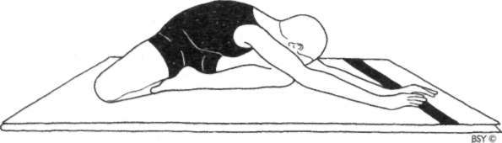

Saithalyasana (animal relaxation pose)

Sit on the floor with the legs outstretched.

Carefully bend the right knee and place the sole of the foot against the inside of the left thigh.

Bend the left knee and place the left heel to the outside of the left buttock.

Turn the torso to the right and rest the hands on the right knee.

Raise the arms above the head, keeping them straight and shoulder width apart.

Bend forward over the right knee bringing the forehead to the floor.

Relax in the position.

To return to the starting position, raise the arms and trunk in one straight line, then lower the hands to the right knee.

Practise 5 times on the right side, then change legs and repeat 5 times on the left side.

**Breathing:** Inhale while raising the arms.

Exhale while bending forward. Breathe normally in the final position.

Inhale while returning to the upright position. Exhale while lowering the arms.

**Awareness:** Physical - on synchronisation of the movement with the breath and relaxation of the back.

Spiritual - on manipura chakra.

**Sequence:** This is a preparatory practice for meditation poses and may precede any backward bending asana such as bhujangasana, saral dhanurasana or dhanurasana which particularly stretch the neck and pelvic region in the opposite direction.

**Contra-indications:** People who have lower back conditions should only bend forward as far as is comfortable.

**Benefits:** This asana stretches the back, pelvic region, insides of the thighs and opens up the hip joints. It balances the nervous system. It also massages the abdominal organs by gently compressing each side alternately against the thighs.

PASCHIMOTTANASANA

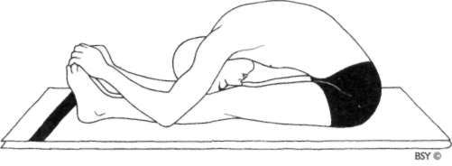

**Paschimottanasana (back stretching pose)**

Sit on the floor with the legs outstretched, feet together and hands on the knees.

This is the starting position. Relax the whole body.

Slowly bend forward from the hips, sliding the hands down the legs. Try to grasp the big toes with the fingers and thumbs. If this is impossible, hold the heels, ankles or any part of the legs that can be reached comfortably. Move slowly without forcing or jerking.

Hold the position for a few seconds. Relax the back and leg muscles allowing them to gently stretch.

Keeping the legs straight and utilising the arm muscles, not the back muscles, begin to bend the elbows and gently bring the trunk down towards the legs, maintaining a firm grip on the toes, feet or legs.

Try to touch the knees with the forehead. Do not strain. This is the final position.

Hold the position for as long as is comfortable and relax. Slowly return to the starting position.

This is one round.

**Breathing:** Inhale in the starting position. Exhale slowly while bending forward. Inhale in the static position.

Exhale while bringing the trunk further towards the legs with the arms.

Breathe slowly and deeply in the final position or retain the breath out if holding for a short duration.

Inhale while returning to the starting position.

**Duration:** Beginners should perform up to 5 rounds, staying in the final position for only a short length of time. Adepts may maintain the final position for up to 5 minutes.

**Awareness:** Physical - on the abdomen, relaxation of the back muscles or the slow breathing process.

Spiritual - on swadhisthana chakra.

**Sequence:** This asana should precede or follow backward bending asanas such as setuasana, chakrasana, bhujang- asana or matsyasana.

**Contra-indications:** People who suffer from slipped disc or sciatica should not practise paschimottanasana.

**Benefits:** This asana stretches the hamstring muscles and increases flexibility in the hip joints. It tones and massages the entire abdominal and pelvic region including the liver, pancreas, spleen, kidneys and adrenal glands. It removes excess weight in this area and helps alleviate disorders of the uro-genital system. It stimulates circulation to the nerves and muscles of the spine. It is used in yoga therapy for the management of prolapse, menstrual disorders, sluggish liver, diabetes, colitis, kidney complaints, bron• chitis and eosinophilia.

GATYATMAK PASCHIMOTTANASANA

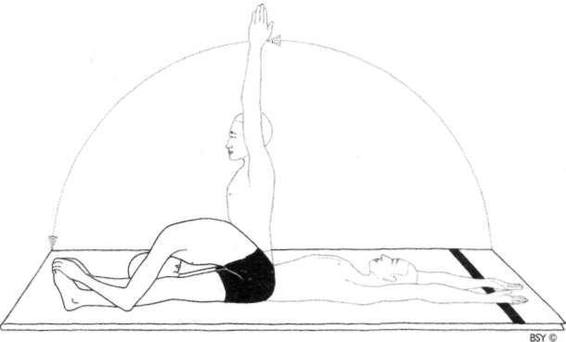

**Gatyatmak Paschimottanasana (dynamic back stretch pose)** Lie flat on the back with the feet together. Raise the arms over the head and bring them to the floor with the palms facing up.

This is the starting position. Relax the whole body.

Raise the trunk to the sitting position with the arms straight above the head and the spine straight.

Bend forward into paschimottanasana in a smooth movement.

Hold the final position for a short time.

Return to the sitting position with the arms straight above the head.

Lean backwards and return to the starting position. This is one round.

Practise up to 10 rounds.

**Breathing:** Breathe normally in the starting position.

Inhale while coming into the sitting position.

Exhale while bending forward into paschimottanasana. Inhale while sitting up.

Exhale while returning to the starting position.

**Awareness:** Physical - on synchronising the movement with the breath.

Spiritual - on swadhisthana chakra.

**Contra-indications:** As for paschimottanasana.

**Benefits:** The benefits are the same as for paschimottanasana although at a reduced level. This is a dynamic practice which speeds up the circulation and metabolic processes. In addition, it renders the whole body more flexible, stimulating physical and pranic energy.

###### Spinal Twisting Asanas

This is an important series of asanas for spinal health. Every asana programme should include at least one practice from this group, preferably following the forward and backward bending postures. The twist imposed on the spine and the whole trunk exercises the muscles, makes the spinal column more flexible and stimulates the spinal nerves. It also has a strong influence on the abdominal muscles, alternately stretch• ing and compressing them as the body twists from one direction to the other. Beginners must be careful not to twist the trunk more than flexibility will allow.

Most of the spinal twist asanas enhance the pranic flow in the samana region, around the navel. This nourishes organs such as the pancreas, kidneys, stomach, small intestines, liver and gall bladder, relieves associated disorders and rejuvenates the tissues generally. The samana region is also related to manipura chakra, a plexus of major nadis or pranic channels, supplying the whole body. These asanas, therefore, have a strong effect on total health and vitality.

On the emotional and psychic levels, controlled twisting represents a means of managing the knots and problems of life. For many people, life seems complicated and their prob• lems appear too difficult to solve. These asanas give an insight and inspire a systematic approach to untying the tangled knots of life.

ARDHA MATSYENDRASANA

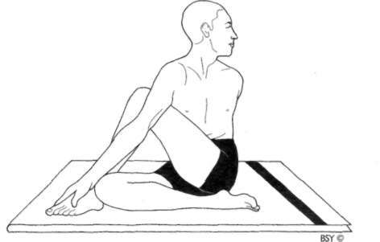

**Ardha Matsyendrasana (half spinal twist)**

Sit with the legs stretched out in front of the body.

Bend the right leg and place the right foot flat on the floor on the outside of the left knee.

The toes of the right foot should face forward.

Bend the left leg and bring the foot around to the right buttock. The outside edge of the foot should be in contact with the floor.

Pass the left arm through the space between the chest and the right knee, and place it against the outside of the right

leg-

Hold the right foot or ankle with the left hand, so that the

right knee is close to the left armpit. Sit up as straight as possible.

Raise the right arm in front of the body and gaze at the fingertips.

Slowly twist to the right, simultaneously moving the arm, trunk and head.

Use the left arm as a lever against the right leg to twist the trunk as far as possible without using the back muscles. Follow the tips of the fingers of the right hand with the gaze and look over the right shoulder.

Do not strain the back.

Bend the right elbow and place the arm around the back of the waist. The back of the right hand should wrap around the left side of the waist.

Alternatively, it can be placed as high as possible between the shoulder blades with the fingers pointing up. This arm position enforces the straightness of the spine.

Reverse the movements to come out of the posture and repeat on the other side.

**Breathing:** Inhale in the forward position.

Exhale while twisting the trunk.

Breathe deeply and slowly without strain in the final position.

Inhale while returning to the starting position.

**Duration:** Practise once on each side, gradually increasing the holding time to 1 or 2 minutes on each side of the body or up to 30 breaths.

**Awareness:** Physical - on keeping the spine straight and on the movement of the abdomen created by the breath in the final position.

Spiritual - on ajna chakra.

**Sequence:** This asana should be performed after completing a series of forward and backward bending asanas.

**Contra-indications:** Women more than two or three months pregnant should avoid this practice. People suffering from peptic ulcer, hernia or hyperthyroidism should only prac• tise this pose under expert guidance.

People with sciatica or slipped disc may benefit from this asana, but great care should be taken.

**Benefits:** This asana simultaneously stretches the muscles on one side of the back and abdomen while contracting the muscles on the other side. It tones the nerves of the spine, makes the back muscles supple, relieves lumbago and muscular spasms, and reduces the tendency of adjoining vertebrae to develop osteophytes. When practised with care, it has proved beneficial for mild cases of slipped disc. Ardha matsyendrasana massages the abdominal organs, alleviating digestive ailments. It regulates the secretion of adrenaline and bile and is recommended in the yogic

management of diabetes. Under special guidance it is used for the yogic management of sinusitis, hay fever, bronchitis, constipation, colitis, menstrual disorders, urinary tract disorders and cervical spondylitis, as long as it can be performed without any discomfort.

**Variation:** For beginners and those with stiff bodies the follow• ing adjustments to the position may be made:

The leg that is placed by the side of the buttock should remain straight and the hand holding the ankle may be wrapped around the opposite thigh, hugging the knee to the chest.

###### Inverted Asanas

Inverted asanas reverse the action of gravity on the body; instead of everything being pulled towards the feet, the orien• tation shifts towards the head. Similarly, on the emotional and psychic levels, inverted asanas turn everything upside down, throwing a new light on old patterns of behaviour and being. Generally, these practices improve health, reduce anxiety and stress, and increase self-confidence. They also increase mental power, concentration and the capacity to sustain large work• loads without strain.

Inverted asanas encourage a rich supply of blood to flow to the brain, nourishing the neurones and flushing out toxins. Blood and lymph, accumulated in the lower limbs and abdo• men, are drained back to the heart, then circulated to the lungs, purified and re-circulated to all parts of the body. This process nourishes the cells of the whole human organism. The enriched blood flow also allows the pituitary gland to operate more efficiently, tuning the entire endocrine system. This has a positive effect on the metabolic processes and even on ways of thinking.

While the body is in an inverted asana, the breath becomes slow and deep, maximising the exchange of carbon dioxide and oxygen, and generally encouraging correct respiration. In addition, the abdominal organs: the liver, spleen, stomach, kidneys and pancreas, receive a powerful massage, helping them to perform their functions more efficiently.

Traditionally, inverted asanas are used to sublimate and transform sexual energy into spiritual energy. The aim of the practices, in this context, is to stimulate the chakras, open

sushumna nadi and unleash kundalini to bring about psychic awakening. While it is unlikely that kundalini will be raised through practice of these asanas alone, inverted postures undoubtedly improve the quality of meditation and concen• tration, refining the consciousness and enabling it to enter unexplored levels of the mind.

This important group of asanas must be performed cor• rectly and with the utmost care. It is emphasised that these are powerful practices and that the following observances should be strictly adhered to.

**Time** of **practice:** Do not practise inverted asanas until at least three hours after taking food. Do not perform inverted asanas immediately after vigorous exercise. Wait for half an hour to allow the body to remove the waste products of muscle metabolism from the blood.

**Equipment:** Always practise these asanas on a folded blan• ket thick enough to protect the vertebra of the neck and back of the head. Never practise on a soft mattress, spring bed or air cushion.

**Duration:** Beginners should only remain in the final posi• tions for a few seconds. Once an asana can be maintained without experiencing the slightest difficulty, the duration may be increased gradually until it can be held for the recom• mended time.

Rest: Always follow inverted poses with shavasana. Rest until the breath and heartbeat are completely normal, then practise the recommended counterpose.

**Precautions:** Do not practise near furniture or anything that might impede a free fall to the floor. During a backward or forward fall, aim to break the fall with the feet. While falling, the body should be completely relaxed, never tense. If any discomfort occurs, discontinue the practice.

**Contra-indications:** People suffering from high blood pressure and back conditions, especially slipped disc, should not practise these asanas. Those with illnesses that make the blood impure should not perform inverted asanas until the blood is purified. Those who are uncertain about the purity of their blood should seek the advice of a yoga teacher or ayurvedic

doctor. Women should not practise inverted postures during pregnancy or menstruation.

**Practice note:** Assume the postures slowly and gently. Inverted asanas with their counterposes are usually placed at the end of an asana programme. Never combine mayurasana with inverted asanas in one practice session.

SARVANGASANA

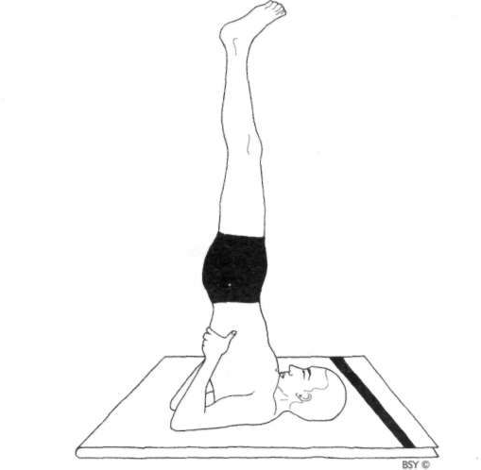

**Sarvangasana (shoulder stand pose)**

Lie on the back on a folded blanket.

Check that the head and spine are aligned and that the legs are straight with the feet together.

Place the hands beside the body with the palms facing down.

Relax the entire body and mind.

Contract the abdominal muscles and, with the support of the arms, slowly raise the legs to the vertical position, keeping them straight.

When the legs are vertical, press the arms and hands down on the floor. Slowly and smoothly roll the buttocks and spine off the floor, raising the trunk to a vertical position.

Turn the palms of the hands upward, bend the elbows and

place the hands behind the ribcage, slightly away from the

spine, to support the back. The elbows should be about shoulder width apart.

Gently push the chest forward so that it presses firmly against the chin.

In the final position, the legs are vertical, together and in a straight line with the trunk. The body is supported by the shoulders, nape of the neck and back of the head. The arms provide stability, the chest rests against the chin and the feet are relaxed.

Close the eyes.

Relax the whole body in the final pose for as long as is comfortable.

To return to the starting position, bring the legs forward until the feet are above and behind the back of the head. Keep the legs straight.

Slowly release the position of the hands and place the arms on the floor beside the body with the palms down. Gradually lower each vertebrae of the spine to the floor, followed by the buttocks, so that the legs resume their initial vertical position.

Lower the legs to the floor slowly, keeping the knees straight.

Perform this action without using the arms for support. The whole movement should combine balance with control so that the body contacts the floor slowly and gently.

Relax in shavasana until the respiration and heartbeat return to normal.

**Breathing:** Inhale in the starting position.

Retain the breath inside while assuming the final pose. Practise slow, deep abdominal breathing in the final pose when the body is steady.

Retain the breath inside while lowering the body to the floor.

**Duration:** Beginners should hold the final position for a few seconds only, gradually increasing the time over a period of weeks to an optimum of 3 to 5 minutes for general health. This practice should be performed only once during the asana programme.

**Awareness:** Physical - on the control of the movement, on the breath or the thyroid gland.

Spiritual - on vishuddhi chakra.

**Sequence:** Sarvangasana is ideally practised immediately before halasana. After halasana, either matsyasana, ushtrasana or supta vajrasana should be practised as a counterpose for half the combined duration of sarvangasana and halasana.

**Contra-indications:** This asana should not be practised by people suffering from enlarged thyroid, liver or spleen, cervical spondylitis, slipped disc, high blood pressure or other heart ailments, weak blood vessels in the eyes, thrombosis or impure blood. It should be avoided during menstruation and advanced stages of pregnancy.

**Benefits:** By pressing the chest against the chin this asana stimulates the thyroid gland, balancing the circulatory, digestive, reproductive, nervous and endocrine systems. Together with the enriched blood flow to the brain, it also tranquillises the mind, relieves mental and emotional stress, fear and headaches, and helps clear psychological disturbances. The thymus gland is also stimulated, boosting the immune system. Its influence on the parathyroid glands ensures normal development and regeneration of the bones, preventing premature calcification.

Abdominal breathing is induced, improving the exchange of air in the body, relieving stress and massaging the abdominal organs. Sarvangasana releases the normal gravitational pressure from the anal muscles, relieving haemorrhoids. It tones the legs, abdomen and repro• ductive organs, draining stagnant blood and fluid, and increasing circulation to these areas.

Flexibility of the neck vertebrae is improved and the nerves passing throug h the neck to the brain are toned. Circulation is increased in this area generally, revitalising the ears, eyes and tonsils, preventing and relieving various throat and nose ailments.

Sarvangasana is used in yoga therapy for the treatment of asthma, diabetes, colitis, thyroid disorders, impotence,

hydrocele, prolapse, menopause, menstrual disorders and leucorrhoea. Regular practice helps to prevent cough, cold and flu.

**Variation I**: Assume sarvangasana.

Exhale and lower one leg forward over the body until it is horizontal to the floor. The other leg should be vertical. Hold the pose for a few seconds.

Inhale, return the leg to the vertical position and resume sarvangasana.

Repeat on the other side.

**Variation 2:** Assume sarvangasana.

Exhale, bend the hips forward, and lower both the straight legs over the head until they are parallel to the floor.

Hold for a few seconds.

Inhale and raise the legs to the vertical position.

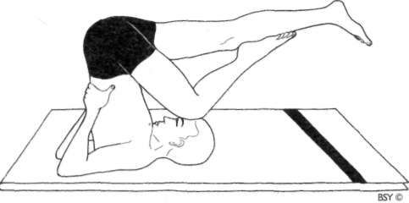

**Variation 3:** Assume sarvangasana.

Inhale and bend the right knee. Place the right foot on the left knee.

Exhale, bend the hips forward and place the right knee on the forehead. The left leg should be horizontal to the floor.

Retain the breath inside while holding this position. Return to sarvangasana.

Repeat on the other side.

HALASANA

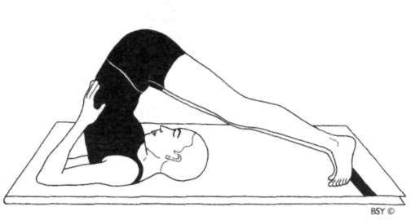

**Halasana (plough pose)**

Lie flat on the back with the legs and feet together. Place the arms beside the body with the palms facing down.

Relax the whole body.

Raise both legs to the vertical position, keeping them straight and together, using only the abdominal muscles. Press down on the arms and lift the buttocks, rolling the back away from the floor. Lower the legs over the head. Try to touch the toes to the floor behind the head.

Do not force the toes to touch the floor.

Turn the palms up, bend the elbows and place the hands behind the ribcage to support the back as in sarvangasana. Relax and hold the final pose for as long as is comfortable. Return to the starting position by lowering the arms with the palms facing down, then slowly lower the back and buttocks to the floor.

Raise the legs to the vertical position. Using the abdominal muscles, lower the legs to the starting position, keeping the knees straight.

**Breathing:** Inhale while in the lying position.

Retain the breath inside while assuming the final pose. Breathe slowly and deeply in the final pose.

Retain the breath inside while returning to the starting position.

**Duration:** Beginners should hold the pose for 15 seconds, gradually adding a few seconds per week until it can be held for one minute.

Adepts may hold the final pose up to 10 minutes or longer.

**Awareness:** Physical - on the abdomen, relaxation of the back muscles, the respiration or the thyroid gland.

Spiritual - on manipura or vishuddhi chakra.

**Sequence:** If possible, perform this asana immediately after sarvangasana. To go from sarvangasana to halasana, bring the feet slightly over the head for balance, slowly remove the arms from their position behind the back and place them on the floor in the starting position, palms facing down. Relax the body and slowly lower the legs over the head, keeping them straight and together, until the toes touch the floor. Keep the legs straight and continue as described above.

Follow halasana with either matsyasana, ushtrasana or supta vajrasana as a counterpose, practised for half the combined duration of sarvangasana and halasana. It may also be followed by the variations for halasana given at the end of this chapter. Halasana is a good preparatory practice for paschimottanasana.

**Contra-indications:** This asana should not be practised by those who suffer from hernia, slipped disc, sciatica, high blood pressure or any serious back problem, especially arthritis of the neck.

**Benefits:** The movement of the diaphragm which takes place during the practice of halasana massages all the internal organs, activates the digestion, relieving constipation and dyspepsia, revitalises the spleen and the suprarenal glands,

promotes the production of insulin by the pancreas and improves liver and kidney function. It strengthens the abdominal muscles, relieves spasms in the back muscles, tones the spinal nerves, improving the operation of the sympathetic nervous system, and increases blood circu• lation to the whole area. It regulates the activities of the thyroid gland which balances the body's metabolic rate, and stimulates the thymus gland, boosting the immune system.

It is used in yoga therapy for the management of asthma, bronchitis, constipation, hepatitis, urinary tract and menstrual disorders.

**Variation I**: In the final pose, walk the feet away from the head until the body is completely stretched and a tight chin lock is performed. Breathe normally for as long as is comfortable in the final pose.

This position stretches the upper back, including the neck, giving more flexibility to the upper spine.

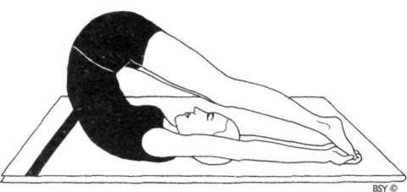

**Variation 2:** In the final pose, begin to walk the toes towards the back of the head, keeping the legs straight and together. Take hold of the toes, keeping the arms straight. Breathe normally for as long as is comfortable in the final pose. This position stretches and increases flexibility in the lumbo-sacral region of the spine.

After practising these variations, return to halasana and then to the starting position.

DRUTA HALASANA

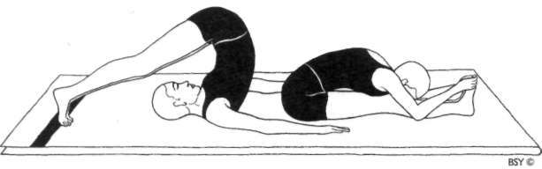

**Druta Halasana (dynamic plough pose)**

Lie flat on the back with the legs and feet together.

Place the arms close to the body with the palms facing down. Relax the whole body.

Press down on the arms. Rapidly roll the legs over the head, keeping the legs straight, and touch the floor behind the head with the toes.

Hold the position for 1 or 2 seconds.

Roll the body rapidly back to the starting position. Immediately sit up and bend the body forward into paschimottanasana. Keep the legs straight and try to touch the knees with the forehead.

Resume the seated position. This completes 1 round.

The practice should be performed with an even flowing movement.

**Breathing:** Inhale and exhale deeply in the lying position before starting.

Retain the breath outside while rolling back into halasana, forward into paschimottanasana and returning to the seated position.

Inhale and exhale in the seated pose.

**Duration:** Practise up to 10 rounds.

**Awareness:** Physical - on the flow of the movement with the breath or on the stretch in the back.

Spiritual - on manipura chakra.

**Sequence:** This practice should be followed by a backward bending counterpose such as either matsyasana or supta vajrasana.

**Contra-indications:** Druta halasana should not be practised by those with sciatica or other back or neck ailments, or by people with high blood pressure.

**Benefits:** This practice has the benefits of both halasana and paschimottanasana. It activates the intestinal peristalsis, improving digestion and removing constipation, facilitates the breakdown of fats by exercising the liver and gall bladder, and stretches the pelvic region.

**Practice note:** The body should be completely stretched out in the lying position before moving into either halasana or paschimottanasana. This aspect can easily be overlooked as the momentum gathers.

ARDHA PADMA HALASANA

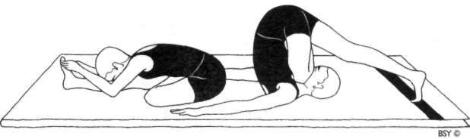

**Ardha Padma Halasana (half lotus plough pose)**

Sit with the legs outstretched and the feet together. Bend the left leg and place the foot on top of the right thigh in the half lotus position. Place the arms close to the body with the palms facing down.

Press down with the hands and roll backward.

Move the straight leg over the head and touch the ground with the toes.

Roll back to the upright position and, without breaking

the movement, bend forward and hold the toes of the outstretched leg.

Bring the forehead to the knee of the outstretched leg. Resume the upright position.

Repeat with the right leg folded in ardha padmasana.

**Breathing:** Inhale and exhale completely before rolling.

Retain the breath outside while rolling. **Duration:** Up to 5 times with each leg folded. **Awareness:** As for druta halasana.

**Sequence:** This practice should be followed by a backward bending counterpose, such as supta vajrasana or matsy- asana, to release the compression in the neck and abdomen.

**Other details:** As for druta halasana.

**Practice note:** Be careful not to strain the muscles of the back or legs. Do not hit the back of the head on the floor.

###### Balancing Asanas

Balancing asanas develop the cerebellum, the brain centre that controls how the body works in motion. Most people are uncoordinated in their movements so their bodies constantly have to compensate for their lack of balance in order to avoid falling or knocking things over. This inefficient method of proceeding expends maximum effort and energy for the minimum results, creating considerable additional strain on the body. These asanas induce physical balance, stilling unconscious movement. As the moving body attains balance it becomes increasingly free to rely on other forces, such as gravity, to support and propel it. This way it conserves its own energy and achieves grace and fluidity of motion.

As well as inducing physical balance, this group of practices develops a balanced mind and a more mature outlook on life. The focus required to perform them with steadiness develops concentration and balance at the emotional, mental and psychic levels. These asanas are especially noted for balancing the nervous system and removing stress and anxiety. For relief of excessive tension these practices should be held for as long as possible.

Balancing asanas may be difficult to perform at first if one's sense of balance has not been developed in normal life. However, the body is very adaptable and progress will quickly be made with a few weeks of regular practice. When practising these asanas it is most important to steady the mind through concentration on one point. Gazing at a black spot or a mark on the wall while balancing allows the body to maintain seemingly difficult positions for long periods of time.

# Pranayama

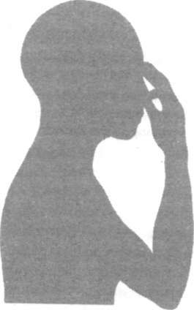

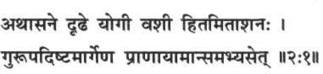

*Athaasane dridhe yogee vashee hitamitaashanaha. Guroopadishtamaargena praanaayaamaansamabhyset.*

Thus being established in asana and having control (of the body), taking a balanced diet; pranayamas should be practised according to the instructions of the guru.

*Hatha Yoga Pradipika (2:1)*

##### Introduction to Pranayama

P

ranayama is generally defined as breath control. Although this interpretation may seem correct in view of the practices involved, it does not convey the full meaning of the term. The word pranayama is comprised of two roots: *prana* plus *ayama.* Prana means 'vital energy' or 'life force'. It is the force which exists in all things, whether animate or inanimate. Although closely related to the air we breathe, it is more subtle than air or oxygen. Therefore, pranayama should not be considered as mere breathing exercises aimed at introducing extra oxygen into the lungs. Pranayama utilises breathing to influence the flow of prana in the *nadis* or energy channels of the *pranamaya*

*kosha* or energy body.

The wordyawwz means 'control' and is used to denote various rules or codes of conduct. However, this is not the word which is joined to prana to form pranayama; the correct word is *ayama* which has far more implications than the word yama. Ayama is defined as 'extension' or 'expansion'. Thus, the word pranayama means 'extension or expansion of the dimension of prana'. The techniques of pranayama provide the method whereby the life force can be activated and regulated in order to go beyond one's normal boundaries or limitations and attain a higher state of vibratory energy.

Four aspects of pranayama

In the pranayama practices there are four important aspects of breathing which are utilised. These are:

1. *Pooraka* or inhalation
2. *Rechaka* or exhalation
3. *Antar kunbhaka* or internal breath retention
4. *Bahir kumbhaka* or external breath retention.

Th e different practices of pranayama involve various techniques which utilise these four aspects of breathing. There is another mode of pranayama which is called *kevala kumbhaka* or spontaneous breath retention. This is an advanced stage of pranayama which occurs during high states of meditation. During this state, the lungs stop their activity and the respiration ceases. At this time, the veil which prevents one from seeing the subtle aspect of existence is lifted and a higher vision of reality is attained.

The most important part of pranayama is actually kumbhaka or breath retention. However, in order to perform kumbhaka successfully, there must be a gradual development of control over the function of respiration. Therefore, in the pranayama practices more emphasis is given to inhalation and exhalation at the beginning, in order to strengthen the lungs and balance the nervous and pranic systems in preparation for the practice of kumbhaka. These practices influence the flow of prana in the nadis, purifying, regulating and activating them, thereby inducing physical and mental stability. (For more information on nadis see the chapter Psychic Physiology of Yoga.)

The pranic body

According to yogic physiology, the human framework is comprised of five bodies or sheaths, which account for the different aspects or dimensions of human existence. These five sheaths are known as:

1. *Annamaya kosha,* the food or material body
2. *Manomaya kosha,* the mental body
3. *Pranamaya kosha,* the bioplasmic or vital energy body
4. *Vijnanamaya kosha,* the psychic or higher mental body
5. *Anandamaya kosha,* the transcendental or bliss body.

Although these five sheaths function together to form an integral whole, the practices of pranayama work mainly with pranamaya kosha. The pranamaya kosha is made up of five major pranas which are collectively known as the *pancha,* or five, pranas: *prana, apana, samana, udana* and *vyana.*

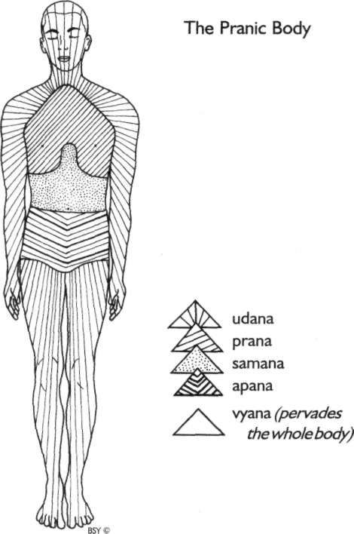

**Prana** in this context, does not refer to cosmic prana but rather to just one part of the pranamaya kosha, governing the area between the larynx and the top of the diaphragm. It is associated with the organs of respiration and speech, and the gullet, together with the muscles and nerves that activate them. It is the force by which the breath is drawn inside.

**Apana** is located below the navel region and provides energy for the large intestine, kidneys, anus and genitals. It is concerned with the expulsion of waste from the body.

**Samana** is located between the heart and the navel. It activates and controls the digestive system: the liver, intestines, pancreas and stomach, and their secretions. Samana also activates the heart and circulatory system, and is responsible for the assimilation and distribution of nutrients.

**Udana** controls the area of the body above the neck, activating all the sensory receptors such as the eyes, nose and ears. Thought and consciousness of the outside world would be impossible without it. Udana also harmonises and activates the limbs and all their associated muscles, ligaments, nerves and joints, as well as being responsible for the erect posture of the body.

**Vyana** pervades the whole body, regulating and controlling all movement, and coordinating the other pranas. It acts as the reserve force for the other pranas.

Along with the five major pranas there are five minor pranas known as the *upa-pranas.* These five sub-pranas are: naga, koorma, krikara, devadatta and dhananjaya. Their functions are described as follows. *Naga* is responsible for belching and hiccups. *Koorma* opens the eyes and stimulates blinking. *Krikara* generates hunger, thirst, sneezing and coughing. *Devadatta* induces sleep and yawning. *Dhananjaya* lingers immediately after death and is responsible for decomposition of the body. For further information on the pranic body, preparatory techniques and pranayama practices described in this section, refer to the Bihar School of Yoga publications, *Prana Pranayama*

*Prana Vidya* and *Yoga Darshan.*

Prana and lifestyle

Lifestyle has a profound impact on the pranamaya kosha and its pranas. Physical activities such as exercise, work, sleep, intake of food and sexual relations, all affect the distribution and flow of prana in the body. Faculties of the mind such as emotion, thought and imagination affect the pranic body even more. Irregularities in lifestyle, dietary indiscretions and stress, deplete and obstruct the pranic flow. This results in what people experience as being 'drained of energy'. Depletion of energy in a particular prana leads to the devitalisation of the

organs and limbs it governs and ultimately to disease or metabolic dysfunction. The techniques of pranayama reverse this process, energising and balancing the different pranas within the pranamaya kosha. Pranayama practices should be performed after asana in an integrated yoga programme.

Breath, health and pranayama

The breath is the most vital process of the body. It influences the activities of each and every cell and, most importantly, is intimately linked with the performance of the brain. Human beings breathe about 15 times per minute and 21,600 times per day. Respiration fuels the burning of oxygen and glucose, producing energy to power every muscular contraction, glan• dular secretion and mental process. The breath is intimately linked to all aspects of human experience.

Most people breathe incorrectly, using only a small part of their lung capacity. Th e breathing is then generally shallow, depriving the body of oxygen and prana essential to its good health. Th e first five practices given in this section are preparatory techniques which introduce correct breathing habits. In addition, they help focus the awareness on the breathing process, which is otherwise normally ignored. Practitioners develop sensitivity to the respiratory process and retrain the muscles of the pulmonary cavity, enhancing their vital capacity and preparing them for pranayama.

Rhythmic, deep and slow respiration stimulates and is stimulated by calm, content states of mind. Irregular breathing disrupts the rhythms of the brain and leads to physical, emotional and mental blocks. These, in turn, lead to inner conflict, imbalanced personality, disordered lifestyle and disease. Pranayama establishes regular breathing patterns, breaking this negative cycle and reversing the process. It does so by taking control of the breath and re-establishing the natural, relaxed rhythms of the body and mind.

Although breathing is mainly an unconscious process, conscious control of it may be taken at any time. Consequently, it forms a bridge between the conscious and unconscious areas of the mind. Through the practice of pranayama, the energy

trapped in neurotic, unconscious mental patterns may be released for use in more creative and joyful activity.

Breathing and life span

In addition to influencing the quality of life, the length or quantity of life is also dictated by the rhythm of the respiration. The ancient yogis and rishis studied nature in great detail. They noticed that animals with a slow breath rate such as pythons, elephants and tortoises have long life spans, whereas those with a fast breathing rate, such as birds, dogs and rabbits, live for only a few years. From this observation they realised the importance of slow breathing for increasing the human lifespan. Those who breathe in short, quick gasps are likely to have a shorter life span than those who breathe slowly and deeply. On the physical level, this is because the respiration is directly related to the heart. A slow breathing rate keeps the heart stronger and better nourished and contributes to a longer life. Deep breathing also increases the absorption of energy by the pranamaya kosha, enhancing dynamism, vitality and general wellbeing.

Pranayama and the spiritual aspirant

Pranayama practices establish a healthy body by removing blockages in the pranamaya kosha, enabling an increased absorption of prana. Th e spiritual seeker, however, also requires tranquillity of mind as an essential prelude to spiritual practice. To this end, many pranayama techniques utilise kumbhaka, breath retention, to establish control over the flow of prana, calming the mind and controlling the thought process.

Once the mind has been stilled and prana flows freely in the nadis and chakras, the doorway to the evolution of con• sciousness opens, leading the aspirant into higher dimensions of spiritual experience. In *The Science of Pranayama,* Swami Sivananda writes, "There is an intimate connection between the breath, nerve currents and control of the inner prana or vital forces. Prana becomes visible on the physical plane as motion and action, and on the mental plane as thought.

Pranayama is the means by which a yogi tries to realise within his individual body the whole cosmic nature, and attempts to attain perfection by attaining all the powers of the universe."

General notes for the practitioner

In the traditional texts, there are innumerable rules and regulations pertaining to pranayama. The main points are to exercise moderation, balance and common sense with regard to inner and outer thinking and living. However, for those who seriously wish to take up the advanced practices of pranayama, the guidance of a guru or experienced teacher is essential.

**Breathing:** Always breathe through the nose and not the mouth unless specifically instructed otherwise. The nose should be cleaned regularly by jala neti prior to the practice session. Be aware of the nostrils throughout the techniques. While inhaling, the nostrils should dilate or expand outwards and while exhaling, they should relax back to their normal position. **Time of practice:** The best time to practise pranayama is during the early morning when the body is fresh and the mind has very few impressions. If this is not possible, another good time is just after sunset. Tranquillising pranayamas may be performed before sleep. Try to practise regularly at the same time and place each day. Regularity in practice increases strength and willpower as well as acclimatising the body and mind to the increased pranic force. Do not be in a hurry; slow,

steady progress is essential.

**Place of practice:** Practise in a quiet, clean and pleasant room which is well ventilated but not draughty. Generally, avoid practising in direct sunlight, as the body will become over-heated, except at dawn when the soft rays of the early morning sun are beneficial. Practising in a draught or wind, in air-conditioning or under a fan may upset the body temper• ature and cause chills.

**Sitting position:** A.comfortable, sustainable meditation posture is necessary to enable efficient breathing and body steadiness during the practice. Siddha/siddha yoni asana is one of the best postures for pranayama. The body should be as

relaxed as possible throughout the practice with the spine, neck and head erect. Sit on a folded blanket or cloth of natural fibre to ensure the maximum conduction of energy during the practice.

Sequence: Pranayama should be performed after asanas and before meditation practice. After practising pranayama one may lie down in shavasana for a few minutes.

**Clothes:** Loose, comfortable clothing made of natural fibres should be worn during the practice. The body may be covered with a sheet or blanket when it is cold or to keep insects away. **Bathing:** Take a bath or shower before commencing the practice, or at least wash the hands, face and feet. Do not take a bath for at least half an hour after the practice to allow the

body temperature to normalise.

**Empty stomach:** Wait at least three to four hours after meals before starting pranayama. Food in the stomach places pressure on the diaphragm and lungs, making full, deep respiration difficult.

**Digestion:** When commencing pranayama practice, con• stipation and a reduction in the quantity of urine may be experienced. In the case of dry motion, stop taking salt and spices, and drink plenty of water. In the case of loose motion, stop the practices for a few days and go on a diet of rice and curd or yoghurt.

**Diet:** A balanced diet of protein, carbohydrates, fats, vitamins and minerals is suitable for most pranayama practices. A combination of grains, pulses, fresh fruit and vegetables, with a little milk product if necessary, is recommended. The more advanced stages of pranayama require a change in diet and a guru should be consulted for guidance on this.

**Avoid strain:** With all pranayama practices it is important to remember that the instruction not to strain, not to try to increase your capacity too fast, applies just as it does to asana practice. If one is advised to practise a pranayama technique for a specific length of time, before moving on to a more advanced practice or ratio, it is wise to follow that instruction. Furthermore, breath retention should only be practised for as long as is comfortable. The lungs are very delicate organs and

any misuse can easily cause them injury. Not only the physical body but also the mental and emotional aspects of the personality need time to adjust. Never strain in any way.

**Side effects:** When practising for the first time, various symptoms may manifest in normally healthy people. These are caused by the process of purification and the expulsion of toxins. Sensations of itching, tingling, heat or cold and feelings of lightness or heaviness may occur. Such experiences are generally temporary but if they persist during the practice, check with a yoga teacher.

**Contra-indications:** Pranayama should not be practised during illness, although simple techniques such as breath awareness and abdominal breathing in shavasana may be performed. Always consult a yoga therapist or teacher before using any pranayama for therapeutic purposes.

**No smoking:** It is not advisable for pranayama practitioners to smoke tobacco or cannabis.

NATURAL BREATHING

This is a simple technique which introduces practitioners to their own respiratory system and breathing patterns. It is very relaxing and may be practised at any time. Awareness of the breathing process is itself sufficient to slow down the respiratory rate and establish a more relaxed rhythm.

**Natural breathing**

Sit in a comfortable meditation posture or lie in shavasana and relax the whole body.

Observe the natural and spontaneous breathing process. Develop total awareness of the rhythmic flow of the breath. Feel the breath flowing in and out of the nose.

Do not control the breath in any way.

Notice that the breath is cool as it enters the nostrils and warm as it flows out.

Observe this with the attitude of a detached witness.

Feel the breath flowing in and out at the back of the mouth above the throat.

Bring the awareness down to the region of the throat and feel the breath flowing in the throat.

Bring the awareness down to the region of the chest and feel the breath flowing in the trachea and bronchial tubes. Next, feel the breath flowing in the lungs.

Be aware of the lungs expanding and relaxing.

Shift the attention to the rib cage and observe the expansion and relaxation of this area.

Bring the awareness down to the abdomen. Feel the abdomen move upward on inhalation and downward on exhalation.

Finally, become aware of the whole breathing process from the nostrils to the abdomen and continue observing it for some time.

Bring the awareness back to observing the physical body as one unit and open the eyes.

ABDOMINAL BREATHING

Abdominal or diaphragmatic breathin g is practised by enhancing the action of the diaphragm and minimising the action of the rib cage. The diaphragm is a domed sheet of muscle that separates the lungs from the abdominal cavity and, when functioning correctly, promotes the most efficient type of breathing. It is the effect of the diaphragm rather than the diaphragm itself that is experienced as the stomach rises and falls. Sensitivity to the muscle itself, however, will come with practice. During inhalation the diaphrag m moves downward, pushing the abdominal contents downward and outward. During exhalation the diaphragm moves upward and the abdominal contents move inward.

Movement of the diaphragm signifies that the lower lobes of the lungs are being utilised. The proper use of the diaphragm causes equal expansion of the alveoli, improves lymphatic drainage from basal parts of the lungs, massages the liver, stomach, intestines and other organs that lie immediately beneath it, exerts a positive effect on the cardiac functions and coronary supply, and improves oxygenation of the blood and circulation.

Abdominal breathing is the most natural and efficient way to breathe. Due to tension, poor posture, restrictive clothing and lack of training, however, it is often forgotten. Once this technique again becomes a part of daily life and correct breathing is restored, there will be a great improvement in the state of physical and mental wellbeing.

**Abdominal (or diaphragmatic) breathing**

Lie in shavasana and relax the whole body.

Observe the spontaneous breath without controlling it in any way. Let it be absolutely natural.

Continue observing the natural breath for some time. Place the right hand on the abdomen just above the navel and the left hand over the centre of the chest.

The right hand will move up with inhalation and down with exhalation. The left hand should not move with the breath.

There should be no tension in the abdomen. Do not try to force the movement in any way.

Try not to expand the chest or move the shoulders. Feel the abdomen expanding and contracting.

Continue breathing slowly and deeply.

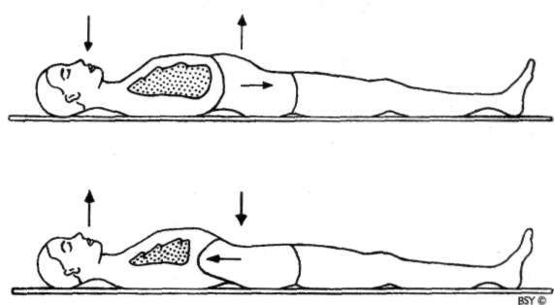

Inhale while expanding the abdomen as much as possible, without expanding the rib cage.

At the end of the inhalation the diaphragm will be compressing the abdomen and the navel will be at its highest point.

On exhalation the diaphragm moves upward and the abdomen moves downward.

At the end of the exhalation the abdomen will be contracted and the navel compressed towards the spine.

Continue for a few minutes.

THORACIC BREATHING

Thoracic breathing utilises the middle lobes of the lungs by expanding and contracting the rib cage. It expends more energy than abdominal breathing for the same quantity of air exchange. It is often associated with physical exercise and exertion, as well as stress and tension, when it helps the body to obtain more oxygen. However, the tendency in many people is to continue this type of breathing long after the stressful situation has passed, creating bad breathing habits and continued tension.

**Thoracic breathing**

Sit in a meditation posture or lie in shavasana and relax the whole body.

Maintain unbroken awareness of the natural breath for some time, concentrating on the sides of the chest.

Discontinue any further use of the diaphragm and begin to inhale by slowly expanding the rib cage.

Feel the movement of the individual ribs outward and upward, and be aware of this expansion drawing air into the lungs.

Expand the chest as much as possible.

Exhale by relaxing the chest muscles. Feel the rib cage contracting and forcing the air out of the lungs.

Breathe slowly and deeply through the chest with total awareness.

Do not use the diaphragm.

Continue thoracic breathing for a few minutes, pausing slightly after each inhalation and exhalation.

CLAVICULAR BREATHING

Clavicular breathing is the final stage of total rib cage expansion. It occurs after the thoracic inhalation has been completed. In order to absorb a little more air into the lungs, the upper ribs and the collar bone are pulled upwards by the muscles of the neck, throat and sternum. This requires maximum expansion on inhalation and only the upper lobes of the lungs are ventilated. In daily life, clavicular breathing is only used under conditions of extreme physical exertion and when experiencing obstructive airway diseases such as asthma.

**Clavicular breathing**

Lie in shavasana and relax the whole body. Perform thoracic breathing for a few minutes. Inhale, fully expanding the rib cage.

When the ribs are fully expanded, inhale a little more until expansion is felt in the upper portion of the lungs around the base of the neck. The shoulders and collar bone should also move up slightly.

This will take some effort.

Exhale slowly, first releasing the lower neck and upper chest, then relax the rest of the rib cage back to its starting position.

Continue for a few more breaths, observing the effect of this type of breathing.

YOGIC BREATHING

Yogic breathing combines the previous three techniques. It is used to maximise inhalation and exhalation. Its purpose is to gain control of the breath, correct poor breathing habits and increase oxygen intake.

It may be practised at any time and is especially useful in situations of high stress or anger for calming the nerves. However, while its inclusion in a daily yoga programme will correct and deepen natural breathing patterns, yogic breathing itself should not be performed continually.

**Yogic breathing**

Sit in a meditation posture or lie in shavasana and relax the whole body.

Inhale slowly and deeply, allowing the abdomen to expand fully.

Try to breathe so slowly that little or no sound of the breath can be heard.

Feel the air reaching into the bottom of the lungs.

At the end of abdominal expansion, start to expand the chest outward and upward.

When the ribs are fully expanded, inhale a little more until expansion is felt in the upper portion of the lungs around the base of the neck. The shoulders and collar bone should also move up slightly. Some tension will be felt in the neck muscles.

The rest of the body should be relaxed.

Feel the air filling the upper lobes of the lungs. This completes one inhalation.

The whole process should be one continuous movement, each phase of breathing merging into the next without any obvious transition point. There should be no jerks or unnecessary strain. The breathing should be like the swell of the sea.

Now start to exhale.

First, relax the lower neck and upper chest, then allow the chest to contract downward and then inward.

Next, allow the diaphragm to push upward and toward the chest.

Without straining, try to empty the lungs as much as possible by drawing or pulling the abdominal wall as near as possible to the spine.

The entire movement should be harmonious and flowing. Hold the breath for a few seconds at the end of exhalation. This completes one round of yogic breathing.

At first perform 5 to 10 rounds and slowly increase to 10 minutes daily.

**Practice note:** Yogic breathing is used in most pranayamas. The main requirement, however, is that respiration be comfortable and relaxed. Consequently, once awareness and control of the breathing process has been established, the clavicular technique is dropped and yogic breathing is modified to become a combination of abdominal and thoracic breathing. The breath should flow naturally and not be forced.

NADI SHODHANA PRANAYAMA

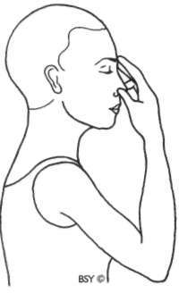

**Hand position: Nasagra Mudra (nosetip position)**

Hold the fingers of the right hand in front of the face. Rest the index and middle fingers gently on the eyebrow centre. Both fingers should be relaxed.

The thumb is above the right nostril and the ring finger above the left. These two digits control the flow of breath in the nostrils by alternately pressing on one nostril, blocking the flow of breath, and then the other.

The little finger is comfortably folded. When practising for long periods, the elbow may be supported by the left hand although care is needed to prevent chest restriction.

**Nadi Shodhana Pranayama (psychic network purification) Technique I: Preparatory practice**

Sit in any comfortable meditation posture, preferably

siddha/siddha yoni asana or padmasana. (Those who cannot sit in a meditation posture may sit against a wall with the legs outstretched or in a chair which has a straight back). Keep the head and spine upright.

Relax the whole body and close the eyes. Practise yogic breathing for some time.

Adopt nasagra mudra with the right hand and place the

left hand on the knee in chin or jnana mudra. Close the right nostril with the thumb.

Inhale and exhale through the left nostril 5 times. The rate of inhalation/exhalation should be normal. Be aware of each breath.

After 5 breaths release the pressure of the thumb on the right nostril and press the left nostril with the ring finger, blocking the flow of air.

Inhale and exhale through the right nostril 5 times, keeping the respiration rate normal.

Lower the hand and breathe 5 times through both nostrils together.

This is one round.

Practise 5 rounds or for 3 to 5 minutes, making sure that there is no sound as the air passes through the nostrils. After practising for 15 days go on to technique 2.

**Technique 2: Alternate nostril breathing**

In this technique the duration of inhalation/exhalation is controlled.

Close the right nostril with the thumb and breathe in through the left nostril.

At the same time count mentally, "1 , Om; 2, Om; 3, Om", until the inhalation ends comfortably. This is the basic count.

Breathe deeply with yogic breathing. Do not strain. Close the left nostril with the ring finger, release the pressure of the thumb on the right nostril and while breathing out through the right nostril, simultaneously count, "1 , Om; 2, Om; 3, Om". The time for inhalation and exhalation should be equal.

Next, inhale through the right nostril, keeping the same count in the same manner.

At the end of inhalation close the right nostril, open the left nostril and exhale through the left nostril, counting as before.

This is one round. Practise 10 rounds.

**Ratio and timing:** After a few days, if there is no difficulty, increase the length of inhalation/exhalation by one count. Continue in this way, increasing the inhalation/exhalation by one count as it becomes easy, until the count of 12:12 is reached.

Do not force the breath in any way and be careful not to speed up the counting during exhalation to compensate for shortage of breath. At the slightest sign of discomfort reduce the count.

After perfecting the above ratio, it may be changed to 1:2. For example, breathe in for a count of 5 and breathe out for a count of 10. Continue extending the breath by adding one count to the inhalation and two to the exhalation, up to the count of 12:24. This ratio establishes a calming rhythm for the brain and heart, assisting the treatment of cardiovascular and nervous system disorders specifically, and stress related conditions generally.

When this technique can be performed with complete ease move on to technique 3.

**Technique 3: with Antar Kumbhaka (inner retention)**

In this technique antar kumbhaka or internal breath retention is introduced.

Close the right nostril and breathe in slowly through the left nostril for a count of 5.

At the end of inhalation, close both nostrils and retain the air in the lungs for a count of 5.

The glottis may be slightly contracted to hold the air within the lungs.

Open the right nostril, breathe in slightly through the right nostril and then slowly breathe out through the same nostril for a count of 5.

This slight inhalation at the end of inner retention helps to bring the respiratory muscles back into action again and relieves the locked condition of the glottis.

The exhalation should be smooth and controlled and of the same length as the inhalation.

At the end of exhalation, immediately inhale through the

right nostril for a count of 5, keeping the left nostril closed.

Again, retain the breath for a count of 5 with both nostrils closed.

Open the left nostril, breathe in slightly through the left nostril and then breathe out through the same nostril for a count of 5.

This is one round.

Maintain constant awareness of the count and of the breath. Practise 10 rounds.

**Ratio and timing:** The maintenance of a strict ratio during inhalation, kumbhaka and exhalation is of the utmost importance. The ratio will change as the ability to hold the breath for longer periods of time progressively devel• ops. After mastering the ratio of 1:1:1, increase the ratio to 1:1:2. For example, inhale for a count of 5, perform internal kumbhaka for a count of 5 and exhale for a count of 10. After some weeks of practice, when this ratio has been mastered, increase the ratio to 1:2:2. Inhale for a count of 5, do internal kumbhaka for a count of 10 and exhale for a count of 10.

After mastering the ratio of 1:2:2, gradually increase the count by adding one unit to the inhalation (e.g. 5 becomes 6), 2 units to the retention and 2 units to the exhalation (making each of them 12). The count of one round will then be 6:12:12. When this has been perfected and there is absolutely no discomfort, increase the count to 7:14:14. Gradually increase the count over a period of one or two years to 24:48:48. Thereafter, gradually increase the ratio to 1:3:2, and 1:4:2. Once this has been established, move on to technique 4.

**Technique 4: with Antar and Bahir Kumbhaka (internal and external retention)**

In this technique bahir kumbhaka or outer breath retention

is introduced.

Do not try to hold the breath outside for too long at first, even though it may seem easy.

Inhale through the left nostril.

Retain the breath inside in antar kumbhaka as described in technique 3.

Exhale through the right nostril.

After exhalation, when the lungs are deflated as much as possible, close both nostrils and hold the breath out for the chosen count.

The glottis may be slightly contracted to hold the air out of the lungs.

Exhale slightly through the right nostril immediately before inhaling. This will release the lock on the lungs and the glottis and bring the respiratory system smoothly back into operation.

Inhale slowly through the right nostril. Retain the breath inside in antar kumbhaka. Exhale through the left nostril.

Again, hold the breath out in bahir kumbhaka to the count, with both nostrils closed.

This is one round.

Remember to exhale slightly through the right nostril before breathing in at the start of the next round.

Practise 5 rounds.

**Ratio and timing:** The ratio should start off as 1:4:2:2 for inhalation, internal retention, exhalation, external reten• tion. The duration of inhalation should slowly be increased from 5 to 6 counts, then from 6 to 7 and so on, and the duration of exhalation and retention should be adjusted accordingly.

Do not increase the count for inhalation until the relative counts for exhalation and breath retention are comfortable.

**Advanced practice:** Nadi shodhana pranayama may be prac• tised in conjunction with jalandhara, moola and uddiyana bandhas (for details of these practices refer to the section Bandha). First practise jalandhara bandha with internal breath retention only. Once this practice has been per• fected, combine jalandhara bandha with external breath retention. Then introduce moola bandha with jalandhara

during internal retention, then external retention. When this has been mastered, apply uddiyana bandha on external retention only.

It may be necessary to adjust the ratio of the breath to suit the individual capacity.

**Breathing:** Breathing should be silent in all techniques of nadi shodhana, ensuring that it is not forced or restricted in any way. As the ratio and duration increases the breath becomes very light and subtle. Increased ratios and breath duration should not be attained at the expense of relax• ation, rhythm and awareness. The flow of breath must be smooth, with no jerks, throughout the practice. Always use the chest and diaphragm muscles and practise yogic breathing. If one of the nostrils is blocked, perform jala neti or breath balancing exercises before commencing.

**Awareness:** Physical - on the breath and the counting.

Mental - it is easy for the mind to wander during nadi shodhana. Simply be aware of this wandering tendency of the mind, continue the practice and the count. This will automatically encourage the awareness to return to the practice.

Spiritual - on ajna chakra.

**Precautions:** Depending on the phase of the moon, one of the two nostrils usually becomes strongly dominant during the time of sunrise and sunset. This is a period of intense *swara,* 'breath', activity and it is not advisable to alter the flows at this time. Under no circumstance should the breath be forced. Never breathe through the mouth. Proceed carefully and only under expert guidance. At the slightest sign of discomfort, reduce the duration of inhalation/ exhalation/retention and, if necessary, discontinue the practice for the day. Nadi shodhana should never be rushed.

**Sequence:** Nadi shodhana should be practised after asanas and heating or cooling pranayamas, and before bhramari and ujjayi pranayamas. The best time to practise is from 4 to 6 am; however, it may be performed any time during the day except after meals.

**Duration:** 5 to 10 rounds or 10 to 15 minutes daily.

**Benefits:** Nadi shodhana ensures that the whole body is nourish• ed by an extra supply of oxygen. Carbon dioxide is efficiently expelled and the blood is purified of toxins. The brain centres are stimulated to work nearer to their optimum capacity. It also induces tranquillity, clarity of thought and concentration, and is recommended for those engaged in mental work. It increases vitality and lowers levels of stress and anxiety by harmonising the pranas. It clears pranic blockages and balances ida and pingala nadis, causing sushumna nadi to flow, which leads to deep states of meditation and spiritual awakening.

**Practice note:** Development of nadi shodhana is intended to take place over a long period of time. Each technique should be practised for a minimum of 6 months, except for technique 1 which may be practised for 2 to 4 weeks. Developing the ratios and timing of the breath in each technique may even take years.

Techniques 1 and 2 prepare the lungs and the nervous system for techniques 3 and 4 which introduce antar and bahir kumbhaka, internal and external breath retention. Mastery of the later techniques may take some time to realise as the body and mind need to adjust to the effects of extended breath retention. The full benefits of this practice will be obtained by systematically perfecting each level rather than by struggling prematurely with the advanced techniques.

***Note:*** *The word* nadi *means 'channel' or 'flow' of energy and* shodhana *means 'purification'. Nadi shodhana, therefore, means that practice which purifies the nadis.*

*The number 24, used for timing the breath, derives from classical texts which use the Gayatri mantra as a metre to measure the length of pranayamas; the Gayatri mantra is made up of 24 individual mantras.*

SHEETALI PRANAYAMA

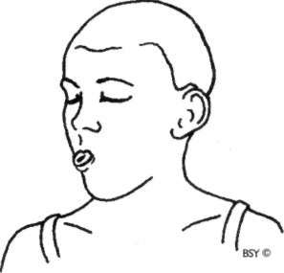

Sheetali Pranayama (cooling breath)

Sit in any comfortable meditation posture with the hands on the knees in chin or jnana mudra.

Close the eyes and relax the whole body.

Extend the tongue outside the mouth as far as possible without strain.

Roll the sides of the tongue up so that it forms a tube. Inhale and draw the breath in through this tube.

At the end of inhalation, draw the tongue in, close the mouth and exhale through the nose.

Practise yogic breathing throughout.

The breath should produce a noise similar to rushing wind.

A feeling of icy coldness will be experienced on the tongue and the roof of the mouth.

This is one round. Practise 9 rounds.

**Duration:** Gradually increase the number of rounds from 9 to 15 and the duration of each inhalation/exhalation.

For general purposes 15 rounds is sufficient; however, up to 60 rounds may be performed in very hot weather.

**Awareness:** On the tongue and the cooling sensation of the breath.

**Sequence:** Practise after asanas and other yogic practices which heat the body in order to restore temperature balance.

**Precaution:** This technique should not be practised in a dirty polluted atmosphere or during cold weather. The nose heats up and cleans the inhaled air before it enters the delicate lungs. However, breathing through the mouth bypasses this air-conditioning and the induction of cold or dirty air directly into the lungs may cause harm.

**Contra-indications:** People suffering from low blood pressure or respiratory disorders such as asthma, bronchitis and excessive mucus should not practise this pranayama. Those with heart disease should practise without breath retention. This practice cools down the activity of the lower energy centres, therefore, those suffering from chronic con• stipation should avoid it. Generally, this pranayama should not be practised in winter or in cool climates.

**Benefits:** This practice cools the body and the mind as well. It affects important brain centres associated with biological drives and temperature regulation. It cools and reduces mental and emotional excitation, and encourages the free flow of prana throughout the body. It induces muscular relaxation, mental tranquillity and may be used as a tranquilliser before sleep. It gives control over hunger and thirst, and generates a feeling of satisfaction. It helps reduce blood pressure and acid stomach.

**Advanced practice:** This pranayama may also be combined with jalandhara bandha on internal retention (for details of this practice refer to the section Bandha). Do not strain when performing kumbhaka, one or two seconds is suffi• cient at first. The duration may be increased gradually as the technique is mastered.

**Practice note:** About one third of the population possesses a genetic inability to roll the sides of the tongue into a tube. The practice of seetkari pranayama gives similar benefits.

***Note:*** *The Sanskrit word sheetali is derived from the root* sheet *which means 'cold'.* Sheetal *means 'that which is calm, passionless and soothing'.*

SEETKARI PRANAYAMA

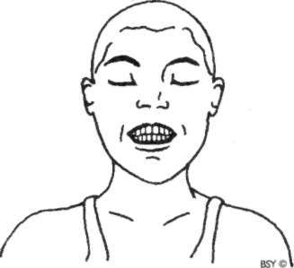

**Seetkari Pranayama (hissing breath)**

Sit in any comfortable meditation posture. Close the eyes and relax the whole body. Hold the teeth lightly together.

Separate the lips, exposing the teeth.

The tongue may be kept flat or folded against the soft palate in khechari mudra (refer to the section Mudra).

Breathe in slowly and deeply through the teeth.

At the end of the inhalation, close the mouth, keeping the tongue either flat or in khechari mudra.

Breathe out slowly through the nose in a controlled manner.

This is one round. Practise 9 rounds.

**Duration:** As for sheetali pranayama.

**Awareness:** On the hissing sound.

**Sequence:** As for sheetali pranayama.

**Contra-indications:** As for sheetali pranayama. Practitioners with sensitive teeth, missing teeth or dentures should practise sheetali pranayama instead.

**Benefits:** As for sheetali pranayama with the additional advan• tage that it keeps the teeth and gums healthy.

**Advanced practice:** As for sheetali pranayama.

***Note:*** *Through perfection of this practice, the adept becomes like the god Kamadeva.* Kama *means 'desire' and* deva *means 'master', therefore, through this practice desire is mastered and a state of balanced purification is achieved.*

BHRAMARI PRANAYAMA

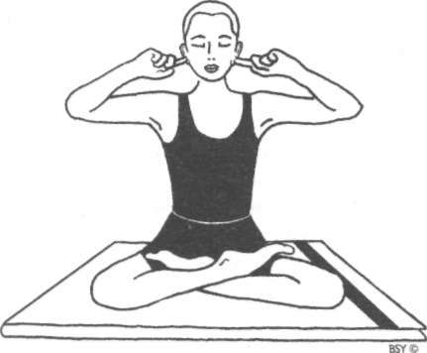

**Bhramari Pranayama (hummin g bee breath )**

Sit in a comfortable meditation asana. The spinal cord should be erect, the head straight and the hands resting on the knees in chin or jnana mudra.

The ideal posture for this practice is padmasana or siddha/ siddha yoni asana.

The position of nadanusandhana asana, which is used in nada yoga, may also be utilised as follows. Sit on a rolled blanket with the heels drawn up to the buttocks. Place the feet flat on the floor with the knees raised and the elbows resting on the knees. (For full details refer to Bihar School of Yoga publication *Yoga and Kriya).*

Close the eyes and relax the whole body for a short time. The lips should remain gently closed with the teeth slightly

separated throughout the practice. This allows the sound vibration to be heard and felt more distinctly in the brain. Make sure the jaws are relaxed.

Raise the arms sideways and bend the elbows, bringing the hands to the ears. Use the index or middle finger to plug the ears. The flaps of the ears may be pressed without inserting the fingers.

If the position of nadanusandhana has been assumed, plug the ears with the thumbs, resting the other four fingers on the head.

Bring the awareness to the centre of the head, where ajna chakra is located, and keep the body absolutely still.

Breathe in through the nose. Exhale slowly and in a controlled manner while making a deep, steady humming sound like that of the black bee.

Th e hummin g sound should be smooth, even and continuous for the duration of the exhalation.

The sound should be soft and mellow, making the front of the skull reverberate.

This is one round.

At the end of exhalation, breathe in deeply and repeat the process.

Perform 5 rounds.

**Awareness:** Physical - on the humming sound within the head and on making the breath steady and even.

Spiritual - on ajna chakra.

**Duration:** 5 to 10 rounds is sufficient in the beginning, then slowly increase to 10 to 15 minutes. In cases of extreme mental tension or anxiety, or when used to assist the healing process, practise for up to 30 minutes.

**Time of practice:** The best time to practise is late at night or in the early morning as there are fewer external noises to interfere with internal perception. Practising at this time awakens psychic sensitivity. However, bhramari may be practised at any time to relieve mental tension, providing the surroundings are peaceful.

**Contra-indications:** Bhramari should not be performed while lying down. People suffering from severe ear infections

should not practise this pranayama until the infection has cleared up. Those with heart disease must practise without breath retention.

**Benefits:** Bhramari relieves stress and cerebral tension, allevi• ating anger, anxiety and insomnia, and reducing blood pressure. It speeds up the healing of body tissue and may be practised after operations. It strengthens and improves the voice and eliminates throat ailments.

**Advanced practice:** Once the basic form of bhramari has been mastered, jalandhara and moola bandhas may be incorpo• rated into the practice in conjunction with internal breath retention (for details of these practices refer to the section Bandha). Do not strain when performing kumbhaka, one or two seconds is sufficient at first. Th e duration may be increased gradually as the technique is mastered. When the head has returned to the upright position and the ears are plugged, slowly exhale producing the humming sound. As an alternative practice, contract the throat while inhaling as in ujjayi pranayama, only more strongly. In this way a humming sound can be produced on inhalation as well as exhalation.

**Practice note:** Bhramari pranayama induces a meditative state by harmonising the mind and directing the awareness inwards. The vibrations of the sounds create a soothing effect on the mind and nervous system. It is also an important aspect of nada yoga which uses subtle sound vibration to attune the practitioners with their true nature.

***Note:*** *The word* bhramari *means 'bee' and the practice is so-called because a sound is produced which imitates that of the black bee.*

UJJAYI PRANAYAMA

**Ujjayi Pranayama (the psychic breath)**

Sit in any comfortable position, preferably a meditation asana.

Close the eyes and relax the whole body.

Take the awareness to the breath in the nostrils and allow the breathing to become calm and rhythmic.

After some time, transfer the awareness to the throat. Try to feel or to imagine that the breath is being drawn in and out through the throat and not through the nostrils; as if inhalation and exhalation are taking place through a small hole in the throat.

As the breathing becomes slower and deeper, gently contract the glottis so that a soft snoring sound like the breathing of a sleeping baby is produced in the throat. If this is practised correctly there will be a simultaneous contraction of the abdomen. This happens by itself, without any effort being made.

Both inhalation and exhalation should be long, deep and controlled.

Practise yogic breathing while concentrating on the sound produced by the breath in the throat.

The sound of the breath should not be very loud. It should just be audible to the practitioner but not to another person unless they are sitting very close.

When this breathing has been mastered, fold the tongue back into khechari mudra (refer to the section Mudra). If the tongue becomes tired, release it, while continuing the ujjayi breathing. When the tongue is rested, again fold it back.

Duration: Practise for 10 to 20 minutes.

Contra-indications: People who are too introverted by nature should not perform this practice. Those suffering from heart disease should not combine bandhas or breath retention with ujjayi.

**Benefits:** Ujjayi is classified as a tranquillising pranayama and it also has a heating effect on the body. This practice is used in yoga therapy to soothe the nervous system and calm the mind. It has a profoundly relaxing effect at the psychic level. It helps to relieve insomnia and may be practised in shavasana just before sleep. The basic form without breath retention or bandhas slows down the heart rate and is useful for people suffering from high blood pressure. Ujjayi alleviates fluid retention. It removes disorders of the *dhatu,* which are the 7 constituents of the body: blood, bone, marrow, fat, semen, skin and flesh.

**Advanced practice:** After becoming proficient in the practice, ujjayi may be performed with jalandhara bandha and moola bandha in conjunction with internal and external kumbhaka (for details of these practices refer to the section Bandha). Do not strain when performing kumbhaka, one or two seconds is sufficient at first. The duration may be increased gradually as the technique is mastered.

**Practice note:** Ujjayi may be performed in any position, stand• ing, sitting or lying. Those suffering from slipped disc or vertebral spondylitis may practise ujjayi in vajrasana or makarasana.

Many people contort their facial muscles when they do ujjayi. This is unnecessary. Try to relax the face as much as possible. Do not contract the throat too strongly. The contraction should be slight and applied continuously throughout the practice.

***Note:*** *The Sanskrit word* ujjayi *means 'victorious'. It is derived from the root* ji, *which means 'to conquer' or 'to acquire by conquest', and the prefix* ud, *which means 'bondage'. Ujjayi is therefore the pranayama which gives freedom from bondage. It is also known as the psychic breath, as it leads to subtle states of mind and is used together with khechari mudra, the tongue lock, in tantric meditation techniques such as mantra japa, ajapa japa, kriya yoga and prana vidya.*

BHASTRIKA PRANAYAMA

**Preparatory practice:** Sit in any comfortable meditation pos• ture, preferably padmasana, ardha padmasana or siddha/ siddha yoni asana, with the hands resting on the knees in either chin or jnana mudra.

Keep the head and spine straight, close the eyes and relax the whole body.

Take a deep breath in and breathe out forcefully through the nose. Do not strain.

Immediately afterwards breathe in with the same force. During inhalation the diaphragm descends and the abdomen moves outward.

During exhalation the diaphragm moves upward and the abdomen moves inward.

The above movements should be slightly exaggerated. Continue in this manner, counting 10 breaths.

At the end of 10 breaths, take a deep breath in and breathe out slowly.

This is one round. Practise up to 5 rounds.

Keep the eyes closed and concentrate on the breathing and the counting.

**Practice note:** When accustomed to this style of breathing, gradually increase the speed, always keeping the breath rhythmical.

Inhalation and exhalation must be equal.

**Bhastrika Pranayama (bellows breath)**

Sit in any comfortable meditation asana, preferably padmasana, ardha padmasana or siddha/siddha yoni asana, with the hands resting on the knees in either chin or jnana mudra.

Keep the head and spine straight. Close the eyes and relax the whole body.

Raise the right hand and perform nasagra mudra.

***Left nostril:*** Close the right nostril with the thumb.

Breathe in and out forcefully, without straining, through the left nostril 10 times. Count each breath mentally. The abdomen should expand and contract rhythmically with the breath.

The pumping action should be performed by the abdomen alone. Do not expand the chest or raise the shoulders. The body should not jerk.

There should be a snuffing sound in the nose but no sound should come from the throat or chest.

After 10 respirations, breathe in deeply through the left nostril keeping the right nostril closed.

Fill the lungs as much as possible, expanding both the chest and abdomen.

Close both nostrils and hold the breath inside. Retain the breath for a few seconds.

Exhale through the left nostril.

***Right nostril:*** Close the left nostril and breathe in and out forcefully 10 times through the right nostril, counting each time.

Inhale slowly and deeply through the right nostril. Close both nostrils and hold the breath inside.

Retain the breath for a few seconds.

Breathe out slowly through the right nostril.

***Both nostrils:*** Open both nostrils.

Breathe in and out forcefully through both nostrils 10 times, mentally counting each time.

Inhale slowly and deeply through both nostrils.

Close both nostrils and retain the breath for a few seconds. Breathe out slowly through both nostrils together.

Breathing through the left, the right and both nostrils, as above, forms one complete round.

**Breathing:** Bhastrika may be practised at three different breath rates: slow, medium and fast, depending on the capacity of the practitioner.

Slow bhastrika is practised to approximately one breath every two seconds, with no undue force on inhalation or exhalation. It is like amplified normal breathing. It is

especially useful for beginners and those using bhastrika for therapeutic purposes, although it may also be practised at all stages.

Medium bhastrika increases the speed of respiration to approximately one breath every second.

Fast bhastrika means a breathing speed of around two breaths per second. Both medium and fast breathing are suitable for intermediate and advanced practitioners.

The abdominal muscles will become stronger with regular practice. As they do so, the number of respirations may be increased by 5 per month from the initial count of 10 to a maximum count of 40 to 50 respirations through the left, the right and both nostrils.

**Duration:** Up to 5 rounds. Slowly increase the duration of retention up to 30 seconds after breathing through the left, the right and both nostrils. Do not strain.

**Awareness:** Physical - on the breathing process, the physical movement of the abdomen and mental counting.

Spiritual - on manipura chakra.

**Precautions:** A feeling of faintness, excessive perspiration or a vomiting sensation indicates that the practice is being performed incorrectly. Avoid violent respiration, facial contortions and excessive shaking of the body. If any of these symptoms are experienced, the advice of a yoga teacher should be sought.

This practice is ideal for purifying the blood and erad• icating a bad complexion. However, if the stages are rushed, all the impurities will be ejected from the body in a rush which may exacerbate the condition. A slow, conscientious approach to this practice is, therefore, recommended.

Bhastrika is a dynamic practice requiring a large expend• iture of physical energy. Beginners are advised to take a short rest after each round.

**Contra-indications:** Bhastrika should not be practised by people who suffer from high blood pressure, heart disease, hernia, gastric ulcer, stroke, epilepsy or vertigo. Those suffering from lung diseases such as asthma and chronic bronchitis,

or who are recovering from tuberculosis, are recom• mended to practise only under expert guidance.

**Benefits:** This practice burns up toxins and removes diseases of the *doshas* or humours: *kapha,* phlegm; *pitta,* bile; and *vata,* wind. Because of the rapid exchange of air in the lungs, there is an increase in the exchange of oxygen and carbon dioxide into and out of the bloodstream. This stimulates the metabolic rate, producing heat and flushing out wastes and toxins. The rapid and rhythmic movement of the diaphragm also massages and stimulates the visceral organs, toning the digestive system.

It is a useful practice for women during labour after a few months of proper preparation. Bhastrika reduces the level of carbon dioxide in the lungs. It is an excellent practice for asthmatics and those suffering from other lung disorders. It alleviates inflammation in the throat and any accumulation of phlegm. It balances and strengthens the nervous system, inducing peace, tranquillity and one- pointedness of mind in preparation for meditation.

**Advanced practice:** Once this practice has been mastered, jalandhara and moola bandha may be combined during each internal breath retention or after each round.

**Practice note:** Both nostrils must be clear and flowing freely. Mucus blockages may be removed through the practice of neti (see the section Shatkarma). If the flow of breath in the nostrils is unequal, it may be balanced by practising padadhirasana as a breath balancing technique (see chapter Vajrasana Group of Asanas).

Beginners should be familiar with abdominal breathing before taking up bhastrika.

***Note:*** *The Sanskrit word* bhastrika *means 'bellows'. Thus, bhastrika pranayama is also known as the bellows breath, as air is drawn forcefully in and out of the lungs like the bellows of a village blacksmith. The bellows increases the flow of air into the fire, producing more heat. Similarly, bhastrika pranayama increases the flow of air into the body to produce inner heat at both the physical and subtle levels, stoking the inner fire ofmind/body.*

KAPALBHATI PRANAYAMA

**Kapalbhati Pranayama (frontal brain cleansing breath)**

Sit in any comfortable meditation asana; padmasana, as a first choice, or siddha/siddha yoni asana, with the head and spine straight and the hands resting on the knees in either chin or jnana mudra.

Close the eyes and relax the whole body.

Inhale deeply through both nostrils, expanding the abdomen, and exhale with a forceful contraction of the abdominal muscles. Do not strain.

The next inhalation takes place by passively allowing the abdominal muscles to expand. Inhalation should be a spontaneous or passive recoil, involving no effort.

Perform 10 respirations to begin with. Count each respiration mentally.

After completing 10 rapid breaths in succession, inhale and exhale deeply.

This is one round. Practise 3 to 5 rounds.

After completing the practice, maintain awareness of the void in the region of the eyebrow centre, feeling an all- pervading emptiness and calm.

**Breathing:** It is important that the rapid breathing used in these techniques be from the abdomen and not from the chest.

The number of respirations may be increased from the initial count of 10 up to 20, as the abdominal muscles become stronger.

**Duration:** Up to 5 rounds of 10 to 20 breaths.

Advanced practitioners may extend the number of rounds to 10 or more; longer periods than this should only be practised under expert guidance.

**Awareness:** Physical - on rhythmic breathing, keeping count of the respirations.

Spiritual - on chidakasha or the void at the eyebrow centre.

**Sequence:** Kapalbhati should be practised after asanas or neti and immediately before pratyahara and dharana meditation techniques. It may be performed at any time of day but should only be practised on an empty stomach, 3 to 4 hours after meals.

**Precautions:** If pain or dizziness is experienced, stop the practice and sit quietly for some time. When the sensation has passed, recommence the practice with more awareness and less force. If the problem continues, consult a yoga teacher.

**Contra-indications:** Kapalbhati should not be practised by those suffering from heart disease, high blood pressure, vertigo, epilepsy, stroke, hernia or gastric ulcer.

**Benefits:** Kapalbhati purifies ida and pingala nadis, and also removes sensory distractions from the mind. It is used to energise the mind for mental work, to remove sleepiness and to prepare the mind for meditation.

It has a similar cleansing effect on the lungs to bhastrika and is, therefore, a good practice for asthmatics and those suffering from emphysema, bronchitis and tuberculosis. After a few months of proper preparation, it can be effective for women to use during childbirth.

It balances and strengthens the nervous system and tones the digestive organs.

For spiritual aspirants, this practice arrests thoughts and visions.

**Practice note:** Although kapalbhati is similar to bhastrika, there are important differences. Bhastrika uses force on both inhalation and exhalation, expanding and contracting the lungs above and below their resting or basic volume. Kapalbhati, on the other hand, actively reduces the volume of air in the lungs below this level through forced exha• lation. In this practice, inhalation remains a passive process which brings the level of air in the lungs back to the basic volume only. This way of breathing reverses the normal breathing process which involves active inhalation and passive exhalation.

**Note:** *Kapalbhati is also one of the six shatkarmas. The Sanskrit word* kapal *means 'cranium' or 'forehead' and* bhati *means 'light' or 'splendour' and also 'perception or 'knowledge'. Hence kapalbhati is the practice which brings a state of light or clarity to the frontal region of the brain. Another name for this practice is kapalshodhana, the word* shodhana *meaning 'to purify'.*

# Mudra

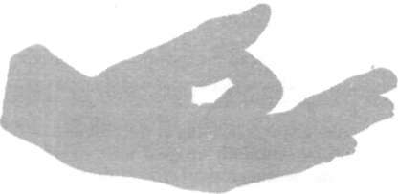

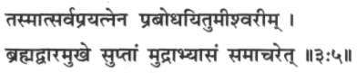

*Tasmaatsarvaprayatnena prabodhayitumeeshvareem. Brahmadvaaramukhe suptaam mudraabhyaasam samaacharet.*

Therefore the goddess sleeping at the entrance of Brahma's door should be constantly aroused with all effort, by per• forming mudra thoroughly.

*Hatha Yoga Pradipika (3:5)*

###### Introduction to Mudra

T

he Sanskrit word *mudra* is translated as 'gesture' or 'attitude'. Mudras can be described as psychic, emotional, devotional and aesthetic gestures or attitudes. Yogis have experienced mudras as attitudes of energy flow, intended to link individual pranic force with universal or cosmic force." The *Kularnava Tantra* traces the word mudra to the root *mud* meaning 'delight' or 'pleasure' and *dravay,* the causal form of *dru* which means 'to draw forth'. Mudra is also defined as a

'seal', 'short-cut' or 'circuit by-pass'.

Mudras are a combination of subtle physical movements which alter mood, attitude and perception, and which deepen awareness and concentration. A mudra may involve the whole body in a combination of asana, pranayama, bandha and visualisation techniques or it may be a simple hand position. The *Hatha Yoga Pradipika* and other yogic texts consider mudra to be a *yoganga,* an independent branch of yoga, requiring a very subtle awareness. Mudras are introduced after some proficiency has been attained in asana, pranayama and bandha, and gross blockages have been removed.

Mudras have been described in various texts from antiquity to the present day in order to preserve them for posterity. However, such references were never detailed or clearly delineated as these techniques were not intended to be learned from a book. Practical instruction from a guru was always considered to be a necessary requisite before attempting them. Mudras are higher practices which lead to awakening of the pranas, chakras and kundalini, and which can bestow major *siddhis,* psychic powers, on the advanced practitioner.

Mudras and prana

The attitudes and postures adopted during mudra practices establish a direct link between *annamaya kosha,* the physical body; *manomaya kosha,* the mental body; and *pranamaya kosha,* the pranic body. Initially, this enables the practitioner to develop awareness of the flow of prana in the body. Ultimately, it establishes pranic balance within the koshas and enables the redirection of subtle energy to the upper chakras, inducing higher states of consciousness.

Mudras manipulate prana in much the same way that energy in the form of light or sound waves is diverted by a mirror or a cliff face. The nadis and chakras constantly radiate prana which normally escapes from the body and dissipates into the external world. By creating barriers within the body through the practice of mudra, the energy is redirected within. For example, by closing the eyes with the fingers in shanmukhi mudra, the prana being radiated through the eyes is reflected back. In the same way, the sexual energy emitted through vajra nadi is redirected to the brain through the practice of vajroli mudra.

Tantric literature states that once the dissipation of prana is arrested through the practice of mudra, the mind becomes introverted, inducing states of *pratyahara* or sense withdrawal and *dharana,* concentration. Because of their ability to redirect prana, mudras are important techniques for awakening kundalini. For this reason they are extensively incorporated in kriya and kundalini yoga practices.

A scientific look at mudras

**In** scientific terms, mudras provide a means to access and influence the unconscious reflexes and primal, instinctive habit patterns that originate in the primitive areas of the brain around the brain stem. They establish a subtle, non-intellectual connection with these areas. Each mudra sets up a different link and has a correspondingly different effect on the body, mind and prana. The aim is to create fixed, repetitive postures and gestures which can snap the practitioner out of instinctive habit patterns and establish a more refined consciousness.

Five groups of yoga mudras

The yoga mudras can be categorised into approximately five groups which are described as follows:

1. ***Hasta,*** hand mudras: The hand mudras presented in this book are meditative mudras. They redirect the prana being emitted by the hands back into the body. Mudras which join the thumb and index finger engage the motor cortex at a very subtle level, generating a loop of energy which moves from the brain down the hand and then back again. Conscious awareness of this process rapidly leads to internalisation. Techniques included in this category:

Jnana mudra Chin mudra Yoni mudra Bhairava mudra Hridaya mudra.

1. ***Mana,*** head mudras: These practices form an integral part of kundalini yoga and many are meditation techniques in their own right. They utilise the eyes, ears, nose, tongue and lips. Techniques included in this category:

Shambhavi mudra Nasikagra drishti Khechari mudra Kaki mudra Bhujangini mudra Bhoochari mudra Akashi mudra Shanmukhi mudra Unmani mudra.

1. ***Kaya,*** postural mudras: These practices utilise physical postures combined with breathing and concentration. Techniques included in this category:

Prana mudra

Vipareeta karani mudra Yoga mudra

Pashinee mudra Manduki mudra Tadagi mudra.

1. ***Bandha,*** lock mudras: These practices combine mudra and bandha. They charge the system with prana and prepare it for kundalini awakening. Techniques included in this category:

Maha mudra

Maha bheda mudra Maha vedha mudra.

1. ***Adhara,*** perineal mudras: These techniques redirect prana from the lower centres to the brain. Mudras concerned with sublimating sexual energy are in this group. Tech• niques included in this category:

Ashwini mudra Vajroli/sahajoli mudra.

Between them these groups engage substantial areas of the cerebral cortex. The comparatively large number of head and han d mudras reflects the fact that operation and interpretation of information coming in from these two areas occupies approximately fifty percent of the cortex.

Mudras are performed either in combination with or after asanas and pranayamas. The mudras presented in this book represent a small selection of those discussed in the yogic texts. For more information on mudras see the Bihar School of Yoga publications *Yoga and Kriya, Yoga Darshan* and *Hatha Yoga Pradipika.*

JNAN A AN D CHI N MUDRAS

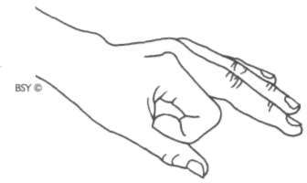

Jnana Mudra (psychic gesture of knowledge)

Assume a comfortable meditation posture.

Fold the index fingers so that they touch the inside root of the thumbs. Straighten the other three fingers of each hand so that they are relaxed and slightly apart.

Place the hands on the knees with the palms facing down. Relax the hands and arms.

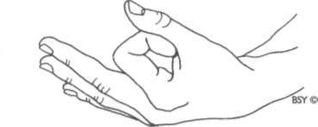

Chin Mudra (psychic gesture of consciousness)

Chin mudra is performed in the same way as jnana mudra except that the palms of both hands face upwards, with the backs of the hands resting on the knees.

Relax the hands and arms.

**Sequence:** One of these two mudras should be adopted when• ever practising meditation, unless otherwise specified.

**Benefits:** Jnana mudra and chin mudra are simple but impor• tant psycho-neural finger locks which make meditation asanas more powerful. The palms and fingers of the hands

have many nerve root endings which constantly emit energy. When the finger touches the thumb, a circuit is produced which allows the energy that would normally dissipate into the environment to travel back into the body and up to the brain.

When the fingers and hands are placed on the knees, the knees are sensitised, creating another pranic circuit that maintains and redirects prana within the body. In addition, placing the hands on the knees stimulates a nadi which runs from the knees, up the inside of the thighs and into the perineum. This nadi is known as *gupta* or the hidden nadi. Sensitising this channel helps stimulate the energies at mooladhara chakra.

When the palms face upward in chin mudra, the chest area is opened up. The practitioner may experience this as a sense of lightness and receptivity which is absent in the practice of jnana mudra.

**Variation:** Jnana and chin mudras are often performed with the tip of the thumb and index finger touching and forming a circle. Beginners may find this variation less secure for prolonged periods of meditation as the thumb and index finger tend to separate more easily when body awareness is lost. Otherwise, this variation is as effective as the basic position.

**Practice note:** The effect of chin or jnana mudras is very subtle and it requires great sensitivity on the part of the practi• tioner to perceive the change in consciousness established. With practice, however, the mind becomes conditioned to the mudra and when it is adopted the signal to enter a meditative state is transmitted.

***Note:*** *The word* jnana *means 'wisdom' or 'knowledge', thus jnana mudra is the gesture of intuitive knowledge.* Chin, *on the other hand, is derived from the word* chit *or* chitta *which means 'consciousness'. Chin mudra, therefore, is the psychic gesture of consciousness.*

*Symbolically, the small, ring and middle fingers represent the three* gunas *or qualities of nature:* tamas, *inertia;* rajas, *activity*

*and creativity; and* sattwa, *luminosity and harmony. In order for consciousness to pass from ignorance to knowledge these three states must be transcended. The index finger represents individual consciousness, the* jivatma, *while the thumb symbolises supreme consciousness. Injnana and chin mudras the individual (index finger) is bowing down to the supreme consciousness (the thumb), acknowledging its unsurpassed power. The index finger, however, is touching the thumb, symbolising the ultimate unity*

*of the two experiences and the culmination of yoga.*

YONI MUDRA

**Yoni Mudra (attitude of the womb or source)**

Assume a comfortable meditation posture with the head and spine straight.

Place the palms of the hands together with the fingers and thumbs straight and pointing away from the body.

Keeping the pads of the index fingers together, turn the little, ring and middle fingers inwards so that the backs of the fingers are touching.

Interlock the little, ring and middle fingers.

Bring the thumbs towards the body and join the pads of the fingers together to form the base of a yoni or womb shape.

**Benefits:** The interlocking of the fingers in this practice creates a complete cross connection of energies from the right hand into the left and vice versa. As well as balancing the energies in the body, it helps balance the activities of the right and left hemispheres of the brain. Placing the tips of the index fingers and thumbs together further intensifies the flow of prana.

This mudra makes the body and mind more stable in meditation and develops greater concentration, awareness and internal physical relaxation.

It redirects pran a back into the body which would otherwise be dispersed. The elbows naturally tend to point to the side when performing this mudra which helps open up the chest area.

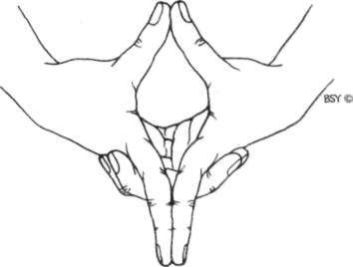

**Variation:** Yoni mudra may also be performed by interlocking the middle, ring and little fingers without turning them inward. The thumbs may be crossed in front of the out• stretched index fingers, or outstretched with the pads touching towards the body.

***Note:*** *The word* yoni *means 'womb' or 'source'. Yoni mudra invokes the primal energy inherent in the womb or source of creation.*

BHAIRAVA MUDRA

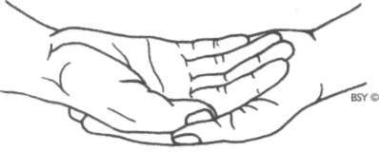

**Bhairava Mudra (fierce or terrifying attitude)**

Assume a comfortable meditation posture with the head and spine straight.

Place the right hand on top of the left, so that the palms of both hands are facing up. Both hands then rest in the lap. Close the eyes and relax the whole body, keeping it motionless.

**Variation:** When the left hand is placed on top of the right the practice is called Bhairavi mudra. Bhairavi is the female counterpart of Bhairava.

***Note:*** *Bhairava is the fierce or terrifying form of Lord Shiva, the aspect responsible for the dissolution of the universe. The two hands represent ida and pingala nadis, and the union of the individual with the supreme consciousness.*

*Bhairava mudra is used in prana mudra. It may also be used during pranayama and meditation practice.*

HRIDAYA MUDRA

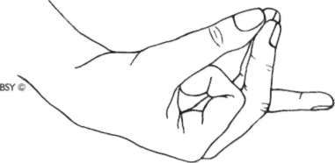

**Hridaya Mudra (heart gesture)**

Sit in any comfortable meditation asana with the head and spine straight.

Place the tips of the index fingers at the root of the thumbs, as in chin and jnana mudras, and join the tips of the middle and ring fingers to the tips of the thumbs so they are placed side by side. The little finger remains straight. Place the hands on the knees with the palms facing upward. Close the eyes and relax the whole body, keeping it motionless.

**Duration:** This practice may be performed for up to 30 minutes.

**Awareness:** Physical - on the breath in the chest area.

Spiritual - on anahata chakra.

**Benefits:** This mudra diverts the flow of prana from the hands to the heart area, improving the vitality of the physical heart. The middle and ring fingers relate directly to nadis connected with the heart, while the thumb closes the pranic circuit and acts as an energiser, diverting the flow of prana from the hands to these nadis. Hridaya mudra is, therefore, beneficial for heart ailments, especially ischemic heart disease. It is very simple and may be used safely and easily in acute situations. The heart is the centre of emotion. Hridaya mudra helps to release pent-up emotion and unburden the heart. It may be practised during emotional conflict and crisis.

###### Psychic Physiology of Yoga

In this book, together with each practice, a particular point is recommended for concentration. If the aim is to relax and gain optimum physical benefit from yoga practices, it is necessary to concentrate on something. By directing the mind to a specific region of the body or to the breath, the effect of a particular practice is increased. Sometimes one of the *chakras* or psychic centres is also used as a point for spiritual concentration.

On a physical level, chakras are associated with the major nerve plexuses and endocrine glands in the body. Many asanas have a particularly powerful and beneficial effect on one or more of these glands or plexuses. For example, sarvangasana exerts a strong pressure on the thyroid gland in the throat region, which is associated with vishuddhi chakra. The thyroid is given a good massage and its functioning is greatly improved. However, if the concentration is directed to this chakra while performing the asana, the beneficial effects will be increased.

Definition of chakra

The word *chakra* literally means 'wheel' or 'circle' but in the yogic context a better translation is 'vortex' or 'whirlpool'. The chakras are vortices of pranic energy at specific areas in the body which control the circulation of prana permeating the entire human structure. Each chakra is a switch which turns on or opens up specific areas of the brain. In most people these psychic centres lie dormant and inactive. Concentration on the chakras while performing yogic practices stimulates the flow of energy through the chakras and helps to activate them.

This in turn awakens the dormant areas in the brain and the corresponding faculties in the psychic and mental bodies, allowing one to experience higher planes of consciousness which are normally inaccessible.

The major chakras are seven in number and are located along the pathway of sushumna which flows through the centre of the spinal cord. Sushumna originates at the perineum and terminates at the top of the head. The chakras are connected to a network of psychic channels called *nadis,* which correspond to the nerves but are more subtle in nature. The chakras are depicted symbolically as lotus flowers, each having a particular number of petals and a characteristic colour. Th e lotus symbolises the three stages the aspirant must pass through in spiritual life: ignorance, aspiration and illumination. It represents spiritual growth from the lowest state of awareness to the highest state of consciousness.

The petals of the lotus, inscribed with the *beeja mantras* or seed sounds of the Sanskrit alphabet, represent the different manifestations of psychic energy connected with the chakras and the nadis or psychic channels leading into and out of them. Within each chakra is a *yantra* comprised of the geometrical symbol of its associated element and beeja mantra. Within the yantra there is also a presiding deity, which represents particular aspects of divinity, along with the corresponding *vahana* or vehicle which is an animal form, representing other psychic aspects related with the particular centre.

Description of the seven chakras

**Mooladhara chakra:** The lowest of the chakras is situated at the perineum in the male body and at the cervix in the female body. The word *mool* means 'root' and *adhara* means 'place'. Therefore, it is known as the root centre. Mooladhara chakra is associated with the sense of smell. It is symbolised by a deep red lotus with four petals. In the centre is a yellow square, the yantra *oiprithvi tattwa,* the earth element, and the beeja mantra *lam.* In the centre of the square is a red triangle, the symbol of *shakti* or creative energy, with its apex pointing

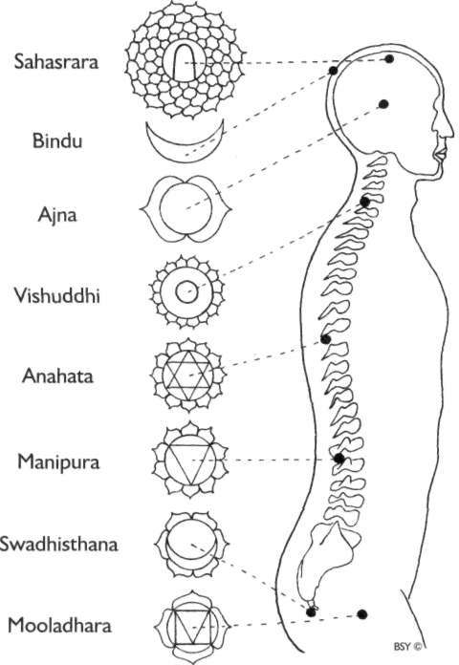

Location of the Chakras

downward. Within the triangle is the smoky coloured *swayambhu linga,* symbolising the astral body. A red serpent, representing the dormant *kundalini* is coiled three and a half times around the linga. The red triangle is supported by an elephant with seven trunks which symbolises the stability and solidarity of the earth.

Mooladhara chakra is the seat or dwelling place of primal energy, kundalini shakti. Kundalini is the serpent coiled in

deep slumber around swayambhu linga. It is the source of all energy in mankind and the universe whether sexual, emotional, mental, psychic or spiritual. While this energy is one, it takes on various qualities and attributes depending on the psychic centre through which it manifests. The aim of yoga is to awaken the dormant kundalini through self-purification and con• centration of mind and to lead it up through the chakras to sahasrara where, as pure energy or Shakti, it unites with pure consciousness, Shiva.

For concentration on mooladhara chakra, visualise the red inverted triangle or the yellow square, symbols of energy and solidity, to enhance inner stability and balance.

**Swadhisthana chakra:** Approximately two fingers' width above mooladhara chakra in the spine, directly behind the genital organs is *swadhisthana chakra.* The literal meaning of the word swadhisthana is 'one's own abode'. The Sanskrit word *swa* means 'self and *sthan* means 'dwelling place'. This chakra is symbolised by a crimson lotus with six petals. In the centre is a white crescent moon, the yantra *of apas tattwa,* the water element, and the beeja mantra *vam.* The crescent moon yantra and beeja mantra are riding on a crocodile, symbolising the subterranean movement of the karmas.

Swadhisthana chakra is associated with seeking pleasure through the tongue and genital organs. Whereas material security is sought in mooladhara chakra, in swadhisthana the emphasis is on enjoyment, on the pleasurable sensations associated with food and drink and sexual interaction. When swadhisthana becomes active, it may manifest as overwhelming desires or cravings for these things. On the physical level, swadhisthana is associated with the organs of excretion and reproduction. Visualisation of this centre can help rectify disorders of these functions.

On a deeper level, swadhisthana chakra is the seat of the individual and collective unconscious; it is the storehouse of all *samskaras,* past mental impressions stored in the form of archetypes. It is the centre of humankind's most primitive and deep-rooted instincts. By purifying this centre the animal nature is transcended.

For concentration on this centre, visualise a vast, deep ocean with dark waves beneath a night sky. The tides of the ocean represent the ebb and flow of awareness.

**Manipura chakra:** Situated in the spine behind the navel is manipura chakra. The word *mani* means 'gem' and*pura* means 'city', therefore, *manipura* means 'city of jewels'. It is so-called because, being the fire centre, it is lustrous like a jewel and radiant with vitality and energy. This chakra is depicted as a bright yellow lotus with ten petals. Within the lotus is a fiery red triangle, the yantra *ol'agni tattwa,* the fire element, and the beeja mantra *ram.* The animal which serves as the vehicle for manipura is the ram, the symbol of assertiveness and energy. Manipura is the centre of self-assertion, dynamism and dominance. It is associated with ambition and the will and ability to rule. On the negative side, this may be expressed in despotism and in seeing things and people merely as a means

to gain personal power or to satisfy personal needs.

The solar plexus is the centre chiefly concerned with the vital process of digestion and food metabolism. It governs the functioning of the gastric glands, the pancreas, gall bladder and so on, which produce and secrete enzymes, acids and juices necessary for the digestion and absorption of nutrients. Manipura chakra is the psychic centre which controls these activities.

The adrenal glands located above the kidneys are also related with manipura. They secrete adrenaline into the blood during an emergency situation. This has the effect of speeding up all the physiological processes, making the mind sharp and alert, the heart beat faster, the respiration rate more rapid and so on. The body is then prepared for a more intense level of activity than normal in what is commonly called the 'fight or flight' reaction. Those people who suffer from sluggishness and depression or malfunctions of the digestive system, such as diabetes and indigestion, should concentrate on manipura chakra and try to feel energy radiating from this region.

For concentration on this centre, visualise the blazing sun or a ball of fire. Experience energy in the form of light radiating from this region and permeating the whole body.

**Anahata chakra:** Situated in the spine, behind the sternum, level with the heart, is anahata chakra. The word *anahata* literally means 'unstruck'. All sound in the manifested universe is produced by the striking together of two objects which sets up vibrations or sound waves. That sound, however, which issues from beyond this material world, the primordial sound, is the source of all sound and is known as *anahadnada,* psychic sound. The heart centre is where this sound manifests. It may be perceived by the yogi as an internal, unborn and undying vibration, the pulse of the universe.

This chakra is symbolised by a blue lotus with twelve petals. In the centre of the lotus is a hexagon formed by two interlacing triangles. This is the yantra *oivayu tattwa,* the air element. The beeja mantra is *yam* and the vehicle is a swift black antelope, the symbol of alertness and compassion. Anahata chakra is the centre of unconditional love. At this level the feelings of universal brotherhood and tolerance begin to develop and all beings are accepted and loved for what they are.

On the physical level, anahata is associated with the heart and lungs, and the circulatory and respiratory systems. Sufferers of diseases such as anaemia, hypertension, palpitations, tuberculosis, asthma and bronchitis may concentrate on anahata while performing asanas and other yogic techniques.

For meditation on anahata chakra, visualise a blue lotus or a blue hexagon, formed by two interlacing triangles, with a tiny, bright flame burning at the centre. Imagine it to be steady and unflickering like a flame in a windless place. This is the symbol of the *jivatma,* the individual soul, the indwelling spirit of all beings which is undisturbed by the winds of the world.

**Vishuddhi chakra:** Situated at the back of the neck, behind the throat pit, is vishuddhi chakra, the centre of purification. Th e word *shuddhi* means 'purification' and the prefix *vi* enhances this quality. It is symbolised by a violet lotus with sixteen petals. In the centre of the lotus is a white circle, the yantra *ofakasha tattwa,* the ether element, and the beeja mantra is *ham.* The animal related to vishuddhi chakra is a white elephant. Right understanding and discrimination develop at

vishuddhi chakra. Here the dualities of life are accepted, allowing one to flow with life and let things happen as they will, without distinguishing between good and bad.

Vishuddhi chakra governs the vocal cords, the region of the larynx, and the thyroid and parathyroid glands. Disorders of this area of the physical body can be remedie d by concentrating on this chakra. The throat centre is the place where the divine nectar called *amrita,* the mystical elixir of immortality, is tasted. This nectar is a kind of sweet secretion which is produced at bindu chakra and then falls down to vishuddhi where it is purified and processed for further use throughout the body.

For concentration on this centre, visualise a large white drop of nectar. Try to experience icy cold drops of sweet nectar falling down to vishuddhi, giving a feeling of blissful intoxication.

**Ajna chakra:** Situated in the midbrain, behind the eyebrow centre, at the top of the spine, is ajna chakra. This centre is also known by various names such as: the third eye; *jnana chakshu,* the eye of wisdom; *triveni,* the confluence of three rivers; guru chakra and the Eye of Shiva. The word *ajna* means 'command'. In deeper states of meditation the disciple receives commands and guidance from the guru, and from the divine or higher self, through this chakra.

Ajna chakra is depicted as a silver lotus with two petals which represent the sun and the moon or *pingala,* the positive force, and *ida,* the negative force. These two pranic flows which are responsible for the experience of duality, converge at this centre with *sushumna,* the spiritual force. In the centre of the lotus is the sacred beeja mantra *om.* The element of this chakra is *manas,* mind. This is the centre where wisdom and intuition develop. When ajna is awakened, the mind becomes steady and strong, and full control over prana is gained.

Ajna corresponds to the pineal gland which has almost atrophied in the adult human being. On the psychic plane this point is the bridge between the mental and psychic dimensions. Therefore, ajna chakra is responsible for supramental faculties such as clairvoyance, clairaudience and telepathy.

Thought is also a very subtle form of energy. When ajna chakra is awakened, it is possible to send and receive thought transmission through this centre. It is like a psychic doorway openin g into deepe r and higher realms of awareness. Stimulating ajna chakra develops all the faculties of the mind, such as intelligence, memory and concentration.

For concentration on ajna chakra, the point of *bhrumadhya* at the eyebrow centre is used. Visualise a tiny point of light or an *om* symbol at this centre and let the thoughts dwell on the inner guru.

**Bindu visarga:** At the top, back portion of the head, where the Hindu brahmins grow a small tuft of hair, is a point known as bindu. The word *bindu* means 'point' or 'drop' and *visarga* means 'to pour drop by drop'. This psychic centre is also known as soma chakra. *Soma* is the nectar of the gods and is also another name for the moon. Bindu visarga is symbolised by a tiny crescent moon on a dark night. It is also associated with the production of semen.

Bindu is the centre of nada, and this centre is used for concentration on the psychic sounds which manifest there. In practices such as bhramari pranayama and shanmukhi mudra, concentration on bindu is used to develop the awareness of nada.

**Sahasrara:** Situated at the crown of the head is sahasrara. It is not really a chakra but the abode of highest consciousness. Th e word *sahasrara* means 'one thousand'. Sahasrara is visualised as a shining lotus of a thousand petals, containing the fifty-two beeja mantras of the Sanskrit alphabet twenty times over. In the centre of the lotus is a shining *jyotirlinga,* lingam of light, symbol of pure consciousness. It is in sahasrara that the mystical union of Shiva and Shakti takes place, the fusion of consciousness with matter and energy, the individual soul with the supreme soul. When kundalini awakens, it ascends through the chakras to sahasrara and merges into the source from whence it originated. Matter and energy merge into pure consciousness in a state of intoxicating bliss, the goal of yoga. Having attained this, the yogi gains supreme knowledge and passes beyond birth and death.

Nadis

The word *nadi* literally means 'flow' or 'current'. The ancient texts say that there are seventy two thousand nadis in the psy• chic body. These are visible as currents of light to a person who has developed psychic vision. In recent times the word nadi has been translated as 'nerve', but actually nadis are composed of astral matter. Like the chakras, they are not actually part of the physical body, although they correspond with the nerves. Nadis are the subtle channels through which the pranic forces flow. Out of the large number of nadis in the psychic body, ten are major and of these, three are most significant. These are ida, pingala and sushumna. The most important of these three is sushumna. All the nadis in the psychic body are subordi• nate to sushumna, even ida and pingala.

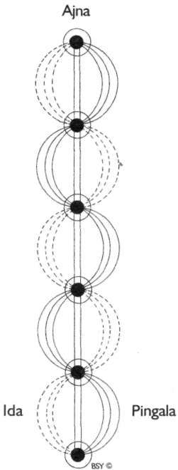

Mooladhara

Ida, pingala and sushumna

Sushumna nadi is the spiritual channel located at the centre of the spinal cord. It originates from mooladhara chakra at the perineum and terminates at sahasrara, at the crown of the head. Ida nadi emanates from the left side of mooladhara and spirals up the spinal cord, passing through each chakra in turn, forming a criss-cross pathway which terminates at the left side of ajna chakra. Pingala nadi emanates from the right side of mooladhara and passes in an opposite manner to that of ida, terminating at the right side of ajna. Ida and pingala

represent the two opposites forces flowing within us. Ida is passive, introvert and feminine; it is also known as the *chandra* or moon nadi. Pingala, on the other hand, is active, extrovert and masculine and is called the *surya* or sun nadi.

Pranic currents and the breath

These pranic currents, ida, pingala and sushumna, operate alternately. The current that is flowing at any particular time may be gauged by noting the flow of breath in the nostrils. When the left nostril has a greater flow of air, then ida nadi is predominant. When the flow is greater in the right nostril, then pingala is predominant. If the flow is equal, then sushumna is predominant. When the right nostril (pingala) flows, there is more vital energy for physical work, digestion of food and so on. The mind is extroverted and the body generates more heat. When the left nostril (ida) is flowing, mental energy is dominant. The mind is introverted and any land of mental work may be undertaken. During sleep ida nadi flows. If pingala flows at night, sleep will be restlessness and disturbed. Likewise, if ida flows while taking food, the digestive process may be slow, causing indigestion.

Altering the flow of nadis and breath

All activities are influenced by the flow of these nadis which alternate approximately every sixty to ninety minutes. It is possible, however, to alter the flow voluntarily by using yogic techniques such as padadhirasan a and pranayama. For example, if ida nadi is flowing and there is physical work to be done, it is possible to redirect the flow of the breath to pingala nadi to obtain the necessary energy. On the other hand, if study or mental work is required, the energy may be directed to flow through ida nadi. For more information on the breath and nadis, see Bihar School of Yoga publication *Swara Yoga, the Tantric Science of Brain Breathing.*

Purpose of hatha yoga

The main aim of hatha yoga is to bring about a balanced flow of prana in ida and pingala nadis. The word hatha is comprised

of two beeja mantras *ham,* representing the sun or solar force, and *tham,* representing the moon or lunar force. To bring about a balance between these two forces, the body must first be purified by the shatkarmas. The aim of hatha yoga is to balance these two flows so that neither the mental nor physical faculties are dominant. During the twenty-four hour period of the day, the flow of ida should predominate for about twelve hours and the flow of pingala for the other twelve hours.

When ida and pingala nadis are purified and balanced, and the mind is controlled, then sushumna, the most important nadi, begins to flow. Sushumna must be flowing for success in meditation. If pingala flows, the body will be restless; if ida flows, the mind will be overactive. When sushumna flows, kundalini awakens and rises through the chakras.

Nadis and the nervous system

At the physical level, ida and pingala correspond to the two aspects of the autonomic nervous system, the sympathetic and the parasympathetic. Pingala coincides with the sympathetic nervous system and ida with the parasympathetic nervous system. The sympathetic nervous system is responsible for the stimulation and acceleration of activities concerned with the external environment and the deceleration of the organs which tend to utilise a lot of energy internally. The sympathetic nerves speed up the heart, dilate the blood vessels, increase the respiration rate and intensify the efficiency of the eyes, ears and other sense organs. The parasympathetic nerves directly oppose the sympathetic nerves for they reduce the heartbeat, constrict the blood vessels and slow respiration. This results in introversion. The flow of prana in ida and pingala is completely involuntary and unconscious until controlled by yogic practices.

Sensitivity and awareness

The primary requirements for locating the chakras and nadis and visualising their symbols and pathways on the psychic plane are sensitivity and awareness. The practices presented in this text all relate to specific chakras and nadis. Th e actual

purpose of these practices is to purify and balance the chakras and nadis so that the kundalini can awaken. As the chakras and nadis become regulated, the awareness of these subtle dimensions is automatically stimulated and the spiritual vision opens. This has been the experience of yogis from time immemorial. In order to attain this experience for oneself, regularity in practice is essential.

For more on this subject refer to the Bihar School of Yoga publications *Kundalini Tantra, Yoga and Kriya, Yoga Darshan, Hatha Yoga Pradipika* and *Prana Pranayama Prana Vidya.*

###### Therapeutic Index

This chapter provides a simple and basic guide to yoga practices promoting the general health of specific areas of the body and the prevention of common ailments. These practices should not be taken as a prescription for therapy. Anyone suffering from a disease or ailment must seek the guidance of a competent and knowledgeable yoga therapist or medical doctor with whom they can discuss their symptomatology. This is particularly true where more than one illness is present, or where severe conditions prevail.

For details of information and health management courses, contact Bihar School of Yoga or any of its branch ashrams. Following are a list of the relevant Bihar School of Yoga publications:

Amaroli

Meditations from the Tantras

*(antar mouna, ajapa japa, yogic relaxation and medita• tion techniques)*

Nawa Yogini Tantra

*(preparation for pregnancy and childbirth, female reproductive organs)*

Prana Pranayama Prana Vidya

The Effects of Yoga on Hypertension

The Practices of Yoga for the Digestive System Yoga and Cardiovascular Management

Yoga Education for Children

Yogic Management of Asthma and Diabetes Yogic Management of Common Diseases Yoga Nidra

**Abdomen:** (general toning and strengthening)

**Asana:** General - Pawanmuktasana parts 2 and 3, supta vajrasana, shashankasana, ushtrasana, trikonasana, yogamudrasana, matsyasana, any backward or forward bending asana, ardha matsyendrasana, halasana, druta halasana.

Advanced - Tolangulasana, merudandasana, mayurasana, niralamba paschimottanasana, hamsasana, brahmachary asana.

**Pranayama:** Bhastrika, kapalbhati.

**Bandha:** Uddiyana bandha.

**Shatkarma:** Agnisar kriya, nauli, shankhaprakshalana, kunjal.

**Acidity:**

**Asana:** Vajrasana for at least 10 minutes after every meal.

**Pranayama:** Nadi shodhana, bhramari.

**Shatkarma:** Agnisar kriya, kunjal.

**Other:** Relaxation and cultivation of mental tranquillity through yoga nidra and meditation.

**Adenoids:** (enlargement)

**Asana:** Simhasana, surya namaskara. **Pranayama:** Ujjayi with khechari mudra. **Shatkarma:** Neti, kunjal.

**Diet:** Avoid non-vegetarian food, milk products and sour food.

**Adrenal glands:** (general toning)

**Asana:** General - Surya namaskara, marjari-asana, shashank bhujangasana, ushtrasana, trikonasana, dhanurasana, bhujangasana, shalabhasana, paschimottanasana, chakrasana, padahastasana, ardha matsyendrasana, halasana.

Advanced - Poorna matsyendrasana, merudandasana, niralamba paschimottanasana, hamsasana, mayurasana, dwi pada sirshasana.

**Pranayama:** Bhastrika.

**Mudra:** Pashinee mudra. Bandha: Uddiyana bandha. **Shatkarma:** Agnisar kriya, nauli.

**Other:** Stress free, regular lifestyle.

**Alzheimer's disease:**

**Asana:** Pawanmuktasana parts 1, 2 and 3. **Pranayama:** Nadi shodhana, bhramari, ujjayi. **Shatkarma:** Neti, trataka.

**Other:** Yoga nidra, ajapa japa, antar mouna.

**Anaemia:**

**Asana:** Surya namaskara, bhujangasana, shalabhasana, sarvangasana, halasana, matsyasana, paschimottanasana. **Pranayama:** Nadi shodhana, sheetali, seetkari, ujjayi in shavasana (without khechari).

**Diet:** Rich in green leafy vegetables and fresh fruits.

**Anger:**

**Asana:** General - Shashankasana, yogamudrasana, paschimottanasana.

Advanced - Garbhasana, koormasana. **Pranayama:** Nadi shodhana, bhramari, sheetali, seetkari, kalpalbhati, ujjayi.

**Mudra:** Bhoochari, akashi, yoga, prana, maha, maha bheda, yoni and pashinee mudras.

**Bandha:** Moola and maha bandhas.

**Other:** All meditation and relaxation practices.

**Angina pectoris:** (pains in the chest)

**Asana:** Shavasana, pawanmuktasana part 1 and part 3:1, makarasana, akarna dhanurasana, hasta utthanasana.

**Pranayama:** (no retention) Ujjayi, nadi shodhana, bhramari.

**Mudra:** Yoga mudra.

**Diet:** Light vegetarian meals.

**Other:** Yoga nidra, ajapa japa, antar mouna.

**Anxiety:** (and nervous tension)

**Asana:** General - Pawanmuktasana part 1, surya namaskara, shashankasana, yogamudrasana, ananda

madirasana, paschimottanasana, bhujangasana, shalabhasana, sarvangasana, halasana, shavasana. Advanced - Garbhasana, koormasana.

**Pranayama:** Nadi shodhana, kapalbati, bhastrika, bhramari, sheetali, seetkari.

**Mudra:** Vipareeta karani, pashinee, shambhavi, bhoochari, yoga, prana and yoni mudras.

**Shatkarma:** Trataka, jala neti, kunjal.

**Other:** Ajapa japa, antar mouna, yoga nidra.

**Appetite:**

**Asana:** Forward and backward bends, surya namaskara.

**Pranayama:** Agnisar kriya. **Bandha:** Uddiyana bandha. **Shatkarma:** Nauli.

**Arms:**

**Asana:** General - Pawanmuktasana part 1:12-16 and part 3:1 - 6, akarna dhanurasana, surya namaskara, dhanurakarshanasana, gomukhasana, mayurasana.

Advanced - Lolasana, baka dhyanasana, vashishthasana, dwi hasta bhujangasana, santolanasana, vrischikasana.

**Arteriosclerosis:** (hardening **of** the arteries)

**Asana:** Pawanmuktasana part 1.

**Pranayama:** Breath awareness, nadi shodhana. **Diet:** Avoid foods containing animal fat rich in cholesterol. Do not smoke or drink alcohol.

**Other:** Yoga nidra.

**Arthritis:**

**Asana:** Pawanmuktasana parts 1, 2 and 3.

**Pranayama:** Nadi shodhana, deep abdominal breathing, bhramari, kapalbhati.

**Diet:** Light veg. meals, avoid sour and artificial food. **Shatkarma:** Neti, kunjal, laghoo shankhaprakshalana. **Other:** Yoga nidra, meditation.

**Asthma:**

**Asana:** Surya namaskara, shashankasana, pranamasana, sarvangasana, supta vajrasana, marjari-asana, ushtrasana,

hasta uttanasana, utthita lolasana, dwikonasana, matsyasana, backward bending asanas, pada hastasana, baddha padmasana. Shavasana with breath awareness. **Pranayama:** Nadi shodhana, bhastrika, kapalbhati.

Deep abdominal breathing at all times.

**Shatkarma:** Vastra dhauti, shankhaprakshalana, kunjal, jala neti.

**Diet:** Avoid mucus producing foods such as milk and milk products, rice and non-vegetarian foods. Eat fruit and vegetables in season, and cooked, rather than raw vegetables (salads) especially in winter.

**Other:** Yoga nidra, ajapa japa, antar mouna and other meditation and relaxation techniques to remove the source of nervousness.

**Backache:**

**Asana:** Pawanmuktasana part 2: 2-3 and part 3:3-4, supta vajrasana, marjari-asana, shashank bhujangasana, vyaghrasana, tadasana, tiryaka tadasana, kati chakrasana, makarasana, all backward bending asanas, meru wakrasana, bhu namanasana.

**Pranayama:** Ujjayi, bhramari.

**Diet:** Light vegetarian diet.

**Other:** Ajapa japa.

**Baldness:**

**Asana:** Shashankasana, inverted poses, especially sirshasana.

**Blood pressure: (high)**

**Asana:** Pawanmuktasana part 1, ananda madirasana, siddhasana, all relaxation poses.

**Pranayama:** Nadi shodhana stages 1 and 2, sheetali, seetkari, ujjayi, bhramari.

**Other:** Yoga nidra, meditation.

**Blood pressure: (low)**

**Asana:** Surya namaskara, dynamic asanas. **Pranayama:** All pranayama especially bhastrika, kapalbhati, surya bheda.

**Mudra:** Vipareeta karani mudra.

**Bandha:** All bandhas.

**Diet:** Balanced vegetarian diet.

**Bronchitis:** *See asthma.*

**Bursitis:**

**Asana:** Pawanmuktasana part 1:1-17.

**Cancer:**

**Asana:** Pawanmuktasana part 1, surya namaskara.

**Pranayama:** Nadi shodhana, bhramari, ujjayi.

**Shatkarma:** Trataka .

**Other:** Amaroli, meditation, yoga nidra.

**Candida:**

**Asana:** Surya namaskara, pawanmuktasana parts 2 and 3, vajrasana series.

**Pranayama:** Nadi shodhana, bhramari, ujjayi, kapalbhati, bhastrika.

**Diet:** Avoid sugar (including honey and fruit), coffee, yeast, alcohol, foods which have been brewed or fermented, cheese, white rice. Take yoghurt and fresh vegetables in season. Ensure a good intake of protein (pulses and grains). Drink plenty of water.

**Other:** Yoga nidra, antar mouna, ajapa japa.

**Chest:** (toning and strengthening)

**Asana:** General - Surya namaskara, pawanmuktasana part 1:16 and part 3, supta vajrasana, ushtrasana, standing asanas, matsyasana, lolasana, backward bending asanas especially chakrasana and dhanurasana, inverted asanas, baddha padmasana, natarajasana, gomukhasana. Advanced - Kukkutasana, baka dhyanasana, vrischik- asana, astavakrasana.

**Cold or cough:**

**Asana:** Surya namaskara, regular practice of asanas and pranayama. Simhasana is especially recommended.

During a cold only relaxing practices should be attempted.

**Shatkarma:** Neti, kunjal, laghoo shankhaprakshalana. **Diet:** Avoid mucus-producing foods such as milk and milk products, rice and non-vegetarian foods.

**Concentration:**

**Asana:** All asanas practised with awareness, particularly inverted and balancing postures.

**Pranayama:** Nadi shodhana, bhramari, bhastrika, ujjayi.

**Mudra:** All mudras.

**Shatkarma:** Trataka .

**Other:** Meditation, yoga nidra.

**Constipation:**

**Asana:** Tadasana, tiryaka tadasana, kati chakrasana, surya namaskara, pawanmuktasana parts 2 and 3, supta vajrasana, shashankasana, ushtrasana, trikonasana, yogamudrasana, matsyasana, all backward and forward bending asanas, all spinal twist asanas, halasana, druta halasana.

Drink 2 to 3 glasses of body temperature warm water before morning practice.

Sit in vajrasana for at least 10 minutes after every meal.

**Pranayama:** Nadi shodhana.

**Mudra:** Ashwini mudra.

**Bandha:** Uddiyana and maha bandhas.

**Shatkarma:** Laghoo shankhaprakshalana, agnisar kriya, nauli.

**Diet:** Fresh fruit, vegetables and drink plenty of water.

**Other:** Yoga nidra.

**Coronary thrombosis:** *See angina pectoris, blood pressure, arteriosclerosis.*

**Deafness:** (not during inflamed and discharging conditions)

**Asana:** Simhasana, all inverted asanas.

**Pranayama:** Bhramari .

**Shatkarma:** Neti .

**Depression:**

**Asana:** Surya namaskara, dynamic asanas, all backward bending, standing and twisting asanas.

**Pranayama:** Bhastrika, kapalbhati, abdominal breathing.

**Shatkarma:** Kunjal, neti, laghoo shankhaprakshalana.

**Diet:** Simple, nutritious vegetarian diet. **Precautions:** Avoid yoga nidra, meditation and bhramari pranayama, as these can cause further introversion.

Diabetes:

**Asana:** General - Surya namaskara, tadasana, yogamudrasana, shashankasana, supta vajrasana, paschimottanasana, bhujangasana, ardha matsyendrasana, halasana, sarvangasana, matsyasana, gomukhasana, shavasana.

Advanced - Dwi hasta bhujangasana, vatayanasana. **Pranayama:** Nadi shodhana, bhramari, bhastrika, ujjayi. **Shatkarma:** Laghoo shankhaprakshalana, kunjal, neti. **Diet:** Food restrictions should be followed.

**Other:** Ajapa japa, yoga nidra.

Diarrhoea:

**Asana:** Pawanmuktasana part 2, vajrasana series, surya namaskara.

**Pranayama:** Nadi shodhana, bhramari, sheetali, seetkari.

**Diet:** Moong dal, khichari, yoghurt, buttermilk.

Dysentery:

**Shatkarma:** Laghoo shankhaprakshalana.

**Precautions:** Avoid dynamic asanas, inverted asanas and nauli.

**Dyspepsia:** (chronic indigestion) *See abdomen, anxiety, acidity.*

**Eczema:** *See skin conditions.*

Epilepsy:

**Asana:** Shashankasana, bhujangasana, ardha matsyendrasana, tadasana, all relaxation asanas. **Shatkarma:** Neti.

**Other:** Yoga nidra, ajapa japa, antar mouna.

**Precautions:** Avoid trataka on a candle flame and hyperventilating practices like bhastrika and kapalbhati.

**Face:**

**Asana:** Surya namaskara, simhasana, sarvangasana, halasana.

**Pranayama:** Nadi shodhana, kapalbhati.

**Mudra:** Vipareeta karani mudra.

**Shatkarma:** Neti, kunjal, laghoo shankhaprakshalana.

**Diet:** Fasting once a week.

Fatigue:

**Asana:** Pawanmuktasana part 1, tadasana, bhujangasana, ushtrasana, chakrasana, dhanurasana, surya namaskara.

**Pranayama:** Nadi shodhana, bhramari, bhastrika.

**Bandha:** Uddiyana and moola bandhas.

**Other:** Yoga nidra.

Feet:

**Asana:** Pawanmuktasana part 1:1-4, tadasana, eka pada pranamasana, vatyanasana, pada angushthasana, comfortable inverted asanas.

**Goitre:** *See thyroid and parathyroid.*

**Gout:**

**Asana:** Pawanmuktasana part 1.

**Diet:** Avoid non-vegetarian foods. Drink plenty of water.

**Hayfever:**

**Asana:** Surya namaskara, simhasana.

**Pranayama:** Bhastrika, kapalbhati.

**Shatkarma:** Laghoo shankaprakshalana, kunjal, neti, trataka.

**Diet:** Avoid non-vegetarian foods and dairy products.

**Other:** Yoga nidra, ajapa japa.

**Headache:** (also migraine)

**Asana:** Relaxation poses, pawanmuktasana part 1, eye exercise 1, shashankasana, tadasana, dwikonasana.

**Pranayama:** Nadi shodhana, bhramari, ujjayi

**Shatkarma:** Neti (kunjal for migraine).

**Precautions:** Avoid eye strain.

**Other:** Yoga nidra. Splash cold water into the eyes at frequent intervals.

**Heart:** *See blood pressure, angina pectoris, arteriosclerosis.*

**Haemorrhoids:** *See piles, varicose veins.*

**Herpes:**

**Asana:** Surya namaskara, pawanmuktasana parts 1, 2 and 3.

**Pranayama:** Nadi shodhana, bhramari, ujjayi.

**Shatkarma:** Laghoo shankhaprakshalana.

**Diet:** Light, nutritious diet; fasting during acute stage. **Other:** Avoid strain and relax with yoga nidra. Amaroli internally and externally.

HIV+:

**Asana:** Pawanmuktasana parts 1, 2 and 3, halasana, sarvangasana, matsyasana, kandharasana, supta vajrasana and all backward bending asanas.

**Pranayama:** Nadi shodhana, bhramari, bhastrika.

**Mudra:** Vipareeta karani mudra.

**Shatkarma:** Laghoo shankhaprakshalana.

**Other:** Amaroli internally, and externally for skin conditions, yoga nidra.

**Hydrocele:**

**Asana:** General - Surya namaskara slowly, vajrasana for as long as possible, all inverted poses, garudasana.

Advanced - Vatayanasana, brahmacharyasana. **Mudra:** Ashwini, vipareeta karani and vajroli mudras. **Bandha:** Moola bandha.

**Hypertension and hypotension:** *See blood pressure.*

**Impotence:**

**Asana:** Pawanmuktasana parts 2 and 3, surya namaskara, sarvangasana, halasana.

**Pranayama:** Nadi shodhana, bhastrika, ujjayi.

**Bandha:** Moola bandha.

**Mudra:** Vajroli, ashwini mudras.

**Impure blood:**

**Asana:** Surya namaskara until profuse sweating occurs, dynamic asanas.

**Pranayama:** Nadi shodhana, kapalbhati.

**Shatkarma:** Laghoo shankhaprakshalana.

**Diet:** A pure fruit and vegetable diet without salt.

**Other:** Amaroli.

Insomnia:

**Asana:** Pawanmuktasana part 1, shashankasana. **Pranayama:** Bhramari, ujjayi, abdominal breathing in shavasana before going to sleep.

**Shatkarma:** Trataka .

**Other:** Yoga nidra before sleep.

**Kidneys:** (toning and removal of ailments)

**Asana:** General - Surya namaskara, supta vajrasana, shashankasana, marjari-asana, shashank bhujangasana, vyaghrasana, trikonasana, matsyasana, all backward bending asanas, paschimottanasana, ardha matsyendr- asana, halasana, gomukhasana, ushtrasana.

Advanced - Merudandasana, hamsasana, mayurasana, koormasana, dwi pada sirasana.

**Pranayama:** Bhastrika.

**Bandha:** Uddiyana bandha.

**Shatkarma:** Laghoo shankhaprakshalana, agnisar kriya, nauli.

**Diet:** Reduce the intake of salt and drink more water. **Precautions:** Do not attempt strenuous asanas or shatkarmas.

Lactation:

**Asana:** Pawanmuktasana parts 1 and 2, comfortable inverted asanas.

**Pranayama:** Breath awareness while feeding, nadi shodhana, bhramari.

**Diet:** Plenty of fluid; foods rich in calcium such as

sesame, cow's milk and milk based products; fresh fruit and vegetables in season. Avoid spicy food, alcohol, tobacco, cannabis, preservatives, large quantities of tea and coffee.

**Other:** Yoga nidra, meditation.

**Precautions:** Avoid dynamic postures. Do not fast.

**Legs:** (toning and strengthening)

**Asana:** General - Surya namaskara, pawanmuktasana part 1:1-11 and part 2:1-3, udarakarshanasana, utthanasana, shalabhasana, dhanurasana, setuasana, ardha chandrasana, all forward bending asanas, eka pada pranamasana, garudasana, nataraja asana, sirsha padasana, bakasana, vashishthasana, utthita hasta padangushthasana, vatayanasana.

Advanced - Eka pada sirasana, koormasana, mayur- asana, hanumanasana, dwi pada sirasana and dwi pada kandharasana.

**Liver:** (general toning and removal of certain associated disorders, e.g. sluggish liver)

**Asana:** Paschimottanasana, meru wakrasana, bhu namanasana, ardha matsyendrasana, merudandasana, utthita hasta merudandasana and ardha padma padmottanasana.

**Shatkarma:** Kunjal, laghoo shankhaprakshalana. **Diet:** Avoid oily, fried foods, alcohol, tobacco and cannabis.

**Lumbago:** *See backache.*

**Lungs:** (general improvement)

**Asana:** Surya namaskara, supta vajrasana, akarna dhanurasana, ushtrasana, hasta uttanasana, utthita lolasana, matsyasana, baddha padmasana, all backward bending asanas, sarvangasana.

**Pranayama:** All pranayama, deep yogic breathing.

**Menopause:**

**Asana:** Pawanmuktasana parts 2 and 3, surya namaskara, bhujangasana, dhanurasana, sarvangasana, halasana, matsyasana, paschimottanasana and balancing postures.

**Mudra:** Ashwini, vajroli, maha and maha bheda mudras.

**Bandha:** Uddiyana and moola bandha.

**Other:** Yoga nidra, ajapa japa, antar mouna.

**Menstruation:**

**Asana:** Surya namaskara, pawanmuktasana parts 2 and 3, bhujangasana, shalabhasana, dhanurasana, paschimottanasana, kandharasana, chakrasana, ushtrasana, inverted asanas in general especially sirshasana, sarvangasana, halasana, hanumanasana.

**Pranayama:** Abdominal breathing, nadi shodhana, bhramari, ujjayi.

**Mudra:** Ashwini, vipareeta karani and vajroli mudras.

**Bandha:** All bandhas, especially moola bandha. **Diet:** Vegetarian diet with fresh fruit and salads. **Other:** Yoga nidra, antar mouna.

**Precautions:** Avoid strenuous and inverted postures, uddiyana bandha and nauli while menstruating.

**Menstruation:** (cramps)

**Asana:** Vajrasana, shashankasana, marjari-asana, shavasana.

**Pranayama:** Abdominal breathing in shavasana, ujjayi.

**Miscarriage:** (recovery)

**Asana:** Pawanmuktasana parts 2 and 3, surya namaskara.

**Pranayama:** Bhastrika.

**Bandha:** Moola, uddiyana and maha bandhas. **Mudra:** Vajroli, ashwini and vipareeta karani mudras. **Shatkarma:** Nauli.

**Precautions:** Any squatting posture or strenuous practices must be avoided during pregnancy.

**Muscular dystrophy:**

**Asana:** Pawanmuktasana part 1. **Pranayama:** Nadi shodhana, bhramari. **Other:** Yoga nidra, ajapa japa, amaroli.

**Neck:** (general toning, weakness, aches, nerve stimulation).

**Asana:** Pawanmuktasana part 1:16-17, advasana, jyestikasana, makarasana, bhujangasana, gomukhasana, supta vajrasana matsyasana, grivasana, kandharasana, all spinal twisting asanas.

**Pranayama:** Ujjayi.

**Other:** Ajapa japa. Reduce deskwork, avoid thick pillows.

**Nerves:** (general toning)

**Asana:** All asanas, especially surya namaskara. **Pranayama:** Nadi shodhana, bhastrika, kapalbhati. **Mudra:** Yoga, prana, vipareeta karani, maha bheda, yoni and naumukhi mudras.

**Bandha:** All bandhas.

**Obesity:**

**Asana:** Pawanmuktasana parts 1, 2 and 3, vajrasana series, surya namaskara, dynamic pada hastasana, druta halasana, vipareeta karani asana, matsyasana.

**Pranayama:** All pranayamas, especially bhastrika, sheetali or seetkari.

**Diet:** Avoid oily, fried or starchy foods, oscillating between fasting and overeating, eating between meals. **Related heading:** *Thyroid and parathyroid.*

**Piles:**

**Asana:** Sarvangasana or vipareeta karani asana for extended periods, ashwini mudra or moola bandha while **in** the inverted position, pawanmuktasana part 2 and part 3:8, tadasana, tiryaka tadasana, kati chakrasana, shashankasana, shashank bhujangasana, supta vajrasana, ushtrasana, matsyasana, paschimottanasana.

**Mudra:** Ashwini mudra for extended periods. **Shatkarma:** Laghoo shankhaprakshalana, moola shodhanam.

**Diet:** Light, easily digestible food such as fresh fruit and vegetables. Drink plenty of water, fruit and vegetable juice, herbal teas. Avoid heavy foods like meat, cheese, fried or oily food, rich sauces, desserts.

**Pituitary and pineal glands:** (general health)

**Asana:** Surya namaskara, all inverted asanas particularly sirshasana, yogamudrasana, matsyasana, sumeru asana, pranamasana, pada hastasana.

**Pranayama:** All pranayamas, especially bhramari, kapalbhati.

**Mudra:** Shambhavi, maha and prana mudras.

**Shatkarma** Trataka, neti.

**Poliomyelitis:**

**Asana:** Pawanmuktasana part 1: active and passive (assisted), bhujangasana, makarasana, jyestikasana, shalabhasana, dhanurasana, paschimottanasana, bhu namanasana, meru wakrasana, ardha matsyendrasana, vajrasana, khandharasana, trikonasana, ashwa sanchalanasana.

**Pranayama:** Nadi shodhana.

**Mudra:** Nasikagra drishti.

**Other:** Prana vidya, amaroli, encouragement to maintain mobility and self-confidence.

**Pregnancy:** (antenatal)

**Asana:** Months 1 to 3 - See reproductive organs. Months 4 to 6 - Pawanmuktasana part 1, matsya kridasana, meditation asanas, vajrasana, bhadrasana, majari-asana, hasta utthanasana, tadasana, tiryaka tadasana, kati chakrasana, utthanasana stages 1-3, meru wakrasana.

Months 7 to 9 - Only pawanmuktasana part 1. **Pranayama:** Nadi shodhana, bhramari, ujjayi, light bhastrika. After 3 months discontinue bhastrika.

**Mudra:** Ashwini and vajroli mudras.

**Bandha:** Moola bandha.

**Diet:** Nutritious, vegetarian diet.

**Shatkarma:** Kunjal to relieve morning sickness, laghoo to avoid constipation. After 3 months only do neti.

**Other:** Yoga nidra, ajapa japa and meditation. **Precautions:** Avoid uddiyana bandha, agnisar kriya and nauli. Take special care not to strain.

**Pregnancy:** (postnatal )

**Asana:** Week 1 - Relaxation asanas.

Week 2 - Add pawanmuktasana part 1 and part 3: 2-7.

Week 3 - Add pawanmuktasana part 2: 1-4, standing asana, backward bends, spinal twists.

Week 4 - Emphasise pawanmuktasana parts 2 and 3, add utthanasana and slow surya namaskara.

**Pranayama:** Week 2 onwards - Nadi shodhana, bhramari, ujjayi, gentle bhastrika.

**Mudra:** Week 3 onwards - Ashwini and vajroli mudras.

**Bandha:** Week 3 onwards - Moola bandha.

**Other:** Week 1 on - Yoga nidra, ajapa japa, meditation.

**Prostate gland:**

**Asana:** Pawanmuktasana part 3, vajrasana, siddhasana.

**Mudra:** Vajroli mudra.

**Bandha:** Moola and maha bandhas.

**Pyorrhoea:**

**Asana:** Surya namaskara.

**Pranayama:** Sheetali, seetkari.

**Reproductive organs:** (general toning - male and female) **Asana:** General - Pawanmuktasana part 1:9-11 and parts 2 and 3, surya namaskara, shashankasana, marjari- asana, shashank bhujangasana, ushtrasana, vyaghrasana, kati chakrasana, tadasana, meru prishthasana, utthanasana, trikonasana, yogamudrasana, matsyasana, tolangulasana, all backward bending asanas, ardha matsyendrasana, inverted asanas, kandharasana, garudasana, vashishthasana, pada angushthasana.

Advanced - Moolabandhasana, dhanurakarshan asana, hanumanasana.

Males - Mayurasana, brahmacharyasana.

**Pranayama:** All pranayamas.

**Mudra:** Ashwini, vajroli, vipareeta karani, maha and maha bheda mudras.

**Bandha:** Moola and maha bandhas.

**Shatkarma:** Agnisar kriya, nauli.

**Other:** Yoga nidra, meditation.

**Rheumatism:** *See arthritis.*

**Sciatica:** *See slipped disc, backache.*

**Sinusitis and sinus troubles:** *See cold or cough.*

**Skin conditions:** (eczema, acne, dermatitis)

**Asana:** Surya namaskara (as many rounds as possible without straining), sarvangasana, halasana, mayurasana. **Pranayama:** All pranayamas.

**Mudra:** Vipareeta karani mudra.

**Shatkarma:** Laghoo shankhaprakshalana.

**Diet:** Avoid excessive coffee, tea, spicy food, non- vegetarian food, sweets, fried or oily food.

**Slipped disc:**

**Asana:** Advasana, jyestikasana, makarasana or matsyakridasana for long periods of time, sphinx, tadasana, vajrasana. Slowly take up asanas mentioned in backache section.

**Pranayama:** Ujjayi.

**Other:** Yoga nidra, ajapa japa in makarasana, hot fomentation. Resting in prone position on a hard bed is most important.

**Precautions:** No forward bending asanas.

**Stammering and stuttering:**

**Asana:** Pawanmuktasana part 1:17, simhasana, matsyasana, supta vajrasana, naukasana, all balancing asanas, mayurasana.

**Pranayama:** Bhramari, ujjayi, sheetali, seetkari.

**Shatkarma:** Neti, kunjal.

**Other:** Mantra chanting, yoga nidra, meditation.

**Related heading:** *Anxiety.*

**Stress and strain:** *See anxiety.*

**Stroke:**

**Asana:** Pawanmuktasana part 1.

**Pranayama:** Simple, gentle pranayama in a lying position.

**Other:** Yoga nidra, ajapa japa.

**Throat:** (removal of ailments and irritations)

**'Asana:** Pawanmuktasana part 1:17, simhagarjanasana, inverted poses, supta vajrasana, matsyasana.

**Pranayama:** Ujjayi, sheetali, seetkari, bhramari.

**Shatkarma:** Neti, kunjal.

**Thyroid and parathyroid:** (general toning)

**Asana:** Surya namaskara, pawanmuktasana part 1:17, inverted asanas especially sarvangasana, halasana, matsyasana, supta vajrasana, yogamudrasana, all backward bending asanas especially grivasana.

**Pranayama:** All pranayamas, especially ujjayi, bhramari, bhastrika with bandhas, moorchha pranayama.

**Mudra:** Pashinee and vipareeta karani mudra.

**Bandha:** Jalandhara bandha.

**Shatkarma:** Neti, kunjal.

**Other:** Yoga nidra, ajapa japa.

**Ulcers:** (peptic and duodenal)

**Asana:** Relaxation postures, pawanmuktasana part 1 and vajrasana series.

**Pranayama:** Nadi shodhana, ujjayi, sheetali, seetkari, bhramari.

**Mudra:** Yoni mudra.

**Diet:** Easily digestible, bland diet which includes milk products, liquid or semi-liquid foods and soft fruits. Avoid tea, coffee, alcohol, raw vegetables, spices, fats and heavy foods in general.

**Other:** Ajapa japa, yoga nidra, antar mouna.

**Precautions:** Kunjal should be strictly avoided.

Varicose veins:

**Asana:** All inverted asanas, pawanmuktasana part 1:1- 11 and part 2:1-3.

Vertigo:

**Asana:** Balancing asanas. **Pranayama:** Bhramari . **Shatkarma:** Trataka, jala neti.

**Wind:** (intestinal - removal)

**Asana:** Pawanmuktasana part 2, shashankasana, supta vajrasana, shashank bhujangasana, kati chakrasana, yogamudrasana, matsyasana, all forward bending asanas, halasana, druta halasana, hamsasana, mayurasana, utthan prishthasana. Sit in vajrasana for at least 10 minutes after meals.

**Pranayama:** Bhastrika, kapalbhati.

**Mudra:** Tadagi mudra.

**Bandha:** Uddiyana bandha.

**Shatkarma:** Agnisar kriya, nauli, laghoo shankha- prakshalana, kunjal.

**Diet:** Chew the food properly and eat slowly. Do not drink water for at least one hour before to one hour after meals. Avoid beans and pulses.

**Worms:**

**Asana:** Naukasana.

**Shatkarma:** Laghoo shankhaprakshalana.

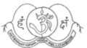

INTERNATIONAL YOGA FELLOWSHIP MOVEMENT (IYFM)

The IYFM is a charitable and philosophical movement founded by Swami Satyananda at Rajnandgaon in 1956 to disseminate the yogic tradition throughout the world. It forms the medium to convey the teachings of Swami Satyananda through its affiliated centres around the world. Swami Niranjanananda is the first Paramacharya of the International Yoga Fellowship Movement.

The IYFM provides guidance, systematized yoga training programs and sets teaching standards for all the affiliated yoga teachers, centres and ashrams. A Yoga Charter to consolidate and unify the humani• tarian efforts of all sannyasin disciples, yoga teachers, spiritual seekers and well-wishers was introduced during the World Yoga Conven• tion in 1993. Affiliation to this Yoga Charter enables the person to become a messenger of goodwill and peace in the world, through active involvement in various far-reaching yoga-related projects.

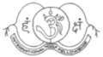

BIHAR SCHOOL OF YOGA (BSY)

The Bihar School of Yoga is a charitable and educational institution founded by Swami Satyananda at Munger in 1963, with the aim of imparting yogic training to all nationalities and to provide a focal point for a mass return to the ancient science of yoga. The Chief Patron of Bihar School of Yoga is Swami Niranjanananda. The original school, Sivanandashram, is the centre for the Munger locality. Ganga Darshan, the new school established in 1981, is situated on a historic hill with panoramic views of the river Ganges.

Yoga Health Management, Teacher Training, Sadhana, Kriya Yoga and other specialized courses are held throughout the year. BSY is also renowned for its sannyasa training and the initiation of female and foreign sannyasins.

BSY provides trained sannyasins and teachers for conducting yoga conventions, seminars and lectures tours around the world. It also contains a comprehensive research library and scientific research centre.

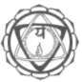

SIVANANDA MATH (SM)

Sivananda Math is a social and charitable institution founded by Swami Satyananda at Munger in 1984, in memory of his guru, Swami Sivananda Saraswati of Rishikesh. The Head Office is now situated at Rikhia in Deoghar district, Bihar. Swami Niranjanananda is the Chief Patron.

Sivananda Math aims to facilitate the growth of the weaker and underprivileged sections of society, especially rural communities. Its activities include: distribution of free scholarships, clothing, farm animals and food, the digging of tube-wells and construction of houses for the needy, assistance to farmers in ploughing and watering their fields. The Rikhia complex also houses a satellite dish system for providing global information to the villagers.

A medical clinic has been established for the provision of medical treatment, advice and education. Veterinary services are also provided. All services are provided free and universally to everyone, regardless of caste and creed.

YOGA RESEARCH FOUNDATION (YRF)

The Yoga Research Foundation is a scientific, research-oriented institu• tion founded by Swami Satyananda at Munger in 1984. Swami Niranjanananda is the Chief Patron of the foundation.

YRF aims to provide an accurate assessment of the practices of different branches of yoga within a scientific framework, and to establish yoga as an essential science for the development of man• kind. At present the foundation is working on projects in the areas of fundamental research and clinical research. It is also studying the effects of yoga on proficiency improvement in various social projects,

e.g. army, prisoners, children. These projects are being carried out in affiliated centres worldwide.

YRF's future plans include literary, scriptural, medical and scientific investigations into other little-known aspects of yoga for physical health, mental well-being and spiritual upliftment.

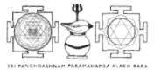

SRI PANCHDASHNAM PARAMAHAMSA ALAKH BARA (PPAB)

Sri Panchdashnam Paramahamsa Alakh Bara was established in 1990 by Swami Satyananda at Rikhia, Deoghar, Bihar. It is a charitable, educational and non-profit making institution aiming to uphold and propagate the highest tradition of sannyasa, namely vairagya (dis- passion), tyaga (renunciation) and tapasya (austerity). It propounds the tapovan style of living adopted by the rishis and munis of the vedic era and is intended only for sannyasins, renunciates, ascetics, tapasvis and paramahamsas. The Alakh Bara does not conduct any activities such as yoga teaching or preaching of any religion or religious concepts. The guidelines set down for the Alakh Bara are based on the classical vedic tradition of sadhana, tapasya and swadhyaya, or atma chintan.

Swami Satyananda, who resides permanently at the Alakh Bara, has performed the Panchagni Vidya and other vedic sadhanas, thus paving the way for future paramahamsas to uphold their tradition.

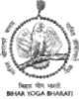

BIHAR YOGA BHARATI (BYB)

Bihar Yoga Bharati was founded by Swami Niranjanananda in 1994 as an educational and charitable institution for advanced studies in yogic sciences. It is the culmination of the vision of Swami Sivananda and Swami Satyananda. BYB is the world's first government accredi• ted university wholly devoted to teaching yoga. A comprehensive yogic education is imparted with provision to grant higher degrees in yogic studies such as MA, MSc, MPhil, DLitt, and PhD to the stu• dents. It offers a complete scientific and yogic education according to the needs of today, through the faculties of Yoga Philosophy, Yoga Psychology, Applied Yogic Science and Yogic Ecology.

Residential courses of four months to two years are conducted in a gurukul environment, so that along with yoga education, the spirit of seva (selfless service), samarpan (dedication) and karuna (compas• sion) for humankind is also imbibed by the students.



YOGA PUBLICATIONS TRUST (YPT)

Yoga Publications Trust (YPT) was established by Swami Niranjan- ananda in 2000. It is an organization devoted to the dissemination and promotion of yogic and allied knowledge - psychology (ancient and modern), ecology, medicine, vedic, upanishadic, tantric darshanas, philosophies (Eastern and Western), mysticism and spirituality - nationally and internationally through the distribution of books, magazines, audio and video cassettes and multimedia.

YPT is primarily concerned with publishing textbooks in the areas of yoga philosophy, psychology and applied yogic science, research materials, practice texts and the inspiring talks of eminent spiritual personalities and authors aimed at the upliftment of humanity by means of the eternal yogic knowledge, lifestyle and practice.